For web intelligence Applet cannot be loaded error, please follow the steps to rectify

- Log into BI4 portal, once logged in select ‘Preference’ as shown in the screen below
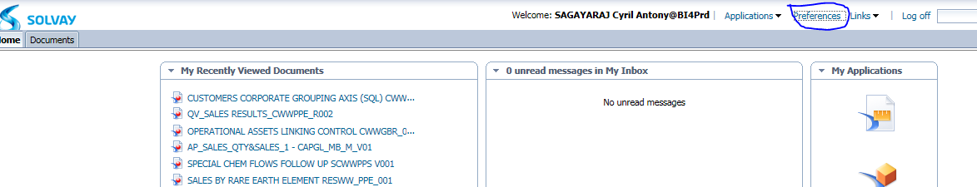

- Once you have selected preference you will get the screen below,once in the below screen select ‘Web intelligence’
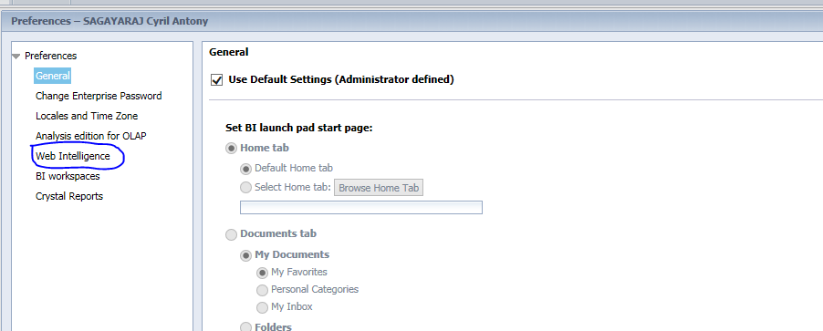
- Once you select ‘web intelligence’ you will get the screen as below,
in it please check if ‘HTML’ is selected if it is ‘HTML’ select ‘Applet’ as shown in the screen below

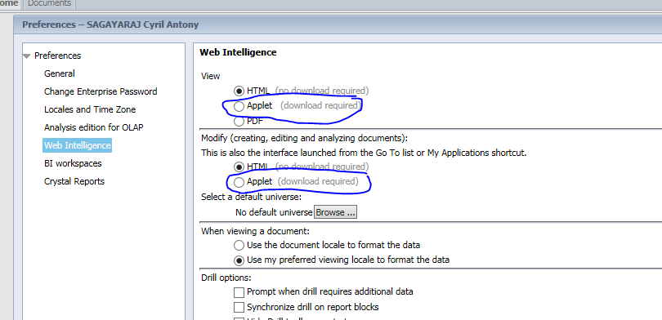
- Once you have selected ‘Applet’ in both the places ‘scroll down and select ‘save and Close’

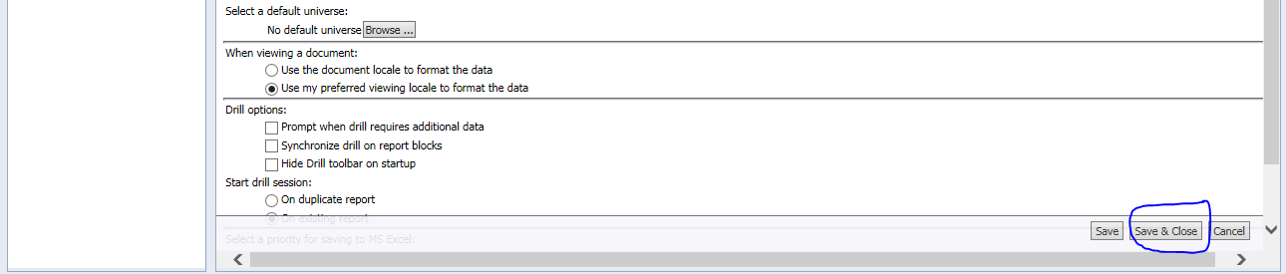
- Log off and log in now ,once your trying to open a report it will open in java mode, if any pop up screen arises say yes.

Export issue
- Once you are in the Report you want to save
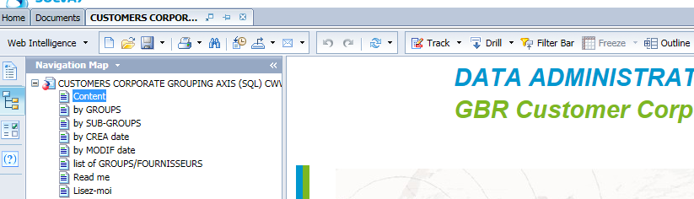
- Select the drop down icon marked in the screen below
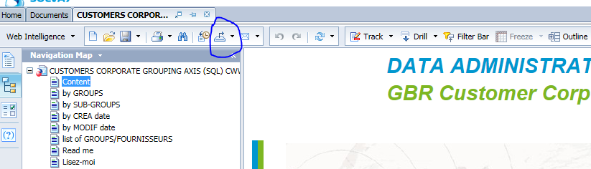
- Once you have selected the Icon you will get the list as shown below
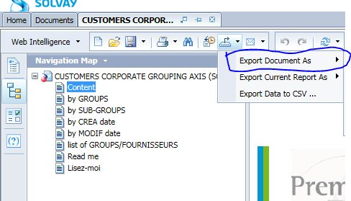
- You can export the Report in the desired format you required as shown in the Image below
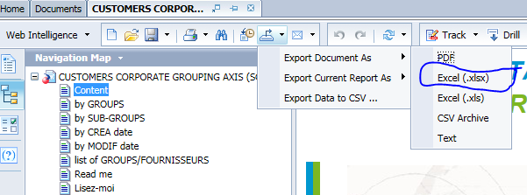

- Once you have done the above step you will get a pop up screen below where it will pop to save the report

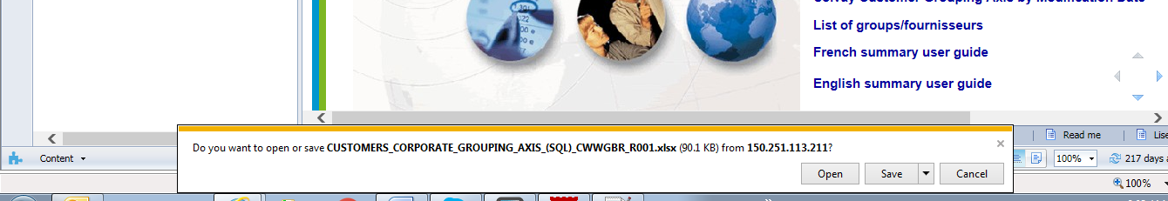
- You can save the report in the desired location using ‘ save as ‘ option.
