

AUTO Usage Decision
2020
Pusuluri, Sireesha
CGI
6/3/2020

Auto Usage Decision
If the goods in an inspection lot are confirmed to be free of defects in an inspection, the system can complete an inspection automatically, provided certain prerequisite conditions have been met.
Prerequisite.
The system can only make an automatic usage decision if the following conditions have been met:
- No characteristic has been rejected in the inspection lot
- All required characteristics have been confirmed and closed
- No defect records exist for the inspection lot
Auto UD process is given Below.
Step 1.
SPRO > Quality Management > Maintain Setting at Plant Level.
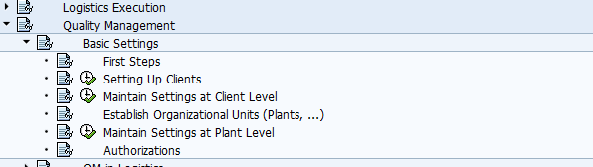
In Plant dependent QM setting maintain wait time in Automatic usage decision tab as per the business requirement.
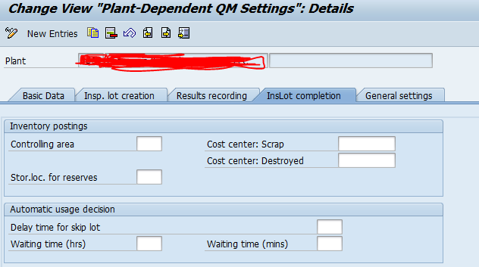
Waiting time: - The number of hours / Mins entered here must have expired after creation of the Lot, before the system makes an automatic usage decision for the corresponding inspection lot.
Step 3.
In material master in QM view activate Automatic UD indicator for the inspection type.
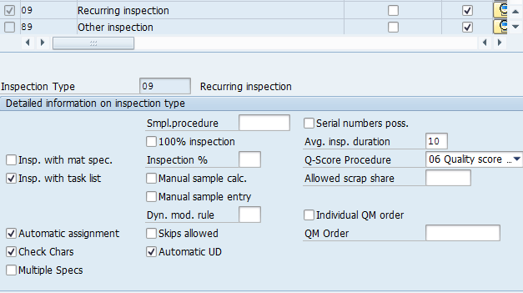
Step 4.
QA01 > Create manual inspection lot for the material.
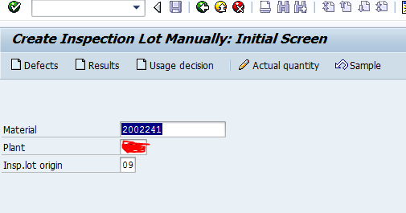
Inspection lot is created for the material of inspection type 09.
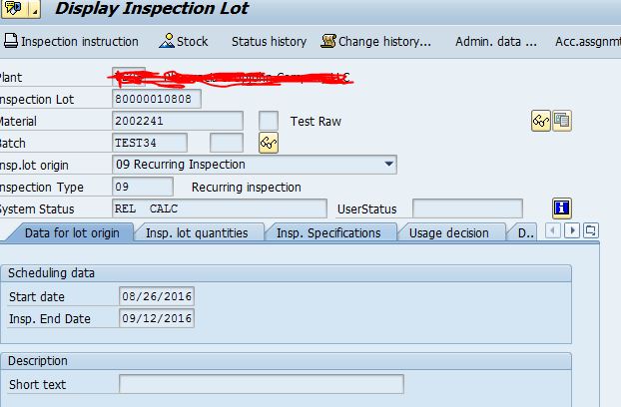
Step 6: -
QE01 > Perform resulting recording.
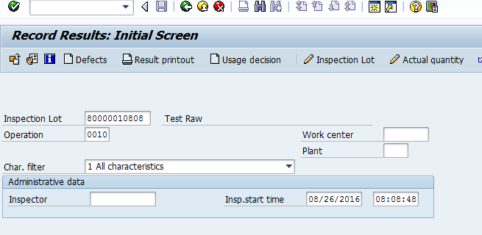
Result recording is completed for the characteristics.
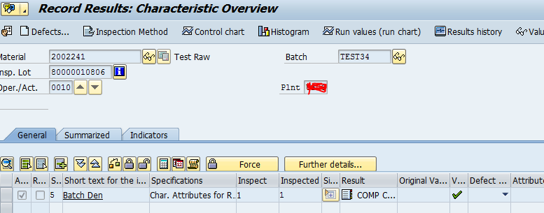
Result recording is mandatory to perform Auto UD if required char indicator is activated for the characteristic.
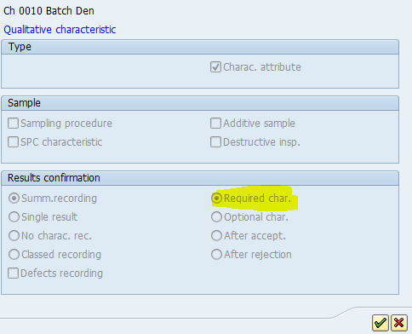
Step 7
Execute T-code QA10 to perform Auto UD for the Inspection lot. You can also schedule job.
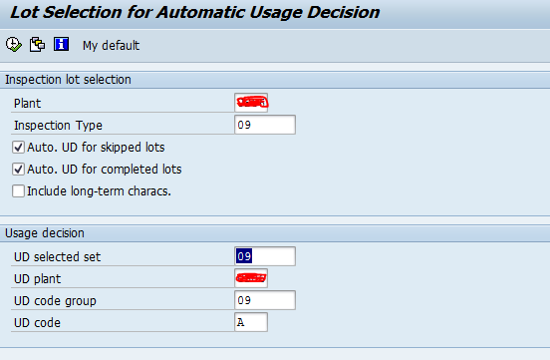
Auto UD has been made successfully for the inspection lot.
