2020
Pusuluri, Sireesha
CGI
4/20/2020


Class Creation

Class creation
Class needs to be created in the TCode CL02. You can then pull in the class into the material in the classification screen.
You can also enter the characteristics values at the bottom half of the screen.
Transaction code: CL01
Enter Class type and Class in below screen with given data
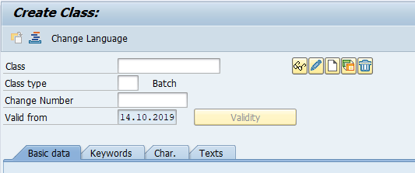
Now press enter
It will look like below
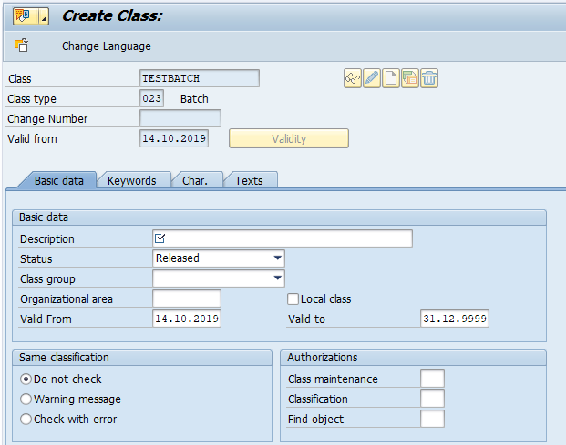
Then now add data in basic data tab
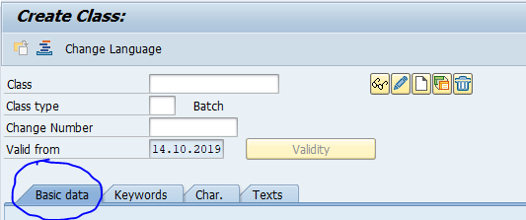
Enter data required
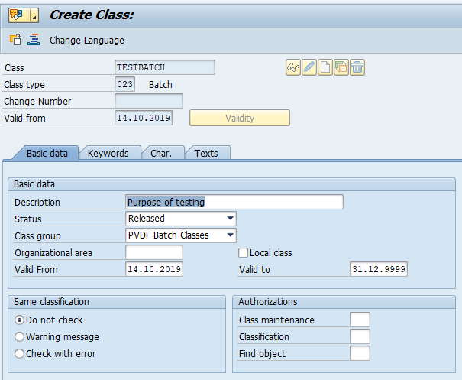
Now go to char. Tab
And enter desired charcteristics from reference class.
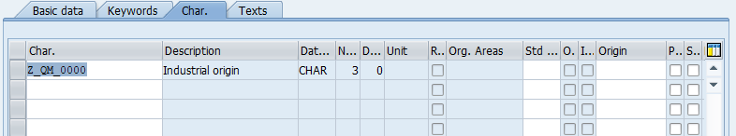
That’s it now class is created


By Ravindhar Manne

1.Enter "CL01"
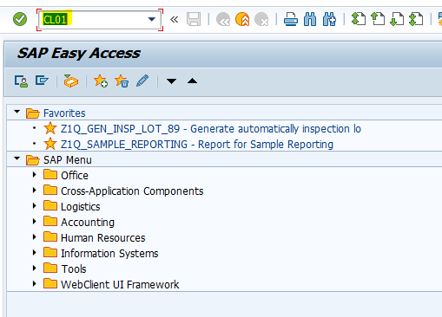
2. Enter required New Class and Class type "023" then click on "create with Template " (red marked) as below.

Without any reference class: If you don't have any reference class then click on "Create" for New class. Here need to enter all details manually.
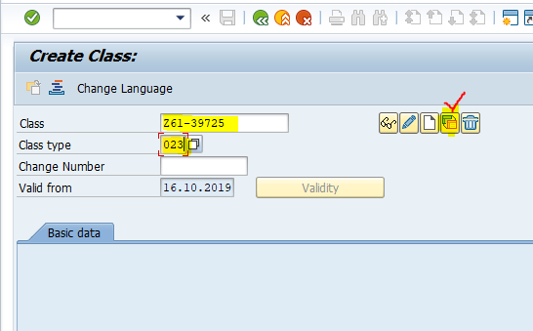

3. Enter the reference class in popup as below to copy details to New Class and Click on "Enter". (ignore of any warning messages).

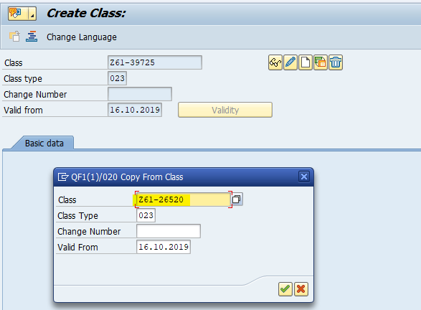
4. Select the required options to copy details in to New class.

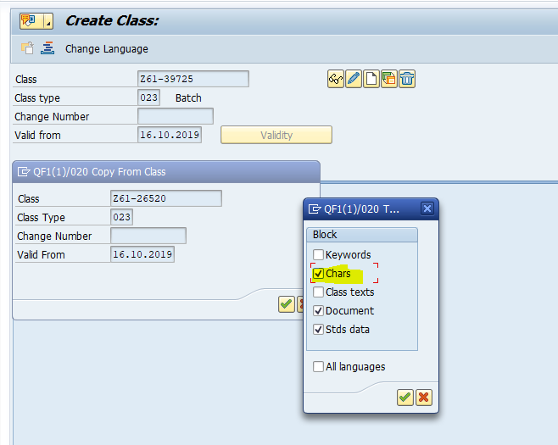

5. Please now enter New class description at below marked area.
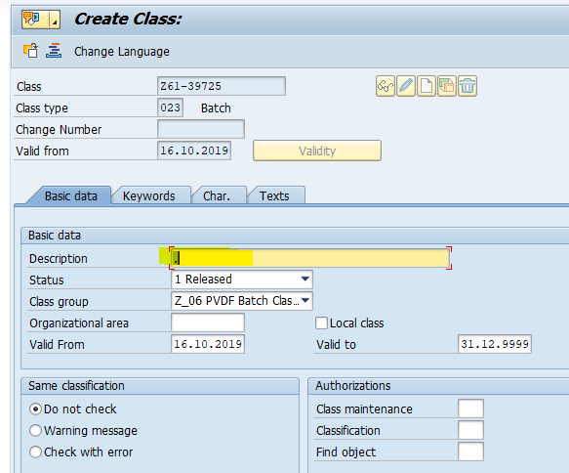

6. Check all char which are already copied from reference class. If required you can add or delete class char from the list.
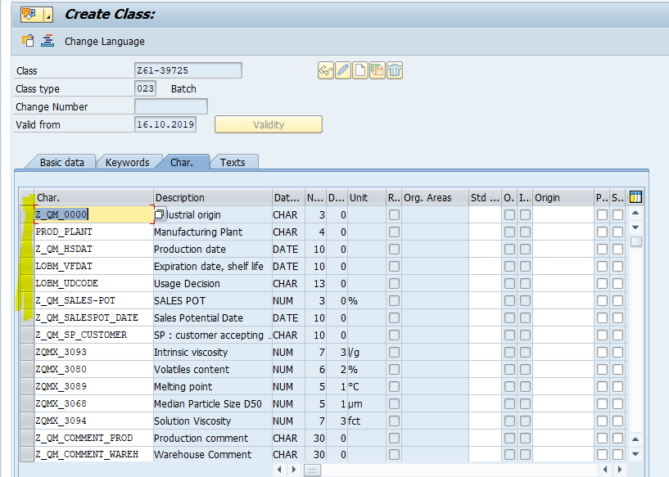
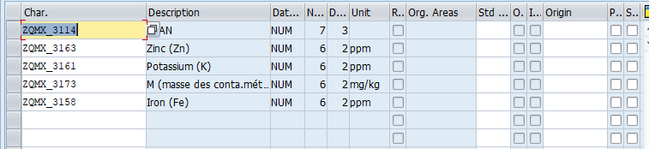

7. Check other tab details and enter more details if required and Save.
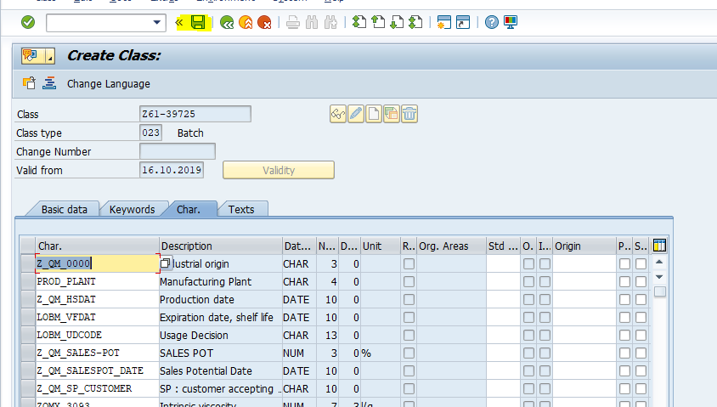

8. Now New Class "Z61-39725" has been created.
​

