2020
Pusuluri, Sireesha
CGI
6/4/2020



Inspection issue types

Inspection Issue Types

Normally on inspection we have to check how they are creating and how they are doing Result recording and Usage decision.
Sometimes with task list and smpl. List also leads to issue.
With having multiple inspection types ((Task list) QP03) and not having any(task list) also leads to issues.
Inspection types starts with
- 01 - Goods Receipt
- 02 - Goods Issue
- 03 - Production
- 04 - Goods Receipt from Production
- 05 - Other Goods Receipt
- 06 - Return from Customers
- 07 - Vendor Audit
- 08 - Stock Transfer
- 09 - Recurring Inspection
- 10 - Delivery to Customer with Customer Order
- 11 - Delivery to Customer Without Sales Order
- 12 - General Delivery
- 13 - Repetitive Manufacturing
- 14 - Plant Maintenance
- 15 - Sample Management
- 16 - Stability Study
- 17 - Externally Triggered Inspection
- 89 - Miscellaneous
Note: with *89* we can’t transfer stock from Quality to unrestricted.
Examples in ticket wise.
Error Type 1
quantity of 600kg in status "in quality control" not able to make some movement - should be deleted

Solution:​
Currently above material Batch stock in Quality.
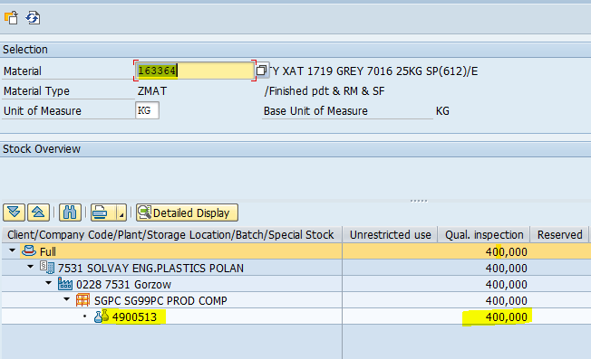

If you want move stock from Quality to Unrestricted please follow below steps to release inspection lot and do the result record and UD.

please follow the below steps to assign inspection plan using QA02.

1. Enter T. Code: QA02
​
2.Change Key date to 07.10.2019 from 03.10.2019 as below. This changes due to exist inspection available (created) from 07.10.2019.
Later click on Task list /spec then specification will be assigned. Now click on save as below.

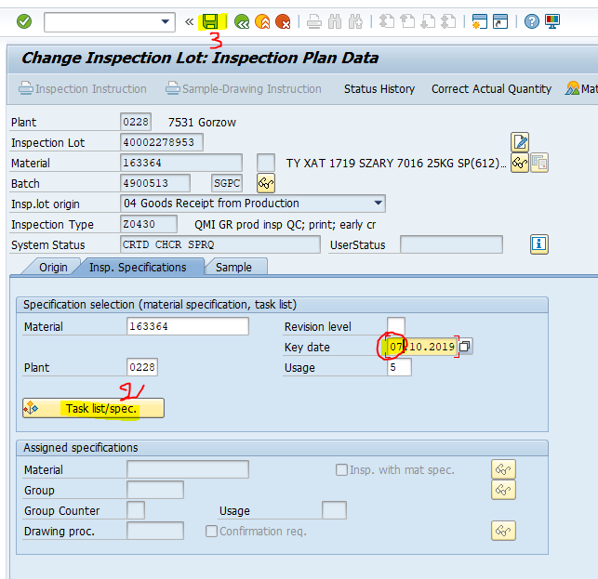
After this the inspection lot will be released status. Now you can do Result Record and UD to move stock from Quality to Unrestricted.

Error Type 2
1. Go to QA32 or QE02 and enter the Inspection Lot.
2. At present the results status is in 3. When the status is in 3 data will not transfer to Batch Characteristics.
3. Please lock the results by clicking the lock button. So that the result status will be updated to 5.
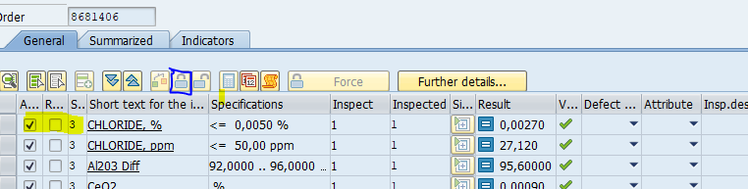4. Once the characteristics are update then you can take the updated COA.

Error Type 3

Normally to do Result recording and Usage decision status of inspection lot should be in REL status.​
But here we have CRTD Status.
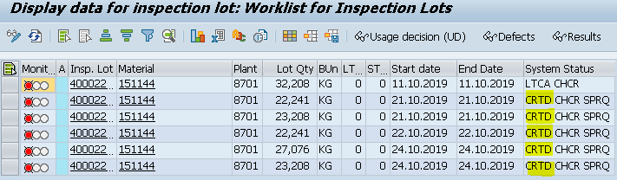
​
when we are trying to check the error we found that task list was not assigned so thats why error is occurring.
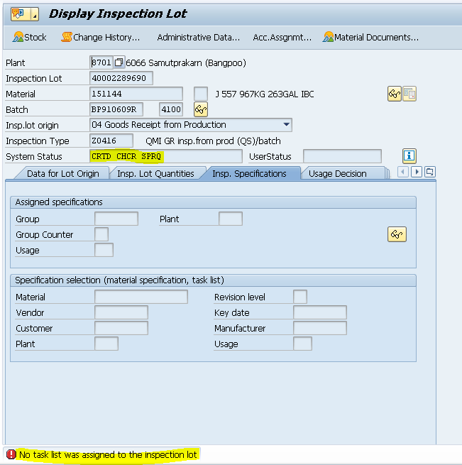
when we check the inspection plan that there are two task lists are available.
​
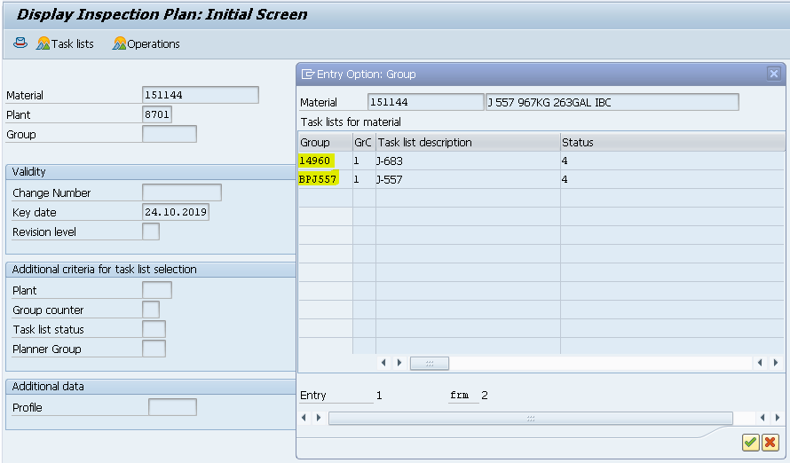
​
At the time of inspection lot creating it got confused and didn't pick any and UD can't be done.
​
To Overcome this, you have to assign task list to the inspection lot.
​
Please go to transaction code QA32 and give the details required.
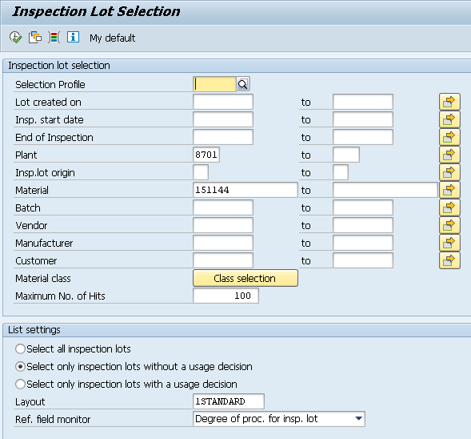
Then select the inspection lot for which you want to do UD.
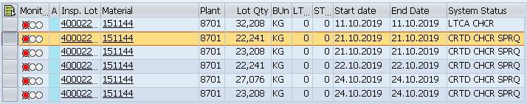
Now Select Inspection Lot in header
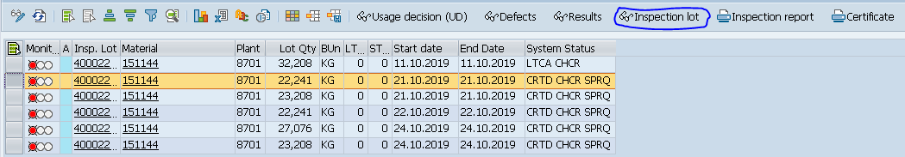
Then In Insp. Specifications give the task list/Spec ( Below image in for other plant and material).
​
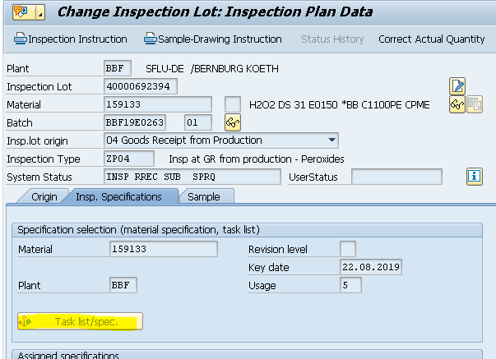
Now add that Task list Manually and you can perform Result recording and Usage Decision.
If any additional Information is required, please contact us.

Error Type 4
Here Inspection Lot which starts with "890000285860" is manual and in this stock won't transfer.​
where as as per inspection lot and stock which you are showing in screenshot are different.
In MMBE screen it is showing different stock
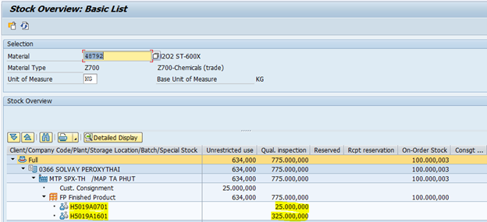
​
Go to transaction QA32 and enter values as below screen.
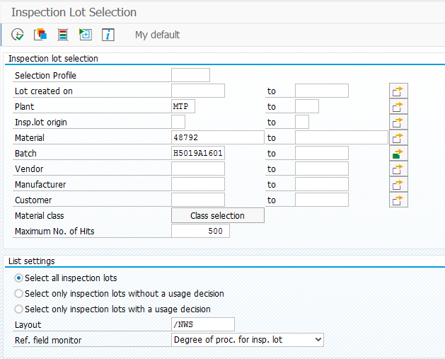
then you will get inspection to do result recording and Usage decision.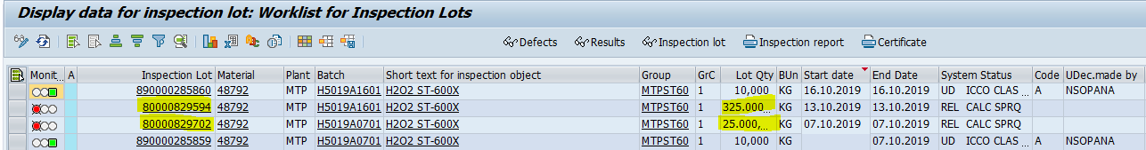

Then stock will move from quality to unrestricted.
As discussed in call please confirm us to close this ticket.
​
Error Type 5
inspection lot is still in CRTD status so you can't do result recording and usage decision. ​
please follow below process
1. Transaction code: QA32
Enter Material, plant and batch.
Select your line and select inspection lot
​
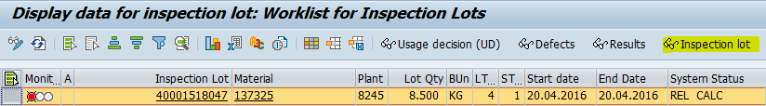
​
2. Go to Insp. Specifications Tab and click on Task List/spec.
​
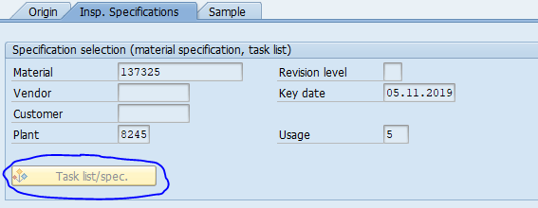
​
​3. Then in Sample Tab click on Smpl. button

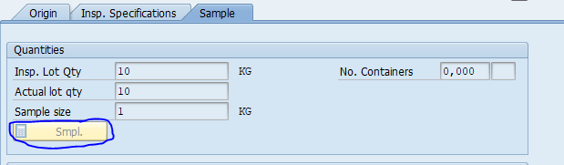

4. Now status will change from CRTD to REL.

After getting status as REL, now you can perform Result Recording and Usage Decision.
Kindly let us know if you still face the issue we will have a fast viewer session

