2020
Pusuluri, Sireesha
CGI
6/4/2020



Process order Errors

Process order Errors
To create process order we can do it from MD11 or COR1
We can create Planned order and convert to process order or directly create Process order.
The status and their description of process orders are:
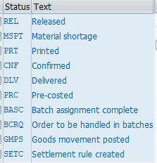
Example Tickets.
Ticket: 3707359
As per our analysis in process order 8702694 Control key for Good receipt confirmation is missing for operation.
​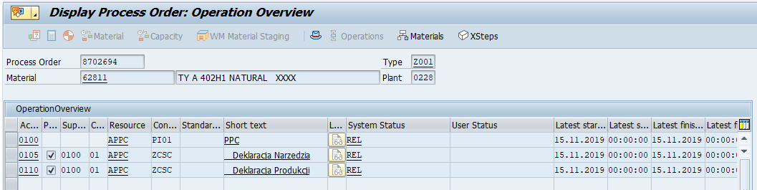
ZCSC is the control key assigned for final operation.
Below are the ZCSC Control key details.
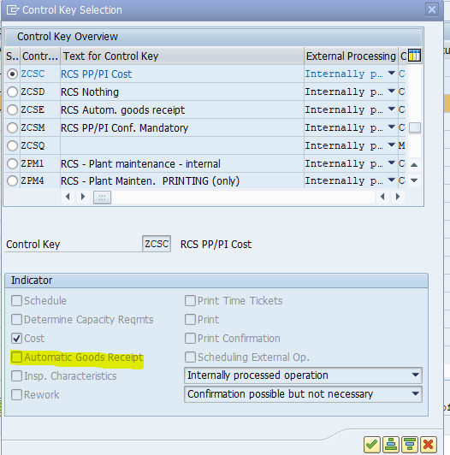
when we compare with old one (reference process order: 8620988) ​Control key for Good receipt confirmation is present for operation.
​
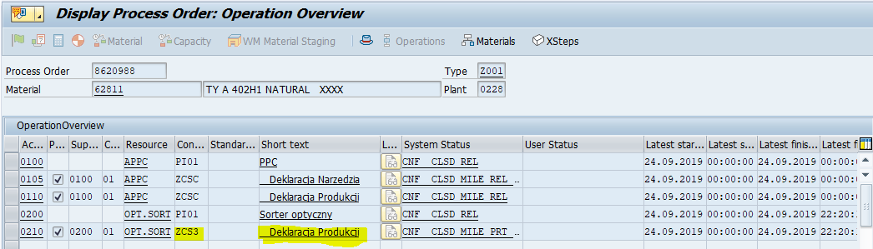
ZCS3 is the control key assigned for final operation.
Below are the ZCS3 Control key details.
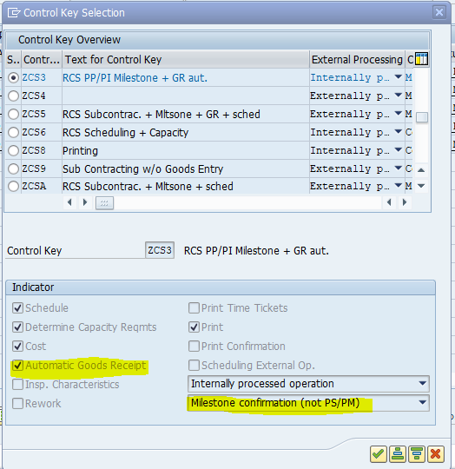

if you still face any issue we will have fast viewer session.

Ticket: 3649265
​We are unable to create Process Order because this material is blocked for Procurement/Production.
Please remove highlighted field in MRP1 View Using MDG System.
So that you will be able to create Process order for this material.
