Pusuluri, Sireesha
CGI

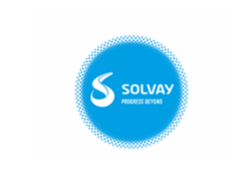
New DMS Document Creation

Document Creation:
Please follow the below steps to create a new document based on previous one(OB).
Step 1: Please go to Transaction CV01N and fill respective fields as below.
Here we are not giving Document version above template because it will get a new number (EX: if we are copying from 14 then our new number will be 15}.
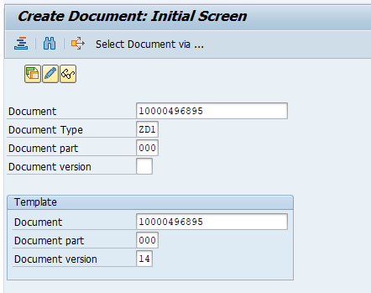

Step 2: After giving respective fields and press enter
we will get a popup window asking us to continue or not.
Please select continue...
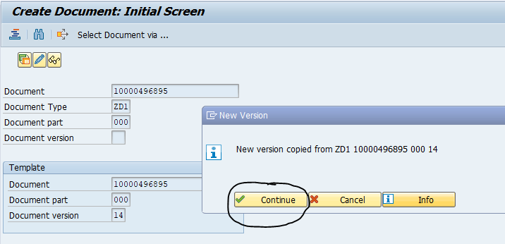

Step 3: Please provide description and now our document status is EE.
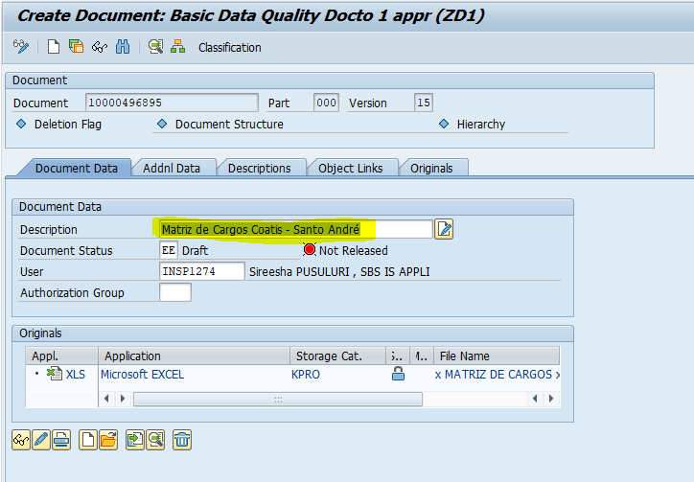

Step 4: Now please change the document status from EE to EC.
And press enter, if you get any popup window again press enter.
Now save it.

Step 5: After creating a new document based old document will be created now.
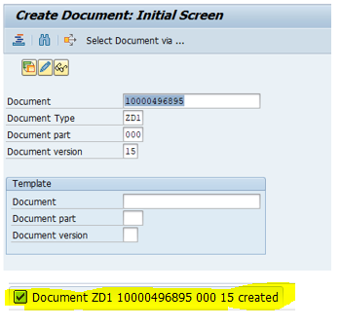
Step 6: Please go to transaction CV02N and provide document number, part, version and type.
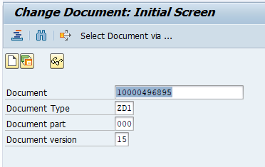

Step 7: Here when you open the document if you find status as EE then again change it to EC and press
enter.
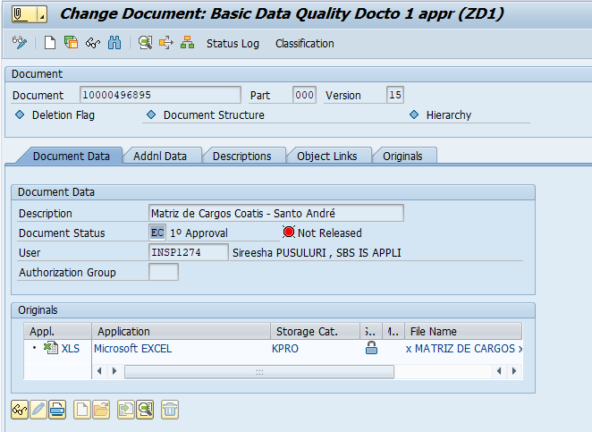
We will get a message as below and save it.

Step 8: Now our document will be in EC and change it to AP.
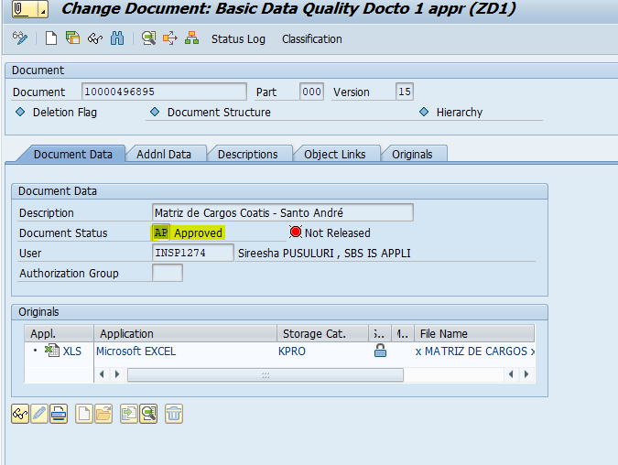

Step 9: we can change it to OB status.
After changing to OB we can’t make any changes.
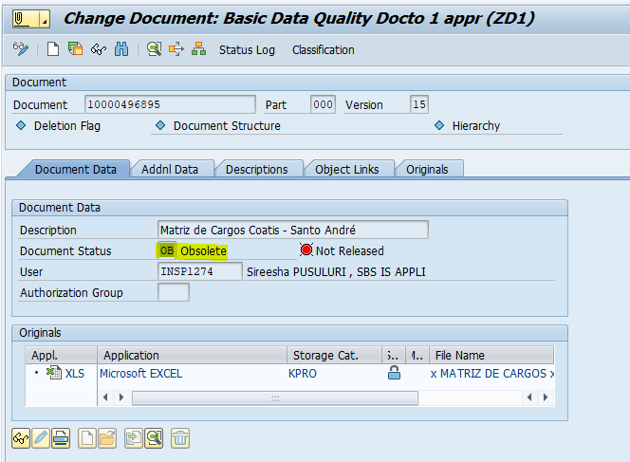

Note:
- To make changes we need to be as part of 1st approval.
- Every time when we change status for document we need to save it.
- Once document is in OB status then we cannot perform any change.

