Pusuluri, Sireesha
CGI

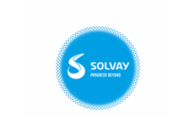

Email Recipient Change

Email Recipient Change
Automatic Transaction E-Mail Recipient Change - 8359_143774
Requirement:
To change E-Mail recipient we need to follow process and need to fill adagio document
Transaction: ZWPP01C

Variant: 8359_143774

Current Email Recipient (to be changed): harrison.martin@solvay.com

New Email Recipient: nicholas.garst@solvay.com

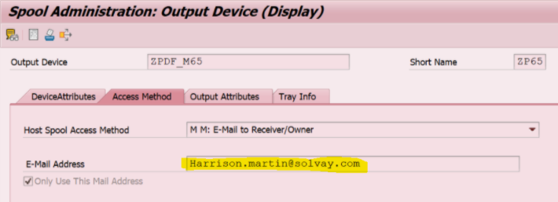

Here we have to get a CD and need to send a proper information to Adagio team with a forward mail.
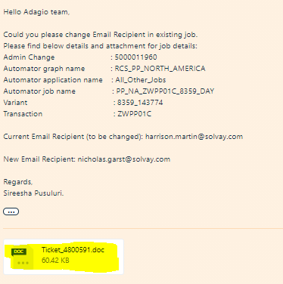

Adagio Document
Need to follow up frequently to get our changes done for our requirement.

