Table of Contents

1 Core principle 2
2 BFC accounts 2
3 Lease accounting exemptions 4
3.1 Overview 4
3.2 Lease component 5
3.3 Group materiality thresholds 6
3.4 Short-term leases 7
3.5 Intercompany leases 9
4 Determining whether a contract contains a lease 10
4.1 General 10
4.2 Identified asset 11
4.3 Control over the use of the identified asset 14
4.4 Summary 18
4.5 Reassessment of whether a contract contains a lease 18
4.6 Lease consideration 19
5 Lease Term 20
5.1 Definition of the lease term 20
5.2 Conditions of enforceability 21
5.3 Reassessment of extension, termination and purchase options 25
5.4 Change in the non-cancellable lease term - without contract modification 26
6 Lessee 26
6.1 Recognition 26
6.2 Initial measurement of the right-of-use asset (“ROU”) 27
6.3 Initial measurement of the lease liability 28
6.4 Discount rate 40
6.5 Subsequent measurement 43
7 Lessor 56
7.1 Lease classification 56
7.2 Finance Lease 57
7.3 Operating lease 59
7.4 Subleases 60
8 Glossary 61
9 Document tracking – Versions 64

Core principle
In this chapter, we outline the principles an entity must apply when accounting for lease contracts. A lease is a contract that conveys the right to control the use of an identified asset for a period of time in exchange for consideration.
The core recognition principles are as follows:
- When an entity is a lessee (customer), at commencement of the lease, it shall recognize a right-of-use asset and a lease liability on its statement of financial position. In the income statement, it recognizes depreciation expense related to the right-of-use asset and finance expense generated by the lease liability.
- When an entity is a lessor (supplier), it shall determine whether the lease is an operating or a finance lease. If it is an operating lease, the entity continues to recognize the leased asset on its statement of financial position and in the income statement, it recognizes lease income and depreciation expense related to the leased asset. If it is a finance lease, the entity derecognizes the leased asset and recognizes a lease receivable (net investment in the lease) on its statement of financial position. In this case, in the income statement, the lease receivable will generate a finance income. Additionally, there will be no depreciation expense recognized on the leased asset as the leased asset is effectively treated as being sold.
Syensqo Group accounting policy on leases has been prepared in accordance with IFRS 16 Leases, and is applicable as from January 1, 2019.
Please note that lease contracts are to be reported to GAR – IFRS team as complex contracts if the undiscounted amount of lease payments (as defined below) exceeds 5 MEUR.

BFC accounts
Lease contracts are included in the following captions of the consolidated statement of financial position and income statement of the Group.
Lessee accounting
- Right-of-use assets (statement of financial position): depending on the nature of the underlying asset that is being leased, right-of-use assets are classified in the following accounts:

BFC accounts | Description
A23100 | Land - Right of use – Gross value
A23300 | Buildings - Right of use – Gross value
A23400 | Transportation equipment – Right of use – Gross value
A23700 | Industrial Equipment - Right of use – Gross value
A23500 | Other tangible assets - Right of use – Gross value
A29310 | Land - Right of use – Depreciation
A29330 | Buildings - Right of use – Depreciation
A29340 | Transportation equipment – Right of use – Depreciation
A29370 | Industrial Equipment - Right of use – Depreciation
A29350 | Other tangible assets - Right of use – Depreciation
A29931 | Land - Right of use – Impairment
A29933 | Buildings - Right of use – Impairment
A29934 | Transportation equipment – Right of use – Impairment
A29937 | Industrial Equipment - Right of use – Impairment
A29935 | Other tangible assets - Right of use – Impairment

Content of BFC accounts
A23100 Land right-of-use includes lease contracts for which the underlying asset of the contract is a land.
A23300 Buildings right-of-use includes lease contracts for which the underlying asset of the contract is a building (building, warehouse, private houses).
A23400 Transportation equipment right-of-use includes lease contracts of all types of vehicles for transportation and handling (e.g. railcars, cars, forklifts).
A23700 Industrial equipment right-of-use includes lease contracts for which the underlying asset is an industrial production asset, and includes utility assets.
A23500 Other tangible assets right-of-use includes lease contracts for which the underlying asset is not classified in any of the other captions of right-of-use. For example, it includes office equipment, hardware material, communication equipment, etc.
Costs incurred by the Lessee on leased assets are not included within the cost of the right-of-use asset and are accounted for under IAS 16.
- Lease liability (statement of financial position): Lease liability is split between current and non-current in the following accounts:
  - L16830: Long-term lease debts – IFRS 16
  - L56030: Long-term lease debts – short-term portion – IFRS 16
- Advance payments made to supplier will be recorded in the following account:
  - A40173: Advance Suppliers right-of-use assets.
- Depreciation of right-of-use asset (income statement): depreciation on the right-of-use asset is recognized in the following accounts:
  - R25860: Period non-proportional depreciation of production
  - R27200: Depreciation services and miscellaneous
  - R33800: Administrative & commercial depreciation expenses
  - R36300: Research & development depreciation expenses
  - R38400: Other recurring depreciation expenses
- The impairment of right-of-use asset (income statement):
  - R45500: Restructuring - Impairment of right of use
  - R48620: Other non-recurring depreciation expenses related to right of use
- Interest expense on the lease liability is recognized in the following account:
  - R53660: Financial charge on lease liability
- Any gain or loss relating to the partial or full termination of the lease is recognized in:
  - R54630: Impact of lease contract modifications (below EBITDA)
Lessor accounting
Lease income from operating (sub)lease towards third parties is recorded in R11200 - Other revenues on activities - Industrial and Administrative & Commercial except if the lease income is generated by a core business activity. In that case revenue is recorded in R10000 – Net sales.

Sublease accounting
BFC Accounts | Description
ASSETS
A26300 | Long-term Finance lease – IFRS 16
A29630 | Long-term Finance lease – IFRS 16 – Write down
A46300 | Short-term finance lease – IFRS 16
A49300 | Short-term finance lease – IFRS 16 – Write down
LIABILITIES
L46030 | Advances received Finance lease – IFRS 16
P&L
R53713 | Financial income on lease receivables
R48770 | Gain on asset disposal (recurring)
R48670 | Loss on asset disposal (recurring)
R48711 | Gain on asset disposal (non recurring)
R48611 | Loss on asset disposal (non recurring)

Content of BFC accounts
A26300 and A46300: The sublease receivable from the sublessee
A29630 and A49300: Expected credit loss allowance on the sublease receivable balance
L46030: Security deposit received from the sublessee
R53713: Interest income earned on the outstanding balance of the sublease receivable
R48770, R48670, R48711, R48611: Gains/losses on the effective disposal of the right-of-use asset when the sublease is initially entered into

Lease accounting exemptions

Overview
Lease accounting shall not apply to:
- Leases to explore for or use minerals, oil, natural gas and similar non-regenerative resources;
- Lease of precious metals (e.g. palladium);
- Leases of intangible assets, including licenses of intellectual property granted by lessor;
- Leases of assets that are legally owned by Syensqo prior to the lease transaction, and whereby Syensqo doesn’t lose control of the assets when it transfers their legal ownership to the lessor. Such lack of loss of control is generally due to the fact that the legal leaseback allows the lessee to use the asset over its entire expected useful life. Those transactions are accounted for as financing arrangements instead of leases (see 6.3.8 and 6.3.9).
Any payments made for those leases are recognized, generally as an expense, in the period to which they pertain.
The Syensqo Group has defined the materiality thresholds, and has elected not to apply lease accounting for short-term leases as described below.
Please note that for statutory reporting purposes, lower materiality thresholds may apply. In this case, you should alert the IFRS 16 team at SBS.
Lease payments associated with the leases that are below materiality thresholds or that are short-term, are recognized as an expense on either a straight-line basis over the lease term or another systematic basis (if more representative of the pattern of the lessee’s benefit).

Lease incentives in case lease accounting is not applied
If lease accounting is not applied, lease incentives, such as a rent-free period, for low-value leases and short-term leases will be recognized on a straight-line basis over the lease term as defined below.

Example
Entity A leases office equipment for 5 years. The total value of the equipment when new is CU 5,000, which is below materiality thresholds.
Lease payments are payable as follows:
Year 1: CU 0 (rent-free period)
Year 2 and 3: CU 1,750 per year
Year 4 and 5: CU 1,500 per year
The lessee’s benefit under the lease arises on a straight-line basis over the lease term.
Total payments: (CU 1,750 * 2) + (CU 1,500 * 2) = CU 6,500
Length of the lease: 5 years
Lease expense recognized each year: (CU 6,500 / 5) = CU 1,300

Lease component
For a contract that is, or contains, a lease, each lease component within the contract will be accounted for as a lease separately from non-lease components of the contract.
The right to use an underlying asset is a separate lease component if the following two conditions are met:
- The lessee can benefit from use of the underlying asset either on its own or together with other resources that are readily available to the lessee (goods or services sold or leased separately or that the lessee has already obtained); and
- The underlying asset is neither highly dependent on, nor highly interrelated with, the other underlying assets in the contract.
Some contracts contain items that do not relate to the transfer of goods/services by the lessor to the lessee (e.g. fees, real estate taxes, insurance or other administrative costs a lessor charges a lessee). These items are not considered separate lease or non-lease components, and lessees and lessors do not allocate consideration in the contract to these items. However, if the lessor provides services (e.g. maintenance, supply of utilities), the contract would generally contain non-lease components.

Example – asset integrated in a larger asset
Entity A enters into a tolling agreement with Supplier. Supplier will invest in a new equipment for the exclusive manufacturing of Entity A’s products. This investment is minor in relation to the full value of the entire production line. Entity A will reimburse the equipment over 5 years through a fixed price per product sold. The equipment is part of an overall production line and cannot operate on its own. There are different customers buying finished goods from the toller’s production line. If Entity A decides to stop the contract, it will have to reimburse the remaining investment.
In the example above, there is no separate lease component as the equipment is integrated in a larger asset (the production line) and the equipment cannot operate on its own. The equipment is highly dependent on other underlying assets in the contract. In this example, we assume that Entity A does not have the right to obtain substantially all the economic benefit from using the equipment because there are other customers buying finished goods from this production line.

Example – Industrial asset
Entity B has signed with Supplier a 10-year agreement for the supply of industrial gas. In order to be able to supply Entity B with the gas, Supplier installs on Entity B’s site a generator. Supplier will be the exclusive supplier for gas during the 10 years. The contract states that the generator will be installed and supplied for no charge. The contract mentions that there is a minimum purchase requirement for the gas.
The generator is specifically identified as supplier cannot supply gas through another source and Entity B has the right to control the use of the generator for the contract term.
Although in the circumstances described, the contract states that the generator is supplied for no charge, some consideration of the contract needs to be allocated to the lease component. Entity B will therefore have to allocate the consideration between the generator (lease component) and the purchase of gas (non-lease component). As there is a minimum purchase requirement for the gas, the payments related to the lease component cannot be considered as completely variable.

Group materiality thresholds
The following leases are exempt from lease accounting for Group reporting purposes:
- All contracts (including master agreements) with annual lease payments below 25,000 EUR;
- Contracts managed through a master agreement/framework and related to assets with individual new asset values below 5,000¹ EUR. In this context, contracts for printers, computers, coffee machines, etc. will generally be exempt from lease accounting. On the contrary, contracts for car, railcars, etc. managed through a master agreement will not meet the exemption criteria.
Please note that for the purpose of calculating the above materiality thresholds, the value of the leased asset or the annual lease payments are determined at the level of the lease component, which may encompass more than one contract (see above – Lease component – on how to determine). For example, if one were to contractually lease multiple components of a single machine separately, then the calculation of materiality thresholds will be based on the aggregate of those contracts. As a result, the materiality thresholds may be assessed for a group of leased assets that, as a whole, meet the conditions of a single lease component.
For example, Entity A enters into an agreement with a lessor for the rent of a car. Annual lease payments for the lease is 12,000 EUR. If the lease agreement is not part of a broader master lease agreement, the contract is below 25,000 EUR annual payments and therefore, lease accounting is not applied.
On the contrary, if the lease agreement is part of a broader master lease agreement whereby Entity A rents 4 similar cars, because of the fact that a car has a new value in excess of 5,000 EUR and the fact that annual lease payments of the master lease agreement are above 25,000 EUR, lease accounting shall be applied.
Note that these thresholds apply equally to contracts where the Group is the lessor.

Short-term leases
A short-term lease is a lease that, at the commencement date, has a lease term of 12 months or less (including any rent-free period). A lease that contains a purchase option is not a short-term lease. The short-term lease exemption shall be applied irrespective of the value of the underlying asset or the value of the lease payments.
The determination of duration of short-term leases must be consistent with the determination of the lease term as defined below, thus considering the likelihood of extension options being exercised or termination options not being exercised.
A short-term lease will be considered as a new lease if there is a lease modification or if there is any change in the lease term (e.g. lessee exercises an option not previously considered in the determination of the lease term). The new lease is evaluated to determine whether it qualifies for the short-term exemption.

Example of short-term lease exemption no longer meeting the criteria of short-term lease
On January 1, 2018, Entity A enters into a 2-year lease agreement as a lessee. Under the terms of the lease, Entity A has a right to terminate the lease at December 31, 2018 without paying any penalty, by giving 3 months’ notice. If Entity A does not exercise the termination option on September 30, 2018 the lease will run until December 31, 2019 (i.e. the remaining duration of the lease will be 15 months from October 1, 2018). Only Entity A has the right to terminate the lease.
At lease commencement date, Entity A determines that it is not reasonably certain to continue the lease beyond the first 12 months. Consequently, the lease meets the definition of a short-term lease as at January 1, 2018.
Entity A does not exercise its termination option on September 30, 2018 that was previously included in determining the lease term. This constitutes a change in the non-cancellable period of the lease and, as such, Entity A should consider the lease to be a new lease from October 1, 2018 with a lease term of 15 months. Consequently, the lease does not meet the definition of a short-term lease from October 1, 2018.
Further, we note that subsequent renewals of a short-term lease creates a rebuttable presumption that the lease term is in excess of 12 months.

Example of short-term lease and lease term (2)
On January 1, 2018, Entity A leases a machine from Entity B for 2 years. Under the terms of the lease, both Entity A and Entity B have a right to terminate the lease at December 31, 2018 by giving 3 months’ notice. There is no penalty associated with the termination options from the perspective of either Entity A or Entity B. If neither party exercises the termination option on September 30, 2018, the lease will run until December 31, 2019 (i.e. the remaining duration of the lease will be 15 months from October 1, 2018).
In the circumstances under consideration, as at January 1, 2018, because Entity A and Entity B both have a right to terminate the lease at the end of one year without penalty the maximum enforceable period of the lease is determined as one year (see below – Definition of the lease term). As such, the lease meets the definition of a short-term lease as at January 1, 2018.

Example of short-term lease and lease term (3)
Entity A has a lease for 2 years that starts on January 1, 20x1 and ends on December 31, 20x2. There are no extension options. The lease is extended on October 1, 20x2 for 6 months from January 1, 20x3 to June 30, 20x3.
On the date of the modification, the contract cannot be considered to be a short-term lease as originally the contract was not a short-term lease. The remaining lease term at the date of the modification is 9 months (from October 1, 20x2 till June 30, 20x3).

Example of short-term lease and lease term (4)
Entity A has a short-term lease that starts on January 1, 20x1 and ends on December 31, 20x1. There are no extension options. The lease is extended on October 1, 20x1 for 6 months from January 1, 20X2 to June 30, 20x2. Entity A applied the short-term lease exemption to the original lease.
On October 1, 20x1, Entity A applies the short-term lease exemption and the lease term at the date of modification is 9 months (from October 1, 20x1 till June 30, 20x2).

Example of short-term lease and lease term (5)
Entity A has a short-term lease that starts on January 1, 20x1 and ends on December 31, 20x1. There are no extension options. The lease is extended on 1 October 20x1 for 12 months from 1 January 20x2 to 31 December 20x2. Entity A applied the short-term lease exemption to the original lease.
On October 1, 20x1, Entity A cannot apply the short-term lease exemption because the lease term is 15 months (from October 1, 20x1 till December 31, 20x2).

Intercompany leases
If a (sub)lease is concluded between two entities of the Syensqo Group that are fully consolidated, the following accounting treatment will be applied:
- The intercompany lessor will recognize the lease income in the period in which the asset was used by the lessee;
- The intercompany lessee will recognize the lease expense in the period in which the asset was used by the entity.
Intercompany lessor and intercompany lessee will record the lease income and the lease expense respectively in a way that in consolidation both income and expense will be eliminated.
Please note that any 'head lease' between the intercompany lessor and a third party (e.g. the intercompany lessor leases a building from a third party and subleases (parts of) it to a group entity) is not exempt from lease accounting and follows the guidance as described in this chapter.

Determining whether a contract contains a lease

General
At inception of the contract, which generally coincides with the date the contract is signed, the Group assesses whether a contract is, or contains, a lease. As mentioned above, a contract is, or contains a lease if the contract conveys the right to control the use of an identified asset (land or depreciable asset) for a period of time in exchange for a consideration.
It should be noted that the definition of a lease is broader than what in many jurisdictions is referred to as a normal leasing contract. For instance, it generally includes rental contracts, and may also extend to contracts where, at first glance, it is not obvious that the substance of the contract conveys the right to control the use of an identified asset (e.g. supply of goods agreement, service agreement, tolling agreement). For example, a service agreement might include the exclusive use of an office space or of a warehouse. In supply of goods or tolling agreements, it might happen that the supplier is able to fulfill its obligations only by using one specific asset. All in all, an entity may enter into an arrangement that does not take the legal form of a lease but yet conveys the right to use an identified asset, and therefore is a lease in accordance with IFRS. The key elements of the definition are:

Is there an identified asset?
Does the customer have the right to obtain substantially all of the economic benefits from the use of the identified asset?
Does the customer have the right to direct the use of the identified asset?
Contract is or contains a lease
Yes
Yes
Yes
Contract does not contain a lease
Does customer control the use of the identified asset throughout the period of use?
No
No
No
Two or more contracts entered into at or near the same time with the same counterparty (or related parties of the counterparty) are considered to form one single contract if one or more of the following criteria are met:
- Contracts are negotiated as a package with an overall commercial objective;
- The amount of consideration to be paid in one contract depends on the price or performance of the other contract; or
- The rights to use underlying assets conveyed in the contracts (or some rights to use underlying assets conveyed in each of the contracts) form a single lease component.
For example, if a lessee enters into a one-year contract for an asset with particular characteristics and enters at the same time into a one-year contract for an asset with similar characteristics starting in one year’s time, those contracts need to be combined if, in substance, they form one single arrangement that achieves one overall commercial objective, i.e. a two-year contract for the asset.

Identified asset

Implicit or explicit asset
An asset is typically identified by being explicitly specified in a contract (asset number, detailed description, serial number, geographical identification for immovable property, …).
However, an asset can also be identified by being implicitly specified at the time that the asset is made available for use by the customer (e.g. supplier has only one asset that can meet the lessee’s needs, and cannot source from a third party). Such assessment takes into account whether the right to use alternative assets is substantive. For example, if the supplier has only one asset in the region, and sourcing the product sold to the customer from a different region would cause an important margin erosion for the supplier due to increased transportation costs, the asset is implicitly specified. Substitution rights are further discussed below.

Substitution rights
Even if an asset is specified in the contract, a customer does not have the right to use an identified asset (and therefore there is no lease) if the supplier has the substantive right to substitute the asset throughout the period of use.

A supplier’s right to substitute an asset is substantive only if both of the following conditions exist:
- The supplier has the practical ability to substitute alternative assets throughout the period of use (alternative assets are readily available to the supplier or could be sourced by the supplier within a reasonable period of time); and
- The supplier would benefit economically from the exercise of its right to substitute the asset (i.e. the economic benefits associated with substituting the asset are expected to exceed the costs associated with substituting the asset).
If the supplier has a right or an obligation to substitute the asset only on or after either a particular date or the occurrence of a specified event, the supplier’s substitution right is not substantive because it does not exist throughout the period of use. The supplier’s right or obligation to substitute the asset for repairs and maintenance, if the asset is not operating properly, or if a technical upgrade becomes available, does not preclude the customer from having the right to use an identified asset and therefore the lease treatment.
If the asset is located at the customer’s premises or elsewhere, the costs associated with substitution are generally higher than when located at the supplier’s premises and, therefore, are more likely to exceed the benefits associated with substituting the asset.

Substitution rights are to be assessed based on facts and circumstances at the inception of the contract and shall exclude consideration of future events that at inception of the contract are not considered likely to occur.

If the customer cannot readily determine whether the supplier has a substantive substitution right, the customer shall presume that any substitution right is not substantive.

Example of non-substantive substitution right
Customer enters into a contract with a railcar manufacturer (Supplier) for the use of an explicitly specified railcar for a two-year period. As the railcar will transport hazardous substances, the contract details the mechanical and safety specifications for the railcar. The railcar has a unique identification number.
Per the terms of the contract, Supplier is permitted to substitute the railcar at any time during the two-year period. Nevertheless, any substitute railcar must meet the mechanical and safety specifications of the railcar mentioned in the contract. There are significant costs involved for the Supplier to provide a railcar that meets Customer’s specifications, and re-marketing the existing railcar.
Supplier’s substitution rights are not substantive as the significant costs involved in providing a substitute railcar to meet the specifications required by the contract prevent the Supplier from economically benefiting from the substitution of the railcar. Therefore if all other conditions are met, the contract is a lease.

Example of substantive substitution right
The contract between Customer and Supplier requires Supplier to transport a specified quantity of goods by using a specified type of rail car in accordance with a stated timetable for a period of 5 years. The timetable and quantity of goods specified are equivalent to Customer having the use of 10 railcars for 5 years. Supplier provides the rail cars, driver and engine as part of the contract. The contract states the nature and quantity of goods to be transported (and the type of rail car to be used to transport the goods). Supplier has a large pool of similar cars that can be used to fulfil the requirements of the contracts. Similarly, one engine could be used to transport not only Customer’s goods, but also the goods of other customers. The cars and engines are stored at Supplier’s premises when not being used to transport the goods.
Supplier has the practical ability to substitute each car and the engine throughout the period of use. Supplier would benefit economically from substituting each car and the engine because the cars and engines are stored at Supplier’s premises and it would for example allow Supplier to (i) use cars or an engine to fulfill a task for which the cars or engine are already positioned to perform (rail yard close to the point of origin) or (ii) use cars or an engine that would otherwise be sitting idle. Supplier’s substitution rights are substantive and therefore there is no lease.

Power purchase agreements (“PPAs”)
The Group regularly enters into agreements for the supply of renewable energy (e.g. electricity generated by means of solar panels, windmills, biomass), or energy generated by means of fossil fuels.
A key element to consider in the lease analysis of such PPAs is whether the output that the Group purchases is the output that was physically generated by the asset. If it is mingled with output generated by other assets, there is no lease. Typically, for PPAs based on generation assets that are not on a Syensqo site, but rather connected to the grid, the electricity which the Group takes from the grid is generated by a multitude of generation assets connected to the grid. Those PPAs generally do not contain a lease. On the other hand, PPAs based on generation assets that are located on a Syensqo site and where Syensqo consumes the electricity generated by the asset, may contain a lease.

Portion of an asset
A capacity portion of an asset is an identified asset if it is physically distinct (for example, a floor of a building, a room in a warehouse). On the contrary, an abstract capacity or other portion of an asset that is not physically distinct (for example, a capacity portion of a server) is not an identified asset, unless it represents substantially all of the capacity of the asset and thereby provides the customer with the right to obtain substantially all of the economic benefits from the use of the asset.

Control over the use of the identified asset

General
To assess whether a contract conveys the right to control the use of an identified asset, the Group assesses whether, throughout the period of use, it has:
- the right to obtain substantially all of the economic benefits from use of the identified asset; and
- the right to direct the use of the identified asset;
If the right to control the use of the identified asset is only for a portion of the term of the contract, the contract contains a lease for that portion of the term.

Right to obtain economic benefits from use
To control the use of an identified asset, a customer is required to have the right to obtain substantially all of the economic benefits from use of the asset throughout the period of use (for example, by having exclusive use of the asset throughout that period). A customer can obtain economic benefits from use of an asset directly or indirectly in many ways, such as by using, holding or sub-leasing the asset. The economic benefits from use of an asset include its primary output and by-products (including potential cash flows derived from these items), and other economic benefits from using the asset that could be realized from a commercial transaction with a third party. As an example, the economic benefits from a renewable energy project (e.g. wind farm, solar plant) can include, next to electricity, green energy certificates.

Example – prior consent of the lessee
Entity B grants an exclusive right to use a storage building to Entity A. The building is to be constructed by Entity B for the sole purpose of storing Entity A’s products. Entity B may be allowed to store similar products belonging to third-party customers in the storage building with Entity A’s prior written consent.
The storage building is an explicitly identified asset. Although Entity B may store other products from a third-party, it is not allowed to do it without prior consent of the lessee. Therefore, it is assumed that Entity A has the right to obtain substantially all of the economic benefits from use of the asset.

Right to direct the use
A customer has the right to direct the use of an identified asset throughout the period of use only if either:
- In most of the Group’s contracts: the customer has the right to direct how and for what purpose the asset is used; or
- In a limited number of the Group’s contracts: the relevant decisions about how and for what purpose the asset is used are predetermined and:
  - The customer has the right to operate the asset (or to direct others to operate the asset in a manner that it determines) throughout the period of use, without the supplier having the right to change those operating instructions; or
  - the customer designed the asset (or specific aspects of the asset) in a way that predetermines how and for what purpose the asset will be used throughout the period of use.
Decision-making rights are relevant when they affect the economic benefits to be derived from use. The decision-making rights that are most relevant are likely to be different for different contracts, depending on the nature of the asset and the terms and conditions of the contract.
Examples of decision-making rights that, depending on the circumstances, grant the right to change how and for what purpose the asset is used, within the defined scope of the customer’s right of use, include:
- rights to change when the output is produced (for example, to decide when an item of machinery or a power plant will be used);
- rights to change where the output is produced (for example, to decide upon the destination of a truck or a railcar, or to decide where an item of equipment is used);
- rights to change whether the output is produced, and the quantity of that output (for example, to decide whether to produce energy from a power plant and how much energy to produce from that power plant); and
- rights to change the type of output that is produced by the asset (for example, to decide whether to use a shipping container to transport goods or for storage).

Operating and maintaining the asset are examples of decision-making rights that do not grant the right to change how and for what purpose an asset is used. Although the decisions about maintaining and operating the asset are often essential to the efficient use of that asset, the right to make those decisions, in and of itself, does not result in the right to change how and for what purpose the asset is used throughout the period of use. However, rights to operate an asset may grant the customer the right to direct the use of the asset if the relevant decisions about how and for what purpose the asset is used are predetermined.

The relevant decisions about how and for what purpose the asset is used can be predetermined in a number of ways. For example, the relevant decisions can be predetermined by the design of the asset or by contractual restrictions on the use of the asset.

If a customer can only specify the output from an asset before the beginning of the period of use and cannot change that output throughout the period of use, the customer does not have the right to direct the use of that asset unless it designed the asset. If the customer did not design the asset or aspects of it, the customer’s ability to specify the output in a contract does not give it any other relevant decision-making rights relating to the use of the asset – the customer instead has the same rights as any customer that purchases goods or services in an arrangement (i.e. the contract does not contain a lease).

A typical example is an electricity supply agreement with electricity generated by a solar farm connected to the customer‘s installations and for which the customer takes substantially all of the output. Often, if there’s sufficient sunlight, electricity will be generated, without the customer having the option to decide whether electricity is actually generated. In such a case, as part of the analysis, it is important to assess whether the customer participated in the design of the solar farm. To that end, we look at the following questions:
- Were we involved in determining the maximum capacity of the wind/solar farm to be installed?
- When selecting the location, on our site, to what extent were we involved in determining the optimal location on the site?
- Were we involved in determining the technology to be used by the supplier?
- Were we involved in the technical configurations of the asset?
A contract may include terms and conditions designed to protect the supplier’s interest in the asset or other assets, to protect its personnel, or to ensure the supplier’s compliance with laws or regulations. These are examples of protective rights. For example, a contract may (i) specify the maximum amount of use of an asset or limit where or when the customer can use the asset, (ii) require a customer to follow particular operating practices, or (iii) require a customer to inform the supplier of changes in how an asset will be used. Protective rights typically define the scope of the customer’s right of use but do not, in isolation, prevent the customer from having the right to direct the use of an asset. In other words, those contracts can still contain a lease.

Example – control of the use
Customer enters into a contract with Supplier to purchase all of the output produced by an explicitly specified industrial asset for three years. The industrial asset is owned and operated by Supplier, but will be located on Customer site. Supplier is unable to provide output to Customer from another asset. The customer decides how much output is produced. Supplier operates and maintains the asset on a daily basis in accordance with industry-approved operating practices. If the asset has performance issues, the Supplier can replace it with another asset.

Because Supplier has only one asset available to satisfy its obligations in the contract and because Customer controls the use of the asset, the contract contains a lease. The Supplier’s right or obligation to substitute the asset for repairs and maintenance, if the asset is not operating properly does not preclude the Customer from having the right to use an identified asset and therefore the lease accounting applies.

Example – control of the use – economic benefits
Customer enters into a contract with Supplier to provide him with 100% of the electricity generated by the plant. Supplier can only provide Customer with electricity through one plant but the plant generates two products: (1) electricity and (2) waste burning capacity.

If the waste burning capacity is purchased by a third party and represents more than an insignificant amount of benefits embedded in the asset, the contract does not contain a lease even though Customer takes 100% of the electricity.

Power purchase agreements (“PPAs”)
To determine whether the lessee or the lessor controls the use of an asset subject to a power purchase agreement, various elements are to be considered:
- PPAs on solar farms, for which decisions have been predetermined - design of the asset: if the off-taker designed the assets, it is assumed that the off-taker has the right to direct the use of these assets. Elements such as the degree of participation of engineers, internal or hired by the Group, in the feasibility study of the project or in determining the location of the installation will have to be analyzed in light of its impact as to how and for what purpose the asset will be used. See 4.3.3
PPAs on generation assets, for which decisions have not been predetermined - If Syensqo has the right to determine when output needs to be produced, as well as the quantities to produce, based on the needs of its own production assets, Syensqo controls the use of the generation asset. Such is independent of the fact that operation and maintenance may be carried out by the supplier.

Summary
The following flowchart shall be used in making the assessment of whether a contract contains a lease or not: 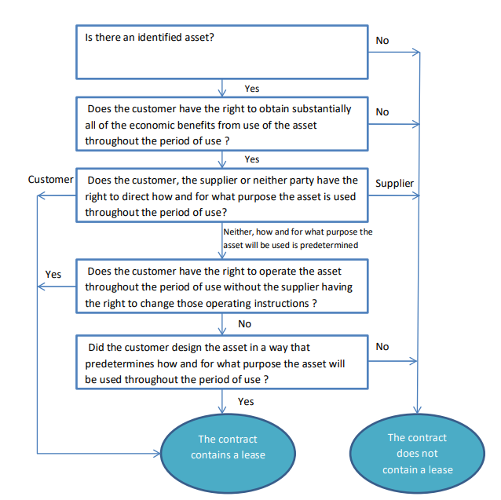

Reassessment of whether a contract contains a lease
A contract is reassessed in order to determine whether or not it contains a lease only if the terms and conditions of the contract are modified (e.g. related to the scope of the leased asset, the consideration). A change in terms and conditions of a contract does not include the exercise of an option (e.g. renewal option) or a failure to exercise an option that is included in the contract.
Changes in estimates (for example, changes in estimates of the economic life or of the residual value of the underlying asset), or changes in circumstances (for example, default by the lessee), do not give rise to a new classification of a lease for accounting purposes.

Lease consideration
A lease does not only exist if fixed payments in cash will be due. It could also exist if any of the following circumstances exist (not exhaustive):
- The consideration defined in the contract is a per unit fee for consumables used in the operation of the underlying asset – i.e. there is no contractually defined consideration for the lease of the underlying asset. Take or pay clauses embedded in a contract could be designed to compensate the lessor for its investments in the asset, in addition to its fixed costs.
- Considerations in-kind;
- The customer will provide services to the supplier or pay in a commodity instead of cash.
- The consideration for the lease is another lease –i.e. the two entities exchange rights to use each other’s assets.
In this case, the entity will have to estimate (the portion of) the consideration to be allocated to the lease.
An agreement can contain lease and non-lease components. For example an agreement can contain the lease of an asset, and the services to operate and maintain it.
A contract may further include an amount payable by the lessee for activities and costs that, in themselves, do not transfer a (distinct) good or service to the lessee. For example, a lessor may include in the total amount payable a charge for administrative tasks, or other costs it incurs associated with the lease, that do not transfer a (distinct) good or service to the lessee. Such amounts payable do not give rise to a separate component of the contract, but are considered to be part of the total consideration that is allocated to the separately identified components of the contract.
A contract may also determine that taxes are billed to the customer. As they depend on the tax law, they are considered variable consideration (see below).

Lease Term

Definition of the lease term
The lease term begins at the commencement date (when asset is available for use) and is defined as follows:

Lease term
Non-cancellable period of the lease (*)
Period after early termination option if reasonably certain not to exercise
Period of extension option if reasonably certain to exercise
(*) including rent free period
If lessor’s consent – that has economical substance – is needed in case of exercise of an extension option, a lessee does not have the right to use the asset beyond the non-cancellable period, and therefore it is not included in the lease term.
Extension and early termination options are incorporated in the lease term if the entity is reasonably certain to exercise them. This assessment is done at commencement date.
Extension and early termination options that are still to be negotiated are not considered when determining the lease term. As an example, a contract may specify that the lease can be extended for another 5 years after its initial term, based on a price to be mutually agreed upon by the parties. In such case, as long as the price has not been negotiated, the 5 year extension option is not considered when determining the lease term.
In this assessment, the following facts and circumstances are considered, without being exhaustive:
- Contractual terms and conditions for optional periods compared with market rates (e.g. termination penalties, payments for optional periods below market price, purchase options that are exercisable at below market rates);
- Significant leasehold improvement works carried out by lessee (or expected to be undertaken) over the term of the contract;
- Costs relating to the termination of the lease (negotiation costs, relocation costs, costs of identifying another underlying asset suitable for the lessee’s needs, costs of integrating a new asset into the lessee’s operations, costs of returning the asset in a contractually specified condition or to a specific location, business interruption, and termination penalties);
- The importance of the underlying asset to the lessee’s operations (specialized asset, location of the asset, availability of suitable alternatives);
- Conditions associated with exercising the option (i.e. when the option can be exercised only if one or more conditions are met), and the likelihood that those conditions will exist;
- Past practices. For example, if a lessee has typically used certain types of assets for a particular period of time or if the lessee has a practice of frequently exercising options on leases of certain types of underlying assets, the lessee shall consider the economic reasons for that past practice in assessing whether it is reasonably certain to exercise an option on leases of those assets.
If only the lessor has the right to terminate the lease, the non-cancellable period of the lease includes the period covered by the option to terminate the lease (at lessor’s discretion). For example, if the contract is for 10 years, and only the lessor has the right to terminate the contract after 5 years, the non-cancelable period is 10 years.
The shorter the non-cancellable period of a lease, the more likely a lessee is to exercise an option to extend the lease or not to exercise an option to terminate the lease. This is because the costs associated with obtaining a replacement asset are likely to be proportionately higher the shorter the non-cancellable period.
Only in extremely rare cases can the useful life of the right-of-use asset be below the lease term.

Conditions of enforceability
The lease term considers the period of enforceability of the contract.
A contract – agreement that creates enforceable right and obligations – is no longer enforceable if the following two conditions are met:
- Both parties have the right to terminate the contract without permission from the other party; and
- With no more than an insignificant penalty.
The definition of penalty is wider than the penalties stipulated in the contract. It encompasses all economic outflows associated with the end of the contract, such as for example:
- Cost of relocating to a new building;
- Cost of finding new tenants;
- Abandoning or dismantling leasehold improvements;
- Economic penalties of switching suppliers such as new costs of installation, lack of revenue following temporary shutdown of the plant;
- Availabilities of alternative suppliers.

Example 1

Entity A enters into a contract with Lessor B. The contract has a duration of 14 years but it gives Entity A the option to early terminate the contract every 2 years without termination penalties.
Entity A is required to assess the lease term.

Lease inception
Contract end
Year 0
2
4
6
8
10
12
14
The early termination option is enforceable for Entity A as it does not need consent to early terminate the contract. Entity A assesses the lease term based on what it thinks it will reasonably do. It is a matter of judgment based on past practices but also based on all facts and circumstances at the time judgment is made.

Example 2

Lease inception
Contract end
Year 0
2
4
6
8
10
12
14
Entity A enters into a contract with Lessor B. The contract has a duration of 14 years but each party has the right to early terminate the contract every two years. There is no termination penalty foreseen. Entity A is required to assess the lease term.
As both parties have the right to early terminate, the early termination option is enforceable only if parties cannot terminate the contract other than with a more than insignificant penalty. As there is no termination penalty foreseen in the contract, Entity A assesses if the contract is enforceable beyond the second year by considering potential economic outflows that could be triggered by an early termination of the contract (costs of relocation, costs of switching suppliers such as new installation costs, temporary shutdown of plant, etc.).
If Entity A considers that it does not bear more than an insignificant penalty by terminating the contract after two years, the contract is not enforceable beyond the second year.
On the contrary, if Entity A considers that it does bear more than an insignificant penalty by terminating the contract after two years, lease term will be assessed based on what Entity A will reasonably do over the 14 years considering all facts and circumstances.

Example 3

Entity A enters into a contract with Lessor B. The contract has a fixed term of 10 years. After the initial term, contract continues until either party terminates with a 3 month notice. There is no termination penalty foreseen after the end of the fixed term. Entity A is required to assess the lease term.

Lease inception
End of fixed term
Year 0
10
In order to assess whether the contract is enforceable after year 10, Entity A needs to assess whether it would suffer more than an insignificant penalty when stopping the contract. As there is no termination penalty foreseen in the contract, Entity A assesses if the contract is enforceable beyond year 10 by considering potential economic outflows that could be triggered by the termination of the contract (costs of relocation, costs of switching suppliers such as new installation costs, temporary shutdown of plant, etc.).
If Entity A considers that it does not bear more than an insignificant penalty by terminating the contract after 10 years, the contract is not enforceable beyond the tenth year.
On the contrary, if Entity A considers that it does bear more than an insignificant penalty by terminating the contract after 10 years, lease term will be assessed based on what Entity A will reasonably do beyond year 10 considering all facts and circumstances.
Only in extremely rare cases, can the lease term exceed the economic useful life of the identified asset.

Example 4

Entity A enters into a contract with Lessor B. The contract has a fixed term of 10 years. After the initial term, lessee has rolling 12 month extension periods. There is no termination penalty foreseen after the end of the fixed term. Entity A is required to assess the lease term.
In order to assess whether the contract is enforceable after year 10, Entity A needs to assess whether it would suffer more than an insignificant penalty when stopping the contract. As there is no termination penalty foreseen in the contract, Entity A assesses if the contract is enforceable beyond year 10 by considering potential economic outflows that could be triggered by the termination of the contract (costs of relocation, costs of switching suppliers such as new installation costs, temporary shutdown of plant, etc.).
Entity A is not able to use the short-term lease exemption if it had initially assessed the lease term to 10 years and that at the end of the 10th year, it exercises an extension option of 12 months.
If Entity A considers that it does not bear more than an insignificant penalty by terminating the contract after 10 years, the contract is not enforceable beyond the tenth year.
On the contrary, if Entity A considers that it does bear more than an insignificant penalty by terminating the contract after 10 years, lease term will be assessed based on what Entity A will reasonably do beyond year 10 considering all facts and circumstances.
Only in extremely rare cases, can the lease term exceed the economic useful life of the identified asset.

Lease inception
End of fixed term; 12 month of extension period
Year 0
10

Reassessment of extension, termination and purchase options
After commencement date, lease term is reassessed upon the occurrence of a significant event or a significant change in circumstances that:
- Is within the control of the lessee; and
- Affects whether the lessee is reasonably certain to exercise an option not previously included in the lease term, or not to exercise an option previously included in the lease term.
Examples of such situations are:
- Significant leasehold improvements that was not anticipated at commencement date;
- Significant modification or customization of the asset that was not anticipated at commencement date;
- Inception of a sublease for a period beyond previously determined term;
- Business decision directly relevant to exercising, or not exercising, an option (decision to extend the lease of a complementary asset, to dispose of an alternative asset or to dispose of a business unit within which the asset is employed, or to invest in a business unit within which the asset will be employed).
The following contracts should be reviewed periodically in order to determine if a significant event or change in circumstances has occurred that would trigger a lease term modification:
- Contracts with annual lease payments above 0.5 MEUR per year shall be reviewed annually.
- Contracts for land, buildings, and industrial equipment with annual lease payments above 0.25 MEUR shall be reviewed every 2 years.

Change in the non-cancellable lease term - without contract modification
An entity will revise the lease term if there is a change in the non-cancellable period of a lease due to:
- Lessee exercises an option not previously included in the lease term;
- Lessee does not exercise an option previously included in the lease term;
- An event occurs that contractually obliges the lessee to exercise an option not previously included in lease term;
- An event occurs that contractually prohibits the lessee from exercising an option previously included in the lease term.

Lessee

Recognition
A lessee recognizes a right-of-use asset and a lease liability at commencement date, which is the date that the lessor makes the asset available for use to the lessee.

Initial measurement of the right-of-use asset (“ROU”)

General
At commencement date, a lessee shall measure the right-of use asset at cost. This cost shall comprise:
- the amount of the initial measurement of the lease liability as defined below;
- any lease payments made at or before the commencement date, less any lease incentives received;
- any initial direct costs incurred by the lessee; and
- an estimate of costs to be incurred by the lessee in dismantling and removing the underlying asset, restoring the site on which it is located or restoring the underlying asset to the condition required by the terms and conditions of the lease, unless those costs are incurred to produce inventories. The lessee incurs the obligation for those costs either at the commencement date or as a consequence of having used the underlying asset during a particular period.

Lease payments made before the commencement date
The value of the right-of-use asset at commencement date includes all lease payments made to the lessor before the commencement date.
An entity generally negotiates a lease before the underlying asset is available for use by the lessee. For some leases, the underlying asset may need to be constructed or redesigned for use by the lessee. Depending on the terms and conditions of the contract, a lessee may be required to make payments relating to the construction or design of the asset.
If a lessee incurs costs relating to the construction or design of an underlying asset, the lessee shall account for those costs applying other applicable Standards, such as IAS 16. If those items are capitalized as property, plant and equipment they impact the Group CAPEX when payment is made. Costs relating to the construction or design of an underlying asset do not include payments made by the lessee for the right to use the underlying asset. Payments for the right to use an underlying asset are payments for a lease, regardless of the timing of those payments.

Lease incentives
Lease incentives are payments made by a lessor to a lessee associated with a lease, or the reimbursement of costs of a lessee such as the reimbursement of the real estate commission paid by the lessee or payments made to a tenant to incentivize an existing tenant of the asset belonging to a third party to terminate his current lease.
However, the reimbursement of leasehold improvements by the lessor has to be accounted for applying other relevant Standards and not as a lease incentive under IFRS 16. This is because costs incurred on leasehold improvements by the lessee are not included within the cost of the right-of-use asset.

Initial direct costs
Initial direct costs are incremental costs of obtaining a lease that would not have been incurred if the lease had not been obtained. Examples of such costs include but are not limited to: external legal and professional fees associated with the arrangement and negotiation of a lease. They exclude internal costs.

Leasing expenses incurred in development projects
Leasing expenses incurred in development projects are not capitalized under IAS 38 and are accounted for under IFRS 16. The period of depreciation of the right-of-use asset will correspond to the lease term of the contract and not the useful life of the asset developed. The right-of-use asset will be tested for impairment under IAS 36 – Impairment along with the cash-generating unit to which it belongs.

Initial measurement of the lease liability

General
The lease liability is initially measured at the present value of the lease payments that are not paid at the commencement date, discounted using the interest rate implicit in the lease or, if that rate cannot be readily determined, the respective Group entity’s incremental borrowing rate (see below – Discount rate). Lease payments included in the measurement of the lease liability comprise the following:
- fixed payments (including in-substance fixed payments), less any lease incentives receivable;
- variable lease payments that depend on an index or a rate, initially measured using the index or rate at the commencement date;
- amounts expected to be payable by the lessee under residual value guarantees;
- the exercise price of a purchase option if the lessee is reasonably certain to exercise that option; and
- payments of penalties for terminating the lease, if lease term reflects the lessee exercising an option to terminate the lease.
Service components (e.g. utilities, operations, maintenance…) are excluded from the measurement of the lease liability. The fact that a service component is not separately identified in the contract doesn’t mean it cannot be reliably estimated: the relative stand-alone price of lease and non-lease components shall be determined on the basis of the price the lessor, or a similar supplier, would charge an entity for that component, or a similar component, separately. If an observable stand-alone price is not readily available, the lessee shall estimate the stand-alone price, maximizing the use of observable information. In case it is not possible to make a reliable estimate, then the service component shall not be separated from the lease payments.

In-substance fixed payments
In-substance fixed payments are payments that may, in form, contain variability but that, in substance, are unavoidable. Examples of in-substance fixed payments are:
- payments that must be made only if an event occurs that has no genuine possibility of not occurring;
- payments that are initially structured as variable lease payments linked to the use of the underlying asset but for which the variability will be resolved at some point after the commencement date so that the payments become fixed for the remainder of the lease term. Those payments become in-substance fixed payments when the variability is resolved;
- There is more than one set of payments that a lessee could make, but only one of those sets of payments is realistic. In this case, an entity shall consider the realistic set of payments to be lease payments; or
- There is more than one realistic set of payments that a lessee could make, but it must make at least one of those sets of payments. In this case, the lowest amount (on a discounted basis) will be considered as the lease payment.

Example of in-substance fixed lease payments
Lessee enters into a 10y lease of a building. Lease payments are 200,000 EUR per month. The contract specifies that the lease payments increase by 1% annually for every 0.1% increase in CPI with a maximum of 2% increase. For the previous 20y, CPI has always increased by more than 1% per year. Given the facts, the possibilities are:
• if CPI increases by 0.1% 🡪 lease payments increase by 1%
• If CPI increases by 0.2% 🡪 lease payments increase by 2%
• If CPI increases by more than 0.2% 🡪 lease payments’ increase is capped to 2%
As there is only a remote likelihood that annual CPI increases will be less than 0.2% during the term based on historical date, this increase has no genuine possibility of not occurring. Therefore, the lease payments will most likely increase by 2% per year.

Variable lease payments
Variable lease payments represent the portion of payments that varies because of changes in facts or circumstances occurring after the commencement date, other than the passage of time. They can include payments following:
- Price changes due to changes in a market rate or the value of an index (e.g. consumer price index);
- Lessee’s performance derived from the underlying assets (e.g. payments based on a specified % of sales);
- Lessee’s usage of the underlying asset.
Only the variable lease payments that depend on an index or a rate are included in the lease liability at commencement date (based on the index or rate prevailing at that moment) because they are unavoidable and do not depend on any future activity of the lessee. The lease liability is subsequently remeasured when there is a change in cash flows for future payments resulting from a change in index or rate.
Variable payments other than those that depend on an index or a rate are excluded from lease liability and accounted for, generally as an operating expense, when incurred.
Non recoverable non-income taxes borne by the lessor, and charged separately to the lessee (e.g. property taxes related to real estate) over the life of the lease are considered variable payments as they depend on tax law, and are equally excluded from the lease liability. They shall be recognized, generally as an operating expense, when incurred.
Non recoverable non-income taxes borne by the lessee (e.g. VAT on cars) and separately billed by the lessor are levies for the lessee. The liability for those levies is recognized based on the tax law, when the obligating event to pay the levy occurs (e.g. the invoicing of the lessor for using the asset during the period, on which VAT is due). These payments are excluded from the lease liability. Non-recoverable VAT payments are in the scope of IFRS 21 Levies.
Non-income taxes not separately billed under the lease contract (implicitly included in global fee billed) are not considered as a non-lease component and are therefore included in the lease liability.

Example of variable lease payments that depend on an index
Lessee enters into a 10-year lease of property with annual lease payments of CU50,000, payable at the beginning of each year. The first payment is made at the commencement date of the lease. The contract specifies that lease payments will increase every two years on the basis of the increase in the Consumer Price Index (“CPI”) for the preceding 24 months. The CPI at the commencement date is 125. This example ignores any initial direct costs. The rate implicit in the lease is not readily determinable. Lessee's incremental borrowing rate is 5 per cent per annum, which reflects the fixed rate at which the Lessee could borrow an amount similar to the value of the right-of-use asset, in the same currency, for a 10-year term, and with similar collateral.
At the commencement of the lease, a lease liability of CU355,391 is recognized and corresponds to the present value of the lease payments (initially measured with the CPI at that date and discounted at 5% per annum) that are not paid at that date. The cost of the right-of-use asset (CU405,391) corresponds to the lease liability (CU355,391) plus payments made at commencement date (CU50,000 ). Lessee expects to consume the right-of-use asset’s future economic benefits evenly over the lease term and, thus, depreciates the right-of-use asset on a straight-line basis.
The lease liability and the right-of-use asset table is as follows:
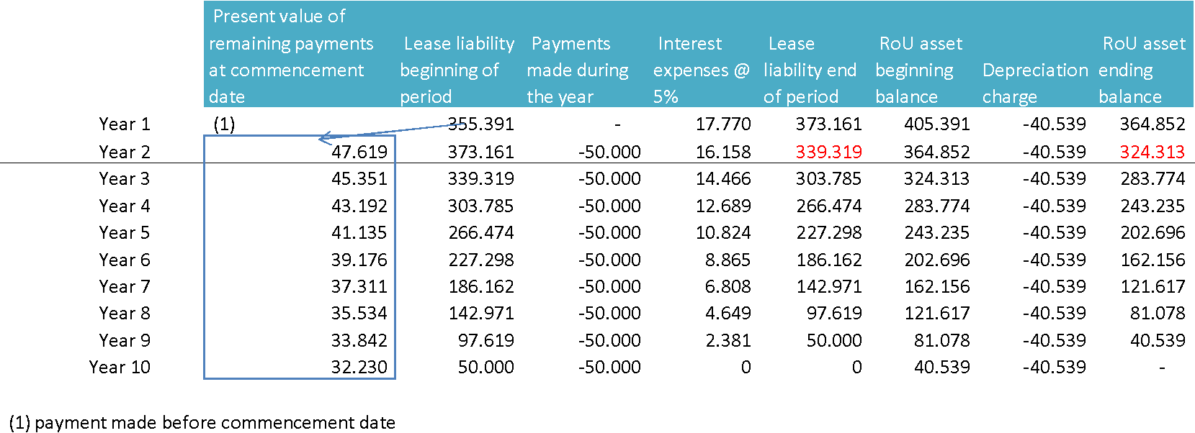
At the beginning of the third year of the lease the CPI is 135.
The payment for the third year, adjusted for the CPI, is CU54,000 (CU50,000 × 135 ÷ 125). Because there is a change in the future lease payments resulting from a change in the CPI used to determine those payments, Lessee remeasures the lease liability to reflect those revised lease payments, i.e. the lease liability now reflects eight annual lease payments of CU54,000 using the same discount rate of 5 per cent per annum that was used at commencement date. Lessee increases the carrying amount of the lease liability (CU339,319) by CU27,145 to the remeasured amount of CU366,464. The corresponding adjustment is made to the right-of-use asset.
The lease liability and the right-of-use asset table has evolved as follows:
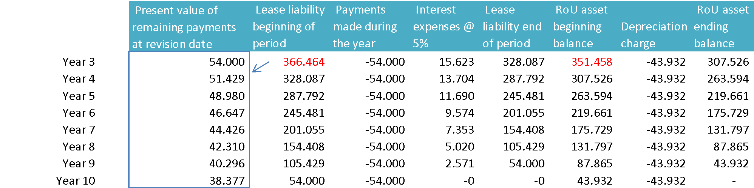

Example of variable lease payments based on usage
Entity A leases a railcar for a fixed, non-cancellable term of 5 years at a rental costs of CU 100,000 per annum payable at the end of each year. If at the end of the 5-year period the mileage of the railcar exceeds 50,000 km, Entity A will be required to pay the lessor an additional CU 2 for every mile in excess of 50,000 km.
At inception of the lease, Entity A expects the mileage at the end of the fifth year to be 55,000 km.
The payments related to the mileage should be recognized in profit and loss as the additional km are used, with no liability recognized until the 50,000 km limit is exceeded.
Although Entity A expects at inception of the lease to drive more than 50,000 km and, as a result, to incur additional rentals, any payments above the CU 100,000 per annum minimum are entirely variable and are not, therefore, in-substance fixed payments.

Example - Variability in the context of power purchase agreement
Consideration within a power purchase agreement may take various forms, including
- A fixed price per period, irrespective of output acquired/generated;
- A payment based on output acquired/generated, that can be fixed, vary within a range, based on a regulated tariff or a market price;
- A payment based on output as explained above, with a minimum amount due irrespective of output acquired/generated (take or pay clause).
Example
Entity A enters into a 20-year contract with Power Company B to purchase electricity produced by a new solar farm. Entity A assesses that the contract contains a lease, because it was highly involved in the design. There is no minimum purchase requirement and there are no fixed payments that Entity A is required to make to Power Company B. However, Entity A is required to purchase all of the electricity produced by the solar plant at a price of CU 10 per MWh.
Entity A notes that is highly probable that the solar plant will generate at least some electricity each year. However, the payment that Entity A makes to B varies based on the amount of electricity produced by the solar farm – i.e. the payments are genuinely variable. In this case, there are no in-substance fixed lease payments. No lease liability shall be recognized.
To the contrary, if a minimum amount were to be due, irrespective of output acquired/generated, then this minimum amount is a fixed payment and shall be included in the lease liability.

Lease component
Many contracts contain a lease coupled with an agreement to purchase or sell other goods or service (non-lease components). The non-lease components are identified and accounted for separately from the lease component in accordance with other standards.
For a contract that contains a lease component and one or more additional lease or non-lease components, a lessee allocates the consideration in the contract to each lease component on the basis of the relative stand-alone price of the lease component and the aggregate stand-alone price of the non-lease components.
On the contrary, if the contracts contain items that do not relate to the transfer of goods or services by the lessor to the lessee (e.g. fees or other administrative costs a lessor charges a lessee), these items are not considered as separate non-lease components, and lessee does not allocate consideration in the contract separately to these items.

Example – allocation of consideration paid for costs that do not transfer a good or service to the lessee
Entity A leases office space in a serviced building. Its contract with lessor includes rent for the office space and additional facilities services (i.e. both lease and non-lease components). In addition, the contract includes amounts payable for costs that do not transfer a good or a service to A.
Amounts related to costs that do not transfer a good or service to the lessee are considered to form part of the overall consideration in the contract that is allocated to the separately identified components of the contract on the basis of their relative stand-alone price.
Assume the total consideration payable by Entity A is CU 2,600 and the contract comprises:
- Lease payments and facility charges (stand-alone prices of CU 2,000 and CU 500 respectively)
- Administration charge CU 100 (which are to cover costs of the lessor which do not relate to a separate transfer of a good or service to the lessee).
The overall consideration of CU 2,600 is allocated to the identified lease and non-lease components on the basis of their relative stand-alone prices:
- Lease component: (CU 2,0000/CU 2,500)* CU 2,600= CU 2,080
- Non-lease component: (CU 500/CU 2,500)* CU 2,600= CU 520
There is no allocation to the administration charge as this does not relate to a separate transfer of a good or service to the lessee.

Residual value guarantees
Lease payments include the amount that the lessee expects to be payable to the lessor following the guarantee the lessee granted to the lessor that the value of the underlying asset at the end of the lease contract will be at least a specified amount.

Example – residual value guarantee
Customer enters into a 5-year lease contract with a lessor for an equipment item. Customer guarantees to the lessor that the price that the lessor will get from selling the equipment item at the end of the lease to a third party will be at least 10,000 EUR. As a result, if the lessor is able to sell the equipment item to a third party at the end of the lease for 4,000 EUR, the Customer will have to pay 6,000 EUR to the lessor. Also, if the lessor sells the equipment for 11,000 EUR, no amount will be due by the Customer.
At commencement date, lessee includes in its lease liability the amount he expects to pay at the end of the contract to the lessor to satisfy its obligations.

Purchase option
Lease payments include the amount of the exercise price of a purchase option if the lessee is reasonably certain to exercise that option. The entity considers all relevant facts and circumstances that create an economic incentive for the lessee to exercise, or not to exercise, the option, including any expected changes in facts and circumstances from the commencement date until the exercise date of the option.
In this assessment, the following facts and circumstances are considered, without being exhaustive:
- Contractual terms and conditions for purchase option compared with market rates;
- Significant leasehold improvement works carried out by lessee (or expected to be undertaken) over the term of the contract;
- Costs relating to the termination of the lease (negotiation costs, relocation costs, costs of identifying another underlying asset suitable for the lessee’s needs, costs of integrating a new asset into the lessee’s operation, costs of returning the asset in a contractually specified conditions or to a specific location);
- The importance of the underlying asset to the lessee’s operations (specialized asset, location of the asset, availability of suitable alternatives);
- Conditions associated with exercising the option (i.e. when the option can be exercised only if one or more conditions are met), and the likelihood that those conditions will exist.
- Past practices. For example, if a lessee has typically used certain types of assets for a particular period of time or if the lessee has a practice of frequently exercising purchase options on leases of certain types of underlying assets, the lessee shall consider the economic reasons for that past practice in assessing whether it is reasonably certain to exercise a purchase option on leases of those assets.

Example – Purchase option: change in assumption
Lessee enters into a 10-year contract for the lease of an equipment item. The contract foresees payment of CU 50,000 payable at the beginning of each year and a purchase option for CU 100,000 payable at the end of the 10-year period. The first payment is made at the commencement date of the lease.
At commencement date, Lessee assesses that it is not reasonably certain to exercise the purchase option.
The rate implicit in the lease is not readily determinable. Lessee's incremental borrowing rate is 5 per cent per annum, which reflects the fixed rate at which Lessee could borrow an amount similar to the value of the right-of-use asset, in the same currency, for a 10-year term, and with similar collateral.
At the commencement of the lease, a lease liability of CU 355,391 is recognized and corresponds to the present value of the lease payments that are not paid at that date. The cost of the right-of-use asset corresponds to the lease liability plus payments made at commencement date. Lessee expects to consume the right-of-use asset’s future economic benefits evenly over the lease term and, thus, depreciates the right-of-use asset on a straight-line basis.
The lease liability and the right-of-use asset table is as follows:
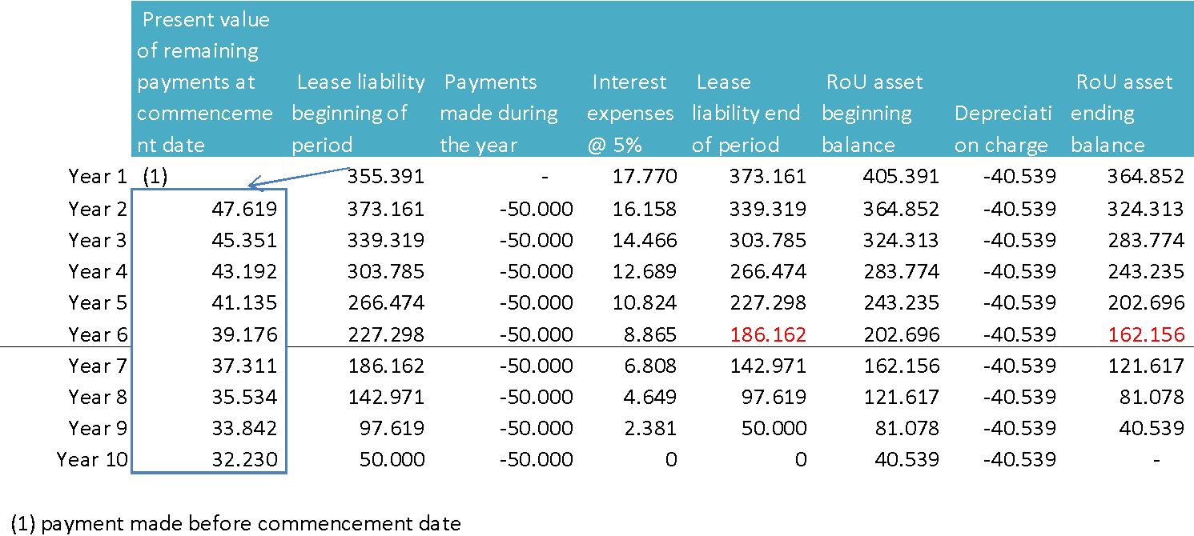
In the 6th year of the lease, Lessee performs significant customization to the underlying asset that was not anticipated at the commencement date such that it is now reasonably certain that the purchase option will be exercised.
The customization of the underlying asset is a significant event that is within the control of Lessee and affects whether Lessee is reasonably certain to exercise the purchase option not previously included in its determination of the lease liability.
Lessee’s incremental borrowing rate at the end of Year 6 is 6% (4-year term).
At the end of the 6th year, before accounting for the change in the assumption, the lease liability is CU 186,162 (present value of 4 remaining payments of CU 50,000, discounted at the original interest rate of 5%).
Following the change of assumption, Lessee remeasures the lease liability at the present value of 4 payments of CU 50,000 and the payment of CU 100,000 and the end of year 10 for the purchase of the underlying asset, all discounted at the revised discount rate (6%) which is CU 267,613. Lessee increases the lease liability by CU 81,450, which represents the difference between the remeasured liability of CU 267,613 and its previous carrying amount of CU 186,162. The corresponding adjustment is made to the right-of-use asset to reflect the cost of the increase in right-of-use.
Dt Right-of-use Asset 81,450
Ct Lease Liability 81,450
Following the remeasurement, the carrying amount of the Lessee’s right-of-use asset is CU 243,607.
Additionally, the right-of-use asset is depreciated over the remaining useful life of the asset, which generally extends beyond the end of the lease term, considering that the lessee will exercise the purchase option embedded in the contract. The example assumes that the remaining useful life extends until the end of year 15.
From beginning of Year 7, the right-of-use asset and the lease liability are as follows:
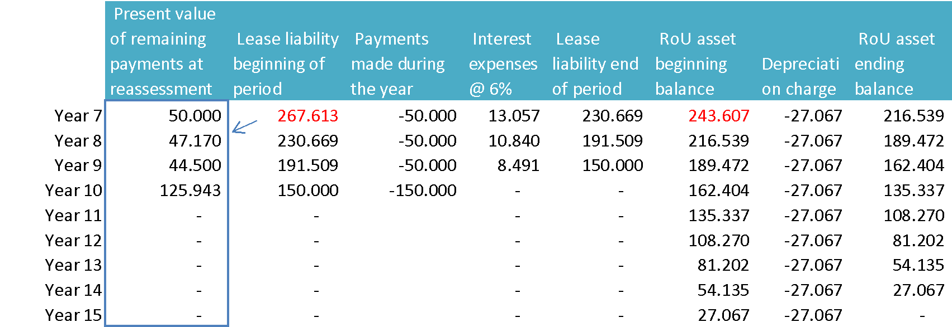

Security Deposit
As long as a security deposit is a true deposit and not a prepaid lease payment, the deposit does not meet the definition of a lease payment because it is not a payment relating to the right to use the underlying asset. Security deposits should be accounted for as a financial asset in accordance with IFRS 9 Financial Instruments, because it is a collateral provided to the lessor.
The security deposit should be recognized initially at fair value based on the prevailing market rate of interest for a similar loan to the lessor and will normally be measured subsequent to initial recognition at amortized cost, resulting in the recognition of interest revenue over the lease term for the difference between the fair value at the commencement of the lease and its nominal amount receivable at the end of the lease term (this difference being the so-called time value).
When the deposit earns interest below the market rate, the excess of the nominal amount of the deposit over its fair value at the commencement of the lease represents, in effect, a prepaid lease payment.
Consequently, it is added to the initial carrying amount of the right-of-use asset and recognized in profit and loss over the lease term as part of the depreciation of that asset.
For the lessor, it is considered in determining whether the lease is an operating or finance lease. If the lease is classified as an operating lease, the prepaid lease payment is included in the total lease payments that are straight-lined. If the lease is classified as a finance lease, the lessor includes the prepaid lease payment in the consideration for the lease and, therefore, in the determination of the gain or loss on the derecognition of the underlying asset, if any. (Refer to Lessor Accounting in section 7)
Materiality thresholds: the above accounting, as illustrated in the example below, shall only apply if the so-called time value exceeds 2 M€.

Example – deposit
Entity A enters into a 5-year lease of a property with Lessor. Annual rent is CU 1,200, payable at the beginning of each year. The interest rate implicit in the lease is 7%. The present value of the lease payments amounts to CU 5,265.
Entity A is also required to pay a deposit of CU 600 to Lessor at the commencement of the lease, and that amount will be reimbursed at the end of the lease term with no interest payments made.
At the commencement date, the fair value of the CU 600 receivable in 5 years, calculated using an appropriate market rate for a lending transaction by Entity A is CU 495.
At commencement of the lease, Entity A recognized:
- Lease obligation for CU 5,265
- A financial asset of CU 495 for the deposit
- A right-of-use asset measured at the aggregated of the lease obligation and a prepaid lease payment of CU 105 (being the difference between the nominal amount of the deposit (CU 600) and its fair value at the commencement date (CU 495)).
Dt Right-of-use Assets CU 5,370
Dt Deposit CU 495
Ct Lease liability CU 5,265
Ct Cash CU 600
Subsequent to initial recognition, the deposit is measured at amortized cost and accreted to its nominal value over the lease term with the difference (CU 105) recognized as interest income.

Legal title to the underlying asset
A lessee may obtain legal title to an underlying asset before that legal title is transferred to the lessor and the asset is leased to the lessee. Obtaining legal title does not in itself determine how to account for the transaction.
If the lessee controls (or obtains control of) the underlying asset before that asset is transferred to the lessor, the transaction is a sale and leaseback transaction (see below).
However, if the lessee does not obtain control of the underlying asset before the asset is transferred to lessor, the transaction is not a sale and leaseback transaction.
If a manufacturer, a lessor and a lessee negotiate a transaction for the purchase of an asset from the manufacturer by the lessor, which is in turn leased to the lessee, the lessee may obtain legal title to the underlying asset before legal title transfers to the lessor. In this case, the below guidance should be considered.

Sale and lease back transaction
A sale and leaseback transaction involves a company selling an asset and leasing back the same asset from the buyer.
Accounting depends on whether the lessee (seller) has control or not over the underlying asset before the asset is transferred to the buyer (lessor).
If an entity (the seller-lessee) transfers an asset to another entity (the buyer-lessor) and leases that asset back from the buyer-lessor, the seller-lessee shall assess whether or not the transfer of the asset is a sale.

Transfer of the asset is a sale
To be considered as a sale of an asset, the transaction will have to satisfy the requirements of IFRS 15, and in substance, control over the asset should be transferred to the buyer (lessor) (see chapter Revenue from Contracts with Customers).
If the transfer of an asset by the seller-lessee satisfies the requirements to be accounted for as a sale of the asset, the seller-lessee shall:
- Derecognize the underlying asset
- Recognize the gain or loss, if any, that relates to the rights transferred to the buyer-lessor and adjusted for off-market terms.
The seller-lessee shall measure the right-of-use asset arising from the leaseback at the proportion of the previous carrying amount of the asset that relates to the right of use retained by the seller-lessee. Accordingly, the seller-lessee shall recognize only the amount of any gain or loss that relates to the rights transferred to the buyer-lessor.
If the fair-value of the consideration for the sale does not equal the fair value of the asset, or if the payments are not at market rates, any below-market terms shall be accounted for as a prepayment of lease payments whereas any above-market terms shall be accounted for as additional financing.
        - Example – Transfer of the asset is a sale
Seller-lessee enters into a sale and leaseback transaction whereby it transfers an asset (PP&E) to Buyer-lessor, and leases that PP&E back for 5 years. The transfer of the PP&E satisfies the requirements in IFRS 15 to be accounted for as a sale.
The carrying amount of the PP&E in Seller-lessee’s financial statements at the date of the transaction is CU1,000,000, and the amount paid by Buyer-lessor for the PP&E is CU1,800,000 (the fair value of the PP&E at that date).
At the date of the transaction, the present value of the expected payments for the lease is CU450,000. There are no initial direct costs. Seller-lessee determines that it is appropriate to calculate the proportion of the PP&E that relates to the right of use retained using the present value of expected payments for the lease.
On this basis, the proportion of the PP&E that relates to the right of use retained is 25%, calculated as CU450,000 (present value of expected payments for the lease) ÷ CU1,800,000 (fair value of the PP&E). Consequently, the proportion of the PP&E that relates to the rights transferred to Buyer-lessor is 75%, calculated as (CU1,800,000 − CU450,000) ÷ CU1,800,000.
Seller-lessee:
(a) measures the right-of-use asset at CU250,000, calculated as CU1,000,000 (previous carrying amount of the PP&E) × 25% (proportion of the PP&E that relates to the right of use it retains).
(b) recognizes a gain of CU600,000 at the date of the transaction, which is the gain that relates to the rights transferred to Buyer-lessor. This gain is calculated as CU800,000 (total gain on sale of the PP&E (CU1,800,000 – CU1,000,000)) × 75% (proportion of the PPE that relates to rights transferred to Buyer-lessor).
At the date of the transaction, Seller-lessee accounts for the transaction as follows:
Dt Cash CU 1,800,000
Dt Right-of-use asset CU 250,000
Ct PP&E CU 1,000,000
Ct Liability CU 450,000
Ct Gain on rights transferred CU 600,000

Transfer of the asset is not a sale
If the transfer of an asset by the seller-lessee does not satisfies the requirements to be accounted for as a sale of the asset, the transaction is a financing transaction. The seller-lessee shall continue to recognize the transferred asset and shall recognize a financial liability equal to the transfer proceeds. It shall account for the financial liability applying IFRS 9, generally at amortized cost.
In general, if (taking into account the impact from extension and purchase options) the leaseback ensures that the lessee will be able to and expects to use the asset over its useful economic life, this in exchange for a consideration that approximates the fair value of the asset at the moment of the transaction, the seller-lessee does not lose control over the asset when it sells the asset to the buyer-lessor. In such case, the leaseback is accounted for as a financing arrangement of the asset (that remains recognized), but not as a lease.

Discount rate

General
At the commencement date, a lessee shall recognize the lease liability, measured at the present value of the lease payments that are not paid at that date. The lease payments shall be discounted using the interest rate implicit in the lease, if that rate can be readily determined. If that rate cannot be readily determined, the lessee shall use the lessee’s incremental borrowing rate. Although, the lease liability is initially recognized at commencement date, the discount rate to be used is the discount rate that prevailed at inception of the lease (at signature date) to reflect the economic conditions that existed at that date. This is also applicable in the case of a lease modification accounted for as a separate lease: the discount rate to be used is the one at signature of the modification even though the actual modification becomes effective at a later point in time.

Interest rate implicit in the lease
The interest rate implicit in a lease corresponds to the rate that causes the present value of (a) the lease payments and (b) the unguaranteed residual value to equal the sum of (i) the fair value of the underlying asset and (ii) any initial direct costs of the lessor.
The interest rate implicit in the lease can only be calculated if the following are known: (i) the lessor’s estimation of the future unguaranteed residual value of the underlying asset, (ii) the lessor’s initial direct costs and (iii) the fair value of the underlying asset.
In practice, if the lease ensures that the lessee will be able to and expects to use the asset over its useful economic life (including the impact from extension and purchase options), then the consideration payable will logically approximate the fair value of the asset at the moment of the transaction. In such cases, the interest rate implicit in the lease can be assessed, assuming that (a) the fair value of the underlying asset (i.e. in case of an outright purchase) can be estimated fairly, and (b) the unguaranteed residual value and the lessor’s incremental direct costs can be assumed to be immaterial.

Example
To illustrate this, let’s assume that Syensqo enters into a contract for the lease of an equipment item for 4 years. The lessor assesses that the fair value of the underlying asset at commencement date of the lease is 20,000 EUR and that the unguaranteed residual value is 7,000 EUR. This unguaranteed residual value is the value the lessor estimates the underlying asset will have at the end of the lease and for which Syensqo does not give any guarantee. There are no initial direct costs.
The contract specifies that the yearly lease payments amount to 4,016 EUR and are made at the end of the period.
The rate implicit in the lease is the rate that causes the present value of payments + the present value of the unguaranteed residual value = 20,000 EUR
In this example the rate implicit in the lease is 5% so that the present value of payments is 14,241 EUR and the present value of the unguaranteed residual value is 5,759 EUR.

Incremental borrowing rate
The incremental borrowing rate is the rate of interest that a lessee would have to pay to borrow over a similar term, and with a similar security, the funds necessary to obtain an asset of a similar value to the right-of-use asset in a similar economic environment.
If the contract requires lease payments to be made in a currency other than the functional currency of the lessee, the incremental borrowing rate of the lessee should be determined based on a borrowing of a similar amount in that foreign currency.
Subsidiaries participating in a centralized treasury function cannot default to the parent’s incremental borrowing rate. Rather all facts and circumstances should be considered to determine the subsidiary/lessee’s incremental borrowing rate. The existence of guarantees of the subsidiary’s obligations may result in a rate that is similar to the parent’s rate as if the parent had entered into the lease directly.

Subsequent measurement

Subsequent measurement of the right-of-use asset
After the commencement date, a lessee measures the right-of-use asset using the cost model. As a result, the right-of-use asset is measured at cost:
- Less any accumulated depreciation and any accumulated impairment losses; and
- Adjusted for any remeasurement of the lease liability.
Right-of-use assets are depreciated using the straight-line depreciation method, from the commencement date to (a) the end of the useful life of the underlying asset, in case the lease transfers ownership of the underlying asset to the Group by the end of the lease term, or the lease contains a purchase option that the Group is reasonably certain to exercise, or (b) the earlier of the end of the useful life and the end of the lease term, in all other cases.

Onerous contracts
A lessee shall apply IAS 36 Impairment of Assets to determine whether the right-of-use asset is impaired and to account for any impairment loss identified.

Subsequent measurement of the lease liability

General
After the commencement date, the lease liability is measured by:
- Increasing the carrying amount to reflect interest on the lease liability;
- Reducing the carrying amount to reflect the lease payments made; and
- Remeasuring the carrying amount to reflect any reassessment or lease modifications, or to reflect revised in-substance fixed lease payments. For example:
  - Change in the cash flows resulting from a change in a reference index or rate (i.e. when the adjustment to the lease payments takes effect) (see above - Example of variable lease payments that depend on an index);
  - Currency exchange impact for lease liability denominated in a foreign currency;
  - The lease is modified and that modification is not accounted for as a separate contract;
  - There is a change in the assessment of:
    - The lease term;
    - A purchase option being exercised;
    - The probability of amounts to be paid under a residual value guarantee.
  - A contingency is resolved that results in some or all variable lease payments becoming fixed payments.
After commencement date, a lessee shall recognize in profit or loss, unless the costs are included in the carrying amount of another asset applying other applicable Standards both:
- Interest on the lease liability; and
- Variable lease payments not included in the measurement of the lease liability in the period in which the event or condition that triggers those payments occurs.
If a lease liability is in a currency different from the functional currency of the entity, it shall be remeasured at spot rate at each reporting date. Such foreign exchange differences are recognized in profit and loss and not as an adjustment to the carrying amount of the right-of-use asset.

Reassessment of the lease liability (without contract modification)
A lessee shall remeasure the lease liability by discounting the revised lease payments using a revised discount rate (for the remainder of the lease term) if either:
- There is a change in the lease term (See above - 5.3 and 5.4). The lessee shall determine the revised lease payments on the basis of the revised lease term; or
- There is a change in the assessment of an option to purchase the underlying assets, assessed considering the events and circumstances described above in the context of a purchase option (See above - 5.3 and 5.4). The revised lease payments will reflect the change in the amounts payable under the purchase option.
A lessee shall remeasure the lease liability by discounting the revised lease payments using the original discount rate when:
- There is a change in the amounts expected to be payable under a residual value guarantee; or
- There is a change in future lease payments resulting from a change in an index or a rate used to determine those payments. Lessee shall remeasure the lease liability to reflect those revised lease payments only when the adjustment to the lease payments takes effect, for the remainder of contractual payments due.
The change in the lease liability is adjusted to the right-of-use asset. If a decrease in the lease liability exceeds the carrying amount of the right-of-use asset, the excess shall immediately be recognized in profit or loss, below EBITDA.

Example – measurement by a lessee and accounting for a change in assumption regarding increase of lease term
Lessee enters into a 10-year lease of a floor of a building, with an option to extend for 5 years. Lease payments are CU 50,000 per year during the initial term and CU 55,000 per year during the optional period, all payable at the beginning of each year.
At commencement date, Lessee concludes that it is not reasonably certain to exercise the option to extend the lease and, therefore, determines that the lease term is 10 years.
The interest rate implicit in the lease is not readily determinable. Lessee’s incremental borrowing rate is 5%, which reflects the fixed rate at which Lessee could borrow an amount similar to the value of the right-of-use asset, in the same currency, for a 10-year term, and with similar collateral.
At the commencement of the lease, a lease liability of CU 355.391 is recognized and corresponds to the present value of the lease payments that are not paid at that date. The cost of the right-of-use asset corresponds to the lease liability plus payments made at commencement date. Lessee expects to consume the right-of-use asset’s future economic benefits evenly over the lease term and, thus, depreciates the right-of-use asset on a straight-line basis.
The lease liability and the right-of-use asset table is as follows:
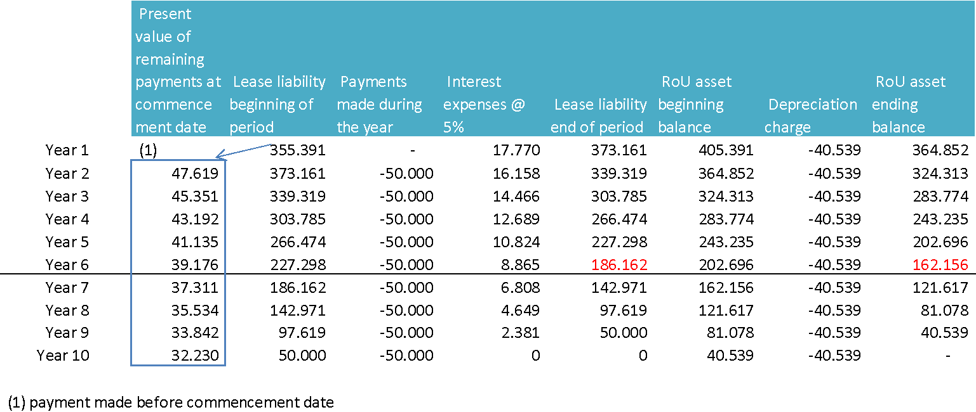
In the 6th year of the lease, Lessee acquires Entity A. Following the acquisition of Entity A, Lessee needs an additional floor in a building suitable for the increased workforce. To minimize costs, Lessee enters into a separate 8-year contract lease of another floor in the building leased that will be available for use at the end of Year 7, and that will be accounted for as a separate lease.
Moving Entity A’s staff to the same building occupied by Lessee creates an economic incentive for Lessee to extend its original lease at the end of the non-cancellable period of 10 years. The acquisition of Entity A and the relocation of Entity A’s staff is a significant event that is within the control of Lessee and affects whether Lessee is reasonably certain to exercise the extension option not previously included in its determination of the lease term.
Lessee’s incremental borrowing rate at the end of Year 6 is 6% (9-year term; i.e. the 4 remaining years under the initial term and the 5 years of the optional renewal period).
At the end of the 6th year, before accounting for the change in the lease term, the lease liability is CU 186,162 (present value of four remaining payments of CU 50,000, discounted at the original interest rate of 5%).
Following the change of lease term, Lessee remeasures the lease liability at the present value of 4 payments of CU 50,000 followed by 5 payments of CU 55,000, all discounted at the revised discount rate, which is CU 378,174. Lessee increases the lease liability by CU 192,012, which represents the difference between the remeasured liability of CU 378,174 and its previous carrying amount of CU 186,162. The corresponding adjustment is made to the right-of-use asset to reflect the cost of the additional right of use:
Dt Right-of- use asset 192,012
Ct Lease liability 192,012
Following the remeasurement, the carrying amount of the Lessee’s right-of-use asset is CU 354,168.
From beginning of Year 7, the right-of-use asset and the lease liability are as follows:
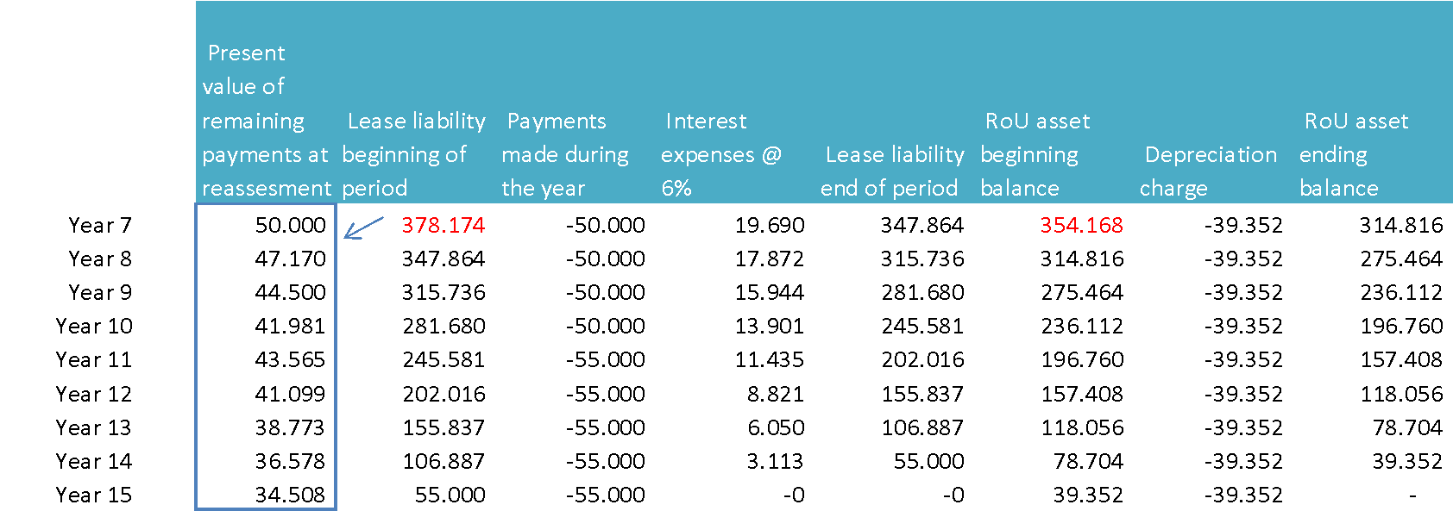

Example – measurement by a lessee and accounting for a change in assumption regarding decrease of lease term
Lessee enters into a 8-year lease of a floor of a building, with an option to extend for 2 years. Lease payments are CU 100,000 per year during the initial term and the extension period, all payable at the end of each year.
At commencement date, Lessee concludes that it is reasonably certain to exercise the option to extend the lease and, therefore, determines that the lease term is 10 years.
The interest rate implicit in the lease is not readily determinable. Lessee’s incremental borrowing rate is 6%, which reflects the fixed rate at which Lessee could borrow an amount similar to the value of the right-of-use asset, in the same currency, for a 10-year term, and with similar collateral.
The lease liability and the right-of-use asset table is as follows:
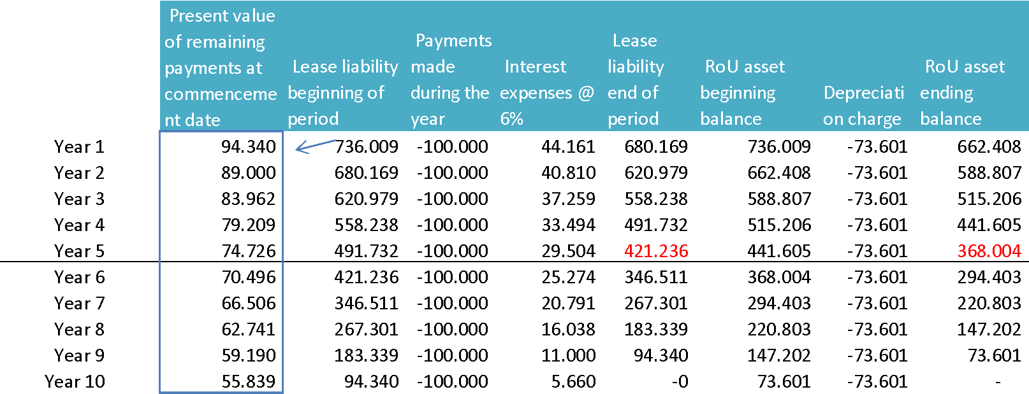
In the 5th year of the lease, Lessee decides to dispose of a business unit within which the asset is mainly employed. Therefore, the Lessee estimates that after 3 years the office leased will no longer correspond to the need of the Company. The disposal of a business unit within which the asset is employed is a significant event that is within the control of Lessee and affects whether Lessee is reasonably certain not to exercise the extension option previously included in its determination of the lease term.
Lessee’s incremental borrowing rate at the end of Year 5 is 7% (3-year term; i.e. the remaining term of the lease without extension).
At the end of the 5th year, before accounting for the change in the lease term, the lease liability is CU 421,236 (present value of 5 remaining payments of CU 100,000, discounted at the original interest rate of 6%).
Following the change of lease term, Lessee remeasures the lease liability at the present value of 3 payments of CU 100,000, all discounted at the revised discount rate (7%) which is CU 262,432. Lessee decreases the lease liability by CU 158,805, which represents the difference between the remeasured liability of CU 262,432 and its previous carrying amount of CU 421,236. The corresponding adjustment is made to the right-of-use asset to reflect the cost of the decrease in right-of-use.
Dt Lease Liability 158,805
Ct Right-of- use asset 158,805
Following the remeasurement, the carrying amount of the Lessee’s right-of-use asset is CU 209,200.
From beginning of Year 6, the right-of-use asset and the lease liability are as follows:
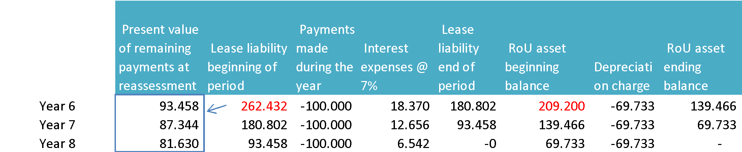

Accounting for lease modifications
A lease modification will be accounted for as a separate lease if both of the following conditions are met:
- The modification increases the scope of the lease by adding the right to use one or more underlying assets; and
- The consideration for the lease increases by an amount commensurate with the stand-alone price for the increase in scope and any appropriate adjustments to that stand-alone price to reflect the circumstances of the particular contract.
For a lease modification that is not accounted for as a separate lease, the lessee shall account for the remeasurement of the lease liability by:
- Decreasing the carrying amount of the right-of-use asset to reflect the partial or full termination of the lease for the lease modifications that decrease the scope of the lease. The lessee shall recognize in profit or loss any gain or loss relating to the partial or full termination of the lease. Those impacts are recognized below EBITDA;
- Making a corresponding adjustment to the right-of-use asset for all other modifications. Such includes cases with a modification that is a change in consideration only. If a decrease in the lease liability exceeds the carrying amount of the right-of-use asset, the excess shall immediately be recognized in profit or loss, below EBITDA.
If several assets with similar characteristics are managed through one contract (e.g.: portfolio of railcars, tanks, etc.), the removal of one unit will not affect the accounting treatment of the remaining units if the terms and conditions (hence the economic substance) of those remaining units have not been affected. In other words, the lessee shall account for the removal of one unit by decreasing the corresponding carrying amount of the right-of-use asset and lease liability to reflect the full termination of the lease for that unit and recognize below EBITDA any gain or loss relating to the full termination of that unit. The discount rate for the lease liability related to the remaining units is not updated in this case.
To the contrary, if the terms and conditions of the remaining units are affected, the guidance provided in section 6.5.2.3.3 Example – lease modification that decreases the scope of the lease applies.

Example – lease modification accounted for as a separate lease
Lessee enters into a 10-year lease for 2,000m² of office space. At the beginning of Year 6, Lessee and Lessor agree to amend the original lease for the remaining 5 years to include an additional 3,000m² of office space in the same building. The increase in total consideration for the lease is commensurate with the current market rate for the new 3,000m² of office space, adjusted for the discount that Lessee receives reflecting that Lessor does not incur costs that it would have otherwise incurred if leasing the same space to a new tenant (e.g. marketing costs).
As both conditions for the lease modifications are met, Lessee accounts for this new lease, separate from the original 10-year lease. Lessee does not make any adjustments to the accounting for the original lease of 2,000m² of office space as a result of this modification.
For a lease that is not accounted for as a separate lease, at the effective date of the modification a lessee shall remeasure the lease liability by discounting the revised lease payments using a revised discount rate determined for the remainder of the lease term.

Example – lease modification that increases the scope of the lease by extending the contractual lease term
Lessee enters into a 10-year lease for 5,000m² of office space. The annual lease payments are CU 100,000 payable at the end of each year. Lessee’s incremental borrowing rate at the commencement date is 6%.
At the commencement of the lease, a lease liability of CU 736,009 is recognized and corresponds to the present value of the lease payments that are not paid at that date. The cost of the right-of-use asset corresponds to the lease liability plus payments made at commencement date. Lessee expects to consume the right-of-use asset’s future economic benefits evenly over the lease term and, thus, depreciates the right-of-use asset on a straight-line basis.
The lease liability and the right-of-use asset table is as follows:
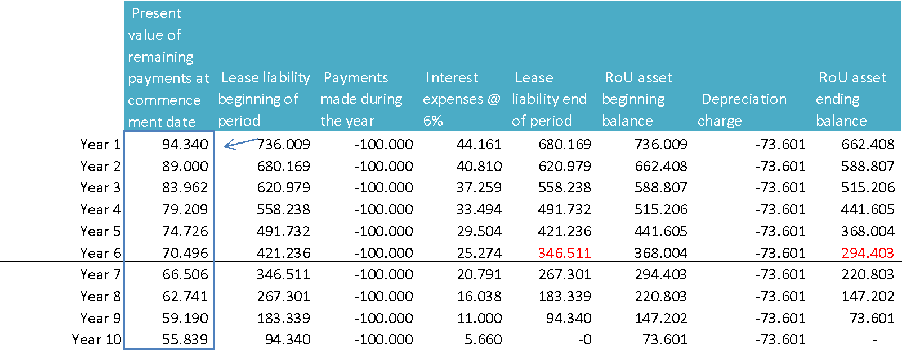
At the beginning of Year 7, Lessee and Lessor agree to amend the original lease by extending the contractual lease term by 4 years. The annual lease payments are unchanged. Lessee’s incremental borrowing rate at the beginning of Year 7 is 7% (8-year term, i.e. the remaining 4-year term plus the 4-year extended term).
At the effective date of the modification, Lessee remeasures the lease liability based on (a) an eight year remaining lease term, (b) annual payments of CU 100,000 and (c) Lessee’s incremental borrowing rate of 7%. The modified lease liability equals CU 597,130. The lease liability immediately before the modification is CU 346,511. Lessee recognizes the difference between the carrying amount of the modified lease liability and the carrying amount of the lease liability immediately before the modification (CU 250,619) as an adjustment to the right-of-use asset.
From beginning of Year 7, the right-of-use asset and the lease liability are as follows:
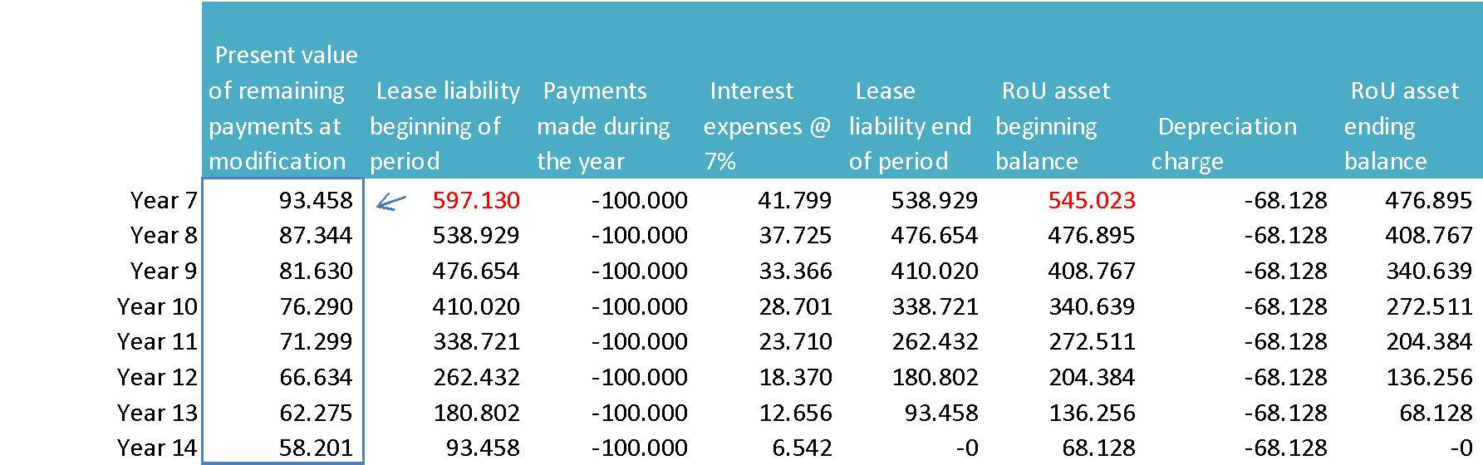

Example – lease modification that decreases the scope of the lease
Lessee enters into a 10-year lease for 5,000m² of office space. The annual lease payments are CU 50,000 payable at the end of each year. Lessee’s incremental borrowing rate at the commencement date is 6%.
At the commencement of the lease, a lease liability of CU 368,004 is recognized and corresponds to the present value of the lease payments that are not paid at that date. The cost of the right-of-use asset corresponds to the lease liability plus payments made at commencement date. Lessee expects to consume the right-of-use asset’s future economic benefits evenly over the lease term and, thus, depreciates the right-of-use asset on a straight-line basis.
The lease liability and the right-of-use asset table is as follows:
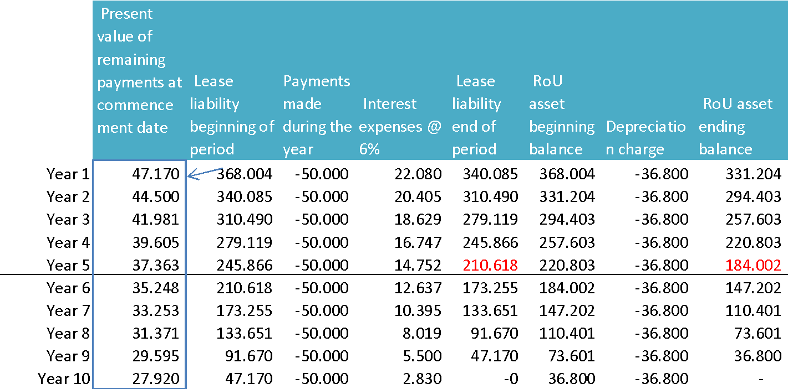
At beginning of Year 6, Lessee and Lessor agree to amend the original lease to reduce the space to only 2,500m² of the original space starting beginning of Year 6. The annual fixed lease payments from Year 6 to Year 10 are CU 30,000. Lessee’s incremental borrowing rate at the beginning of year 6 is 5% (5-year term).
At the effective date of the modification, Lessee remeasures the lease liability based on (a) a five year remaining lease term, (b) annual payments of CU 30,000 and (c) Lessee’s incremental borrowing rate of 5%. The modified lease liability equals CU 129,884.
Lessee determines the proportionate decrease in the carrying amount of the right-of-use asset on the basis of the remaining right-of-use asset (i.e.: 2,500m² corresponding to 50% of the original right-of-use asset).
50 % of the pre-modification right-of-use asset (CU 184,002) is CU 92,001. 50% of the pre-modification lease liability (CU 210,618) is CU 105,309. Consequently, Lessee reduces the carrying amount of the right-of-use asset by CU 92,001, corresponding to the 50% of the right-of-use asset for which the lease is discontinued, and the carrying amount of the lease liability by CU 105,309, corresponding to the 50% of the lease liability for which the lease is discontinued. Lessee recognizes the difference as a gain in profit or loss at the effective date of modification (beginning of Year 6):
Dt Lease Liability 105,309
Ct Right-of-use asset 92,001
Ct Impact of contracts lease modifications 13,308
Lessee recognizes the difference between the remaining lease liability of CU 105,209 and the modified lease liability of CU 129,884 (CU 24,575) as an adjustment to the right-of-use asset reflecting the change in the consideration paid for the lease and the revised discount rate.
From beginning of Year 6, the right-of-use asset and the lease liability are as follows:
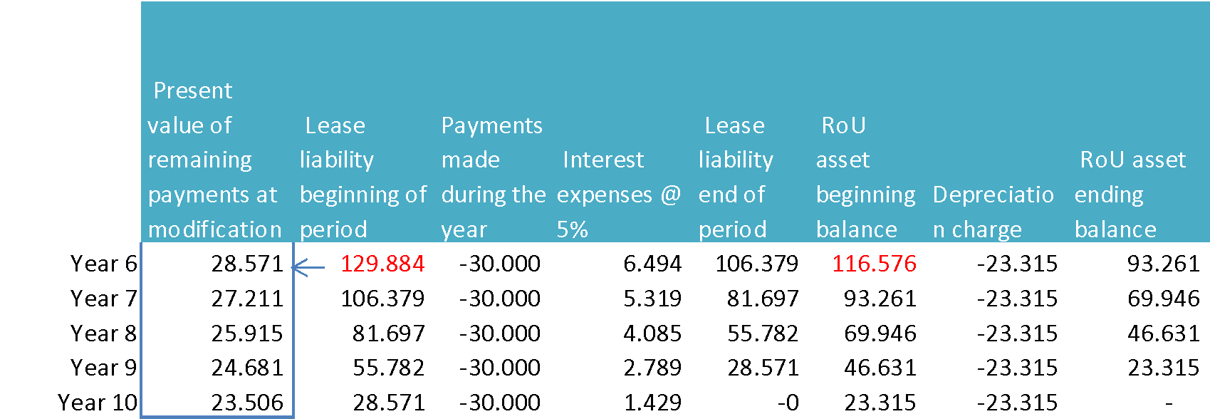

Example – lease modification that increases the scope of the lease but decreases the lease term
Lessee enters into a 10-year lease for 2,000m² of office space. The annual lease payments are CU 100,000 payable at the end of each year. Lessee’s incremental borrowing rate at commencement date is 6%. At the beginning of Year 6, Lessee and Lessor agree to amend the original lease to (a) include an additional 1,500 m² of space in the same building starting Year 6 and (b) reduce the lease term from 10 years to 8 years. The annual fixed payment for the 3,500m² is CU 150,000 payable at the end of each year. Lessee’s incremental borrowing rate at the beginning of Year 6 is 7%.
The consideration for the increase in scope of 1,500m² is not commensurate with the stand-alone price of the original contract. Consequently, Lessee does not account for the increase in scope as a separate lease.
The pre-modification right-of-use asset and the pre-modification lease liability are as follows:
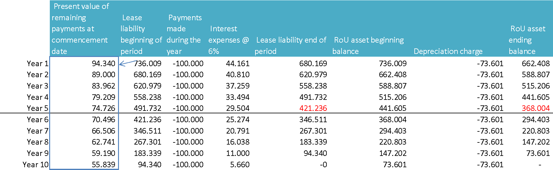
Decrease of lease term
At the effective date of the modification, the pre-modification right-of-use asset is CU 368,004. Lessee determines the proportionate decrease in the carrying amount of the right-of-use asset based on the remaining right-of-use for the original 2,000m² of office space: 3 years remaining instead of 5 years. The remaining right-of-use asset for the original 2,000m² is CU 220,802 (CU 368,004/5 * 3).
At the effective date of the modification, the pre-modification lease liability is CU 421,236. The remaining lease liability for the original 2,000m² of office space is CU 267,301 (i.e. present value of 3 annual payments of CU 100,000 discounted at the original rate of 6%).
Consequently, Lessee reduces the carrying amount of the right-of-use asset by CU 147,202 (CU 368,004 – CU 220,802), and the carrying amount of the lease liability by CU 153,935 (CU 421,236 – CU 267,301). Lessee recognizes the difference between the decrease in lease liability and the decrease in the right-of-use asset (CU 153,935 - CU 147,202= CU 6,733) as a gain in profit or loss below EBITDA at the effective date of the modification:
Dt Lease liability CU 153,935
Ct Right-of-Use asset CU 147,202
Ct Impact of contracts lease modifications CU 6,733
At the effective date of modification, Lessee recognizes the effect of the remeasurement of the remaining lease liability reflecting the revised discount rate of 7% which is CU 4,869 (CU 267,301 – CU 262,432):
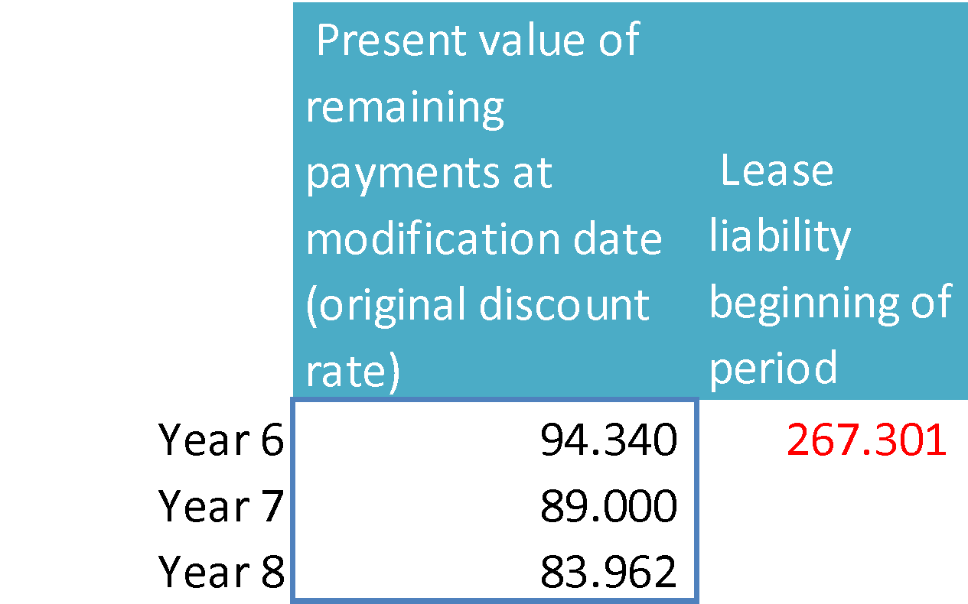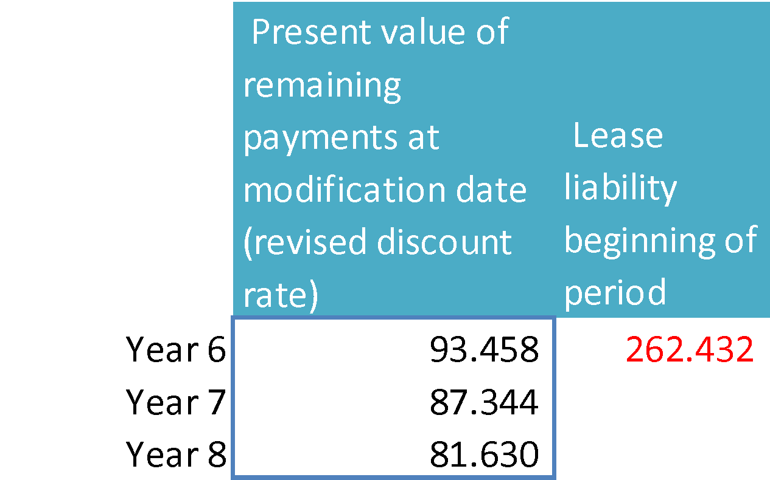
Dt Lease liability CU 4,869
Ct Right-of-Use asset CU 4,869
Increase in the leased space
At the commencement of the lease for the additional 1,500m² of space, Lessee recognizes the increase in the lease liability related to the increase of scope of CU 131,216 (present value of 3 annual payments of CU 50,000 discounted at the revised interest rate of 7%) as an adjustment to the right-of-use asset
Dt Right-of-Use asset CU 131,216
Ct Lease liability CU 131,216
The modified right-of use asset and the modified lease liability is as follows:
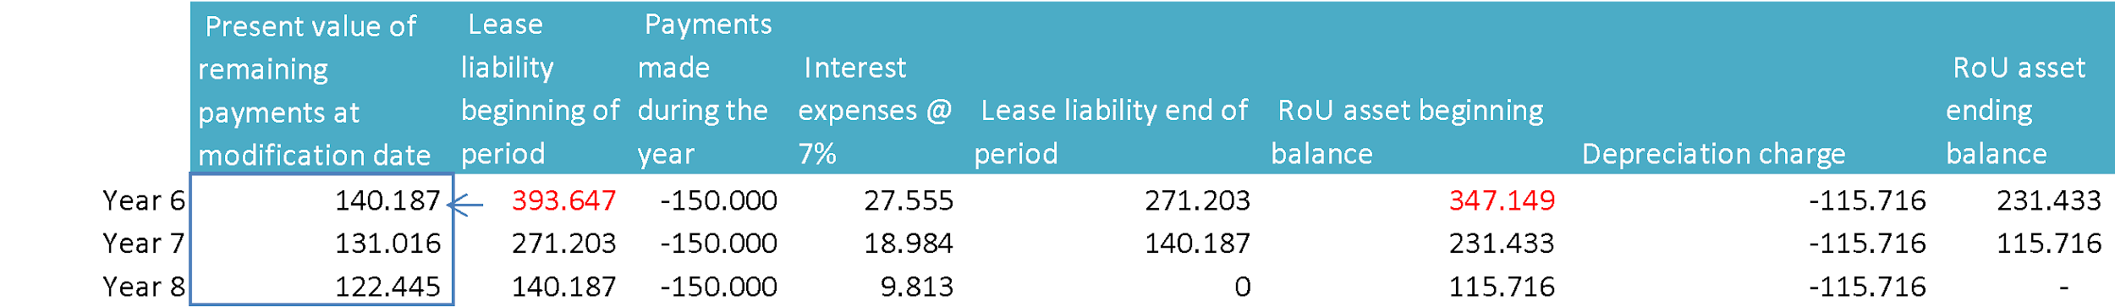

Difference between a reassessment and a lease modification
As explained above, the distinction between a lease reassessment and a lease modification is important as it has different accounting implications. The distinction is based on whether the main conditions underlying the change (e.g. change of lease term) were predefined in the original contract: if they were predefined, the change is a lease reassessment, if they were subject to negotiation, the change is a lease modification.

Lessor

Lease classification
At inception of the leases, a lessor (or intermediate lessor) classifies each of its leases as either:
- A finance lease if it transfers substantially all the risks and rewards incidental to ownership of the underlying asset; or
- An operating lease if it does not transfer substantially all the risks and rewards incidental to ownership of the underlying asset.

Criteria for lease classification
The classification of leases is based on the extent to which the lease transfers the risks and rewards incidental to ownership of an underlying asset. Risks include the possibilities of losses from idle capacity or technological obsolescence. Rewards may be represented by the expectation of profitable operation over the underlying asset’s economic life and of gain from appreciation in value or realization of a residual value.
The classification depends on the substance of the transaction rather than the form. Examples of situations that individually or in combination would normally lead to a lease being classified as finance lease:
- the lease transfers ownership of the underlying asset to the lessee by the end of the lease term;
- the lessee has the option to purchase the underlying asset at a price which is expected to be sufficiently lower than fair value at the date the option becomes exercisable that, at the inception of the lease, it is reasonably certain that the option will be exercised;
- the lease term is for the major part* of the economic life of the asset, even if title is not transferred;
- at the inception of the lease, the present value of the lease payments amounts to at least substantially all* of the fair value of the underlying asset;
- the lease assets are of a specialized nature such that only the lessee can use them without major modifications being made.
*IFRS does not provide any guidance on “major part” of the economic life and “substantially all” of the fair value of the underlying asset to be covered by the present value of the minimum lease payments. If the lease term is equal to 75% or more of the estimated economic life of the leased asset, the lease will generally be a finance lease. Additionally, if the present value of the lease payments is 90 percent or more of the fair value of the underlying asset at inception of the lease, then the lease generally should be classified as a finance lease. However, it is necessary to consider all relevant factors when assessing the classification of a lease, which is an analysis in substance and it shall be clear that the above percentages are indicative only.
Additional indicators of situations that individually or in combination could also lead to a lease being classified as a finance lease are:
- if the lessee can cancel the lease, the lessor’s losses associated with the cancellation are borne by the lessee;
- gains or losses from the fluctuation in the fair value of the residual accrue to the lessee (for example, in the form of a rent rebate equaling most of the sales proceeds at the end of the lease); and
- the lessee has the ability to continue the lease for a secondary period at a rent that is substantially lower than market rent.
If it is clear that the lease does not transfer substantially all the risks and rewards incidental to ownership of an underlying asset, the lease is classified as an operating lease.
For a lease that includes both land and buildings elements, the lessor separately assesses the classification of each element as a finance lease or an operating lease, noting that land normally has an indefinite economic life. The lessor allocates lease payments between the land and the buildings elements in proportion to the relative fair values of the leasehold interests in the land element and buildings element of the lease at the inception date. If the lease payments cannot be allocated reliably between these two elements, the entire lease is classified as a finance lease, unless it is clear that both elements are operating leases, in which case, the entire lease is classified as an operating lease.
For a lease of land and buildings in which the amount for the land element is immaterial to the lease, the lessor may treat the land and buildings as a single unit for the purpose of lease classification and classify it as a finance lease or an operating lease. In such a case, the lessor regards the economic life of the buildings as the economic life of the entire underlying asset.
For the lessor, security deposits received (that are not true deposits but rather prepaid lease payments) are considered in determining whether the lease is an operating or finance lease. If the lease is classified as an operating lease, the prepaid lease payment is included in the total lease payments that are straight-lined. If the lease is classified as a finance lease, the lessor includes the prepaid lease payment in the consideration for the lease and, therefore, in the determination of the gain or loss on the derecognition of the underlying asset, if any.

Reassessment of lease classification
Lease classification is made at the inception date and is reassessed only if there is a lease modification. Changes in estimates (for example, changes in estimates of the economic life or of the residual value of the underlying asset), or changes in circumstances (for example, default by the lessee), do not give rise to a new classification of a lease for accounting purposes.

Finance Lease

Recognition
At the commencement date, a lessor shall derecognize the carrying amount of assets leased out under a finance lease and instead recognize a receivable at an amount equal to the net investment in the lease. Any resulting difference between the two shall be recognized in profit or loss similarly to gains/losses from the sale of PP&E.
Debit | Lease receivables - LT
Debit | Lease receivables - ST
Credit | Tangible Assets

Initial measurement
The gross investment in the lease corresponds to the sum of:
- The lease payments (as defined below) receivable by a lessor under a finance lease; and
- Any unguaranteed residual value (i.e. not guaranteed by the lessee or a third party) accruing by the lessor,
The net investment in the lease is the gross investment in the lease discounted using the interest implicit in the lease (see definition in 6.4.2).
Lease payments included in the measurement of the receivable comprise the following:
- fixed payments (including in-substance fixed payments), less any lease incentives payable;
- variable lease payments that depend on an index or a rate, initially measured using the index or rate at the commencement date;
- any residual value guarantees provided to the lessor;
- the exercise price of a purchase option if the lessee is reasonably certain to exercise that option; and
- payments of penalties for terminating the lease, if lease term reflects the lessee exercising an option to terminate the lease.
Initial direct costs are included in the initial measurement of the net investment in the lease and reduce the amount of finance income recognized over the lease term.

Subsequent measurement
A lessor shall recognize finance income over the lease term, based on a pattern reflecting a constant periodic rate of return on the lessor’s net investment in the lease.
Debit | Cash
Credit | Lease Receivable
Credit | Financial Income

A lessor shall regularly review estimated unguaranteed residual values used. If there has been a reduction in the estimated unguaranteed residual value, the lessor shall revise the income allocation over the lease term and recognize immediately any reduction in respect of amounts accrued.
In accordance with IFRS 9 Financial Instruments, an expected credit loss allowance shall be recognized on the net investment in the lease. In the statement of financial position, the net investment in the lease is presented net of the loss allowance. Lessors evaluate their net investment in the lease for impairment by applying the derecognition and impairment requirements of IFRS 9.

Example – Lessor’s gross and net investment in the lease
Lessor enters into a lease agreement that has the following details:
- The leased asset has a fair value of CU 10,000
- The lessee is required to make 5 annual rental payments of CU 2,100 that are payable at the start of each year
- The unguaranteed estimated residual value at the end of 5 years is CU 1,000.
- The initial direct costs are immaterial.
- The interest rate implicit in the lease is 6.62%
The lessor’s gross investment in the lease of CU 11,500 is the total rents receivable of CU 10,500 and the unguaranteed residual value of CU 1,000.
The lessor’s gross and net investment in the lease is as follows:

Year | Net investment in the lease at start of the period  (a) | Rental received (b) | Finance income  (c) =  (a)-(b)*6.62% | Gross investment in the lease at start of the period  (d) | Gross investment in the lease at end of the period  (e) =  (d) –(b) | Unearned finance income  (f) =  (d) – (a) – (c)
1 | 10,000 | 2,100 | 523 | 11,500 | 9,400 | 977
2 | 8,423 | 2,100 | 419 | 9,400 | 7,300 | 558
3 | 6,742 | 2,100 | 307 | 7,300 | 5,200 | 251
4 | 4,949 | 2,100 | 189 | 5,200 | 3,100 | 62
5 | 3,038 | 2,100 | 62 | 3,100 | 1,000 | 0
 |  | 10,500 | 1,500

Accounting for lease modification
A lease modification will be accounted for as a separate lease if both of the following conditions are met:
- The modification increases the scope of the lease by adding the right to use one or more underlying assets; and
- The consideration for the lease increases by an amount commensurate with the stand-alone price for the increase in scope and any appropriate adjustments to that stand-alone price to reflect the circumstances of the particular contract.
For a lease modification that is not accounted for as a separate lease, the lessor shall account for the remeasurement of the lease liability by:
- if the lease would have been classified as an operating lease had the modification been in effect at the inception date, the lessor shall:
  - account for the lease modification as a new lease from the effective date of the modification; and
  - measure the carrying amount of the underlying asset as the net investment in the original lease immediately before the effective date of the lease modification.
- otherwise, the lessor shall apply the requirements of IFRS 9 – Financial Instruments.

Operating lease

Recognition and initial measurement
The following recognition and initial measurement principles apply to operating leases:
- lease payments are recognized as income on either a straight-line basis or another systematic basis (if more representative of the pattern in which benefit from the use of the underlying asset is diminished);
- initial direct costs incurred in obtaining an operating lease are added to the carrying amount of the underlying asset and recognized as an expense over the lease term on the same basis as the lease income;
- Depreciation expense and impairment losses are recognized on the underlying asset in accordance with IAS 16 – Property, Plant and Equipment and IAS 36 – Impairment of Assets.
At each period end,

Debit | Account receivable or cash
Credit | Other operating income

At each period end, the asset is depreciated following IAS 16 rules,

Debit | Depreciation expense
Credit | Fixed asset - Acc. Depreciation

Lease modification
A lessor shall account for a modification to an operating lease as a new lease from the effective date of the modification, considering any prepaid or accrued lease payments relating to the original lease as part of the lease payments for the new lease.

Subleases
When an underlying asset is subleased to a third party, one party acts as both the lessee and lessor of the underlying asset. The original lease is often referred to as a head lease, the original lessee is the intermediate lessor or sub-lessor and the ultimate lessee is the sub-lessee.
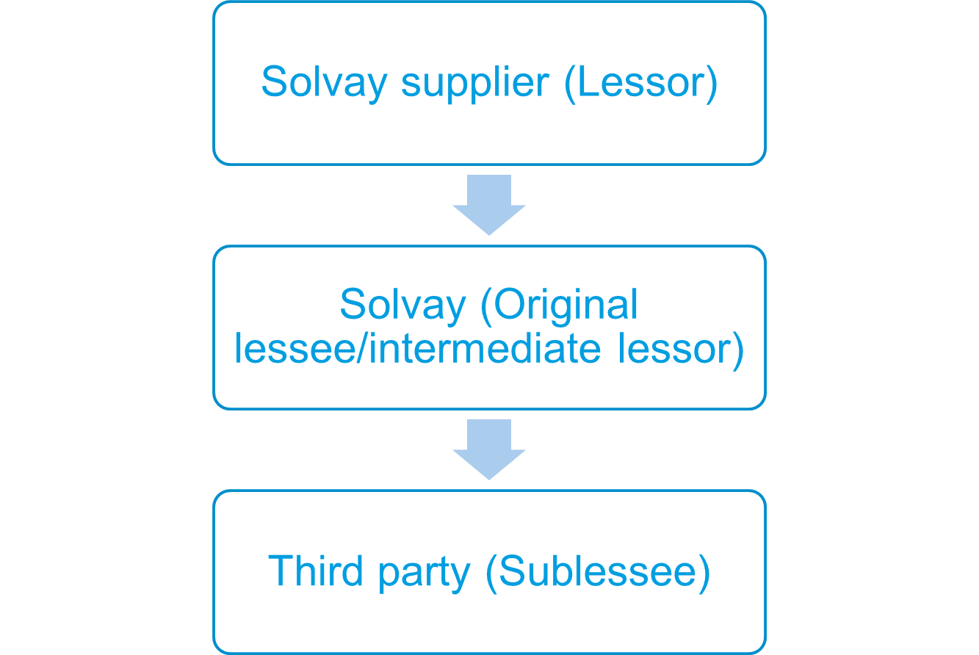
In classifying a sublease, an intermediate lessor shall classify the sublease as a finance lease or an operating lease as follows:
- if the head lease is a short-term lease for which the entity, as a lessee, has applied the short-term lease accounting exemption (see above), the sublease shall be classified as an operating lease;
- otherwise, the sublease shall be classified by reference to the right-of-use asset arising from the head lease, rather than by reference to the underlying asset itself (i.e. the item of property, plant or equipment that is the subject of the lease).
- For example: Entity A (original lessee/intermediate lessor) leases a building for 5 years. The building has an economic life of 30 years. Entity A subleases the building for 4 years. The sublease is classified with reference to the right-of-use asset in the head lease (and not the underlying building). When assessing the useful life criterion, the sublease term of 4 years is compared with the 5 year term of the right-of-use asset in the head lease and not with the 30-year economic life of the building.
An intermediate lessor who subleases, or expects to sublease an asset, cannot account for the head lease as a lease of a low-value asset even when the criteria for the low-value asset exemption are met.
If a sublease is for all of the remaining term of the corresponding head lease, the intermediate lessor no longer has the right to use the underlying asset, it is therefore appropriate for an intermediate lessor in such a case to derecognize the right-of-use asset and recognize the net investment in the sublease.
If the interest rate implicit in the sublease cannot be readily determined, an intermediate lessor may use the discount rate used for the head lease (adjusted for any initial direct costs associated with the sublease) to measure the net investment in the sublease.

Finance sublease
When the intermediate lessor enters into the sublease which is a finance lease, the intermediate lessor:
- derecognizes the right-of-use asset relating to the head lease that it transfers to the sublessee and recognizes the net investment in the sublease;
- recognizes any difference between the right-of-use asset and the net investment in the sublease in profit or loss;
- retains the lease liability relating to the head lease in its statement of financial position, which represents the lease payments owed to the head lessor;
- During the term of the sublease, the intermediate lessor recognizes both interest income on the sublease and interest expense on the head lease.

Operating sublease
When the intermediate lessor enters into an operating sublease, the intermediate lessor retains the lease liability and the right-of-use asset relating to the head lease in its statement of financial position. During the term of the sublease, the intermediate lessor:
- recognizes a depreciation charge for the right-of-use asset and interest expense on the lease liability; and
- recognizes lease income from the sublease.

Decision tree for sublease classification 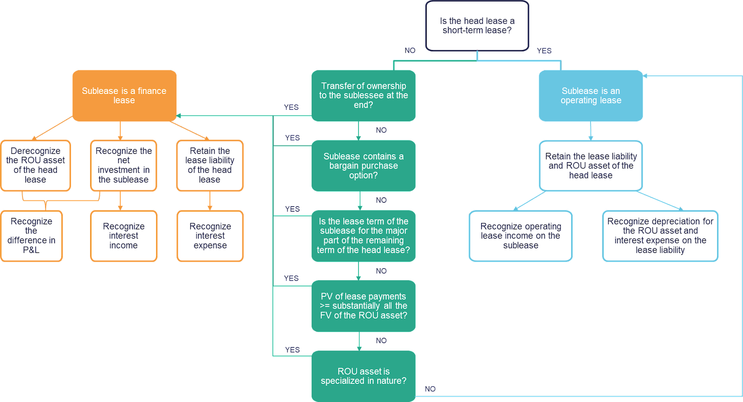

Glossary
The following terminology is used in the framework of lease accounting and is explained here below:
- Commencement date of the lease: The date on which a lessor makes an underlying asset available for use by a lessee.
- Economic life: The period over which an asset is expected to be economically usable by one or more users.
- Effective date of the modification: The date when both parties agree to a lease modification. In practice this generally is the date the modification is signed.
- Fair value: For the purpose of applying the lessor accounting requirements in this chapter, the amount for which an asset could be exchanged, or a liability settled, between knowledgeable, willing parties in an arm’s length transaction.
- Finance lease (lessor accounting only): A lease that transfers substantially all the risks and rewards incidental to ownership of an underlying asset.
- Fixed payments: Payments made by a lessee to a lessor for the right to use an underlying asset during the lease term, excluding variable lease payments.
- Gross investment in the lease (lessor accounting only): The sum of:
  - The lease payments receivable by a lessor under a finance lease; and
  - Any unguaranteed residual value accruing by the lessor.
- Inception date of the lease: The earlier of the date of a lease agreement and the date of commitment by the parties to the principal terms and conditions of the lease. In practice this generally is the date the lease is signed.
- Initial direct costs: Incremental costs of obtaining a lease that would not have been incurred if the lease had not been obtained.
- Interest rate implicit in the lease: The rate of interest that causes the present value of (a) the lease payments and (b) the unguaranteed residual value to equal the sum of (i) the fair value of the underlying asset and (ii) any initial direct costs of the lessor.
- Lease: A contract, or part of a contract, that conveys the right to use an asset (the underlying asset) for a period of time in exchange for consideration.
- Lease incentives: Payments made by a lessor to a lessee associated with a lease, or the reimbursement or assumption by a lessor of costs of a lessee.
- Lease modification: A change in the scope of a lease, or the consideration for a lease, that was not part of the original terms and conditions of the lease (for example, adding or terminating the right to use one or more underlying assets, or extending or shortening the contractual lease term).
- Lease payments: Payments made by a lessee to a lessor relating to the right to use an underlying asset during the lease term, comprising the following:
  - fixed payments (including in-substance fixed payments, less any lease incentives;
  - variable lease payments that depend on an index or a rate;
  - the exercise price of a purchase option if the lessee is reasonably certain to exercise that option; and
  - payments of penalties for terminating the lease, if the lease term reflects the lessee exercising an option to terminate the lease.
For the lessee, lease payments also include amounts expected to be payable by the lessee under residual value guarantees. Lease payments do not include payments allocated to non-lease components of a contract, unless the lessee elects to combine non-lease components with a lease component and to account for them as a single lease component.

For the lessor, lease payments also include any residual value guarantees provided to the lessor by the lessee, a party related to the lessee or a third party unrelated to the lessor that is financially capable of discharging the obligations under the guarantee. Lease payments do not include payments allocated to non-lease components.
- Lease term : The non-cancellable period for which a lessee has the right to use an underlying asset, together with both:
  - periods covered by an option to extend the lease if the lessee is reasonably certain to exercise that option; and
  - periods covered by an option to terminate the lease if the lessee is reasonably certain not to exercise that option.
- Lessee: An entity that obtains the right to use an underlying asset for a period of time in exchange for consideration.
- Lessee’s incremental borrowing rate: The rate of interest that a lessee would have to pay to borrow over a similar term, and with a similar security, the funds necessary to obtain an asset of a similar value to the right-of-use asset in a similar economic environment.
- Lessor: An entity that provides the right to use an underlying asset for a period of time in exchange for consideration.
- Net investment in the lease (lessor accounting): The gross investment in the lease discounted at the interest rate implicit in the lease.
- Operating lease (lessor accounting only): A lease that does not transfer substantially all the risks and rewards incidental to ownership of an underlying asset.
- Optional lease payments (lessor accounting only): Payments to be made by a lessee to a lessor for the right to use an underlying asset during periods covered by an option to extend or terminate a lease that are not included in the lease term.
- Period of use: The total period of time that an asset is used to fulfil a contract with a customer (including any non-consecutive periods of time).
- Residual value guarantee: A guarantee made to a lessor by a party unrelated to the lessor that the value (or part of the value) of an underlying asset at the end of a lease will be at least a specified amount.
- Right-of-use asset: An asset that represents a lessee’s right to use an underlying asset for the lease term.
- Short-term lease: A lease that, at the commencement date, has a lease term of 12 months or less. A lease that contains a purchase option is not a short-term lease. The short-term lease classification does not apply to short-term extension periods of a lease that initially was not a short-term lease.
- Sublease: A transaction for which an underlying asset is re-leased by a lessee (‘intermediate lessor’) to a third party, and the lease (‘head lease’) between the head lessor and lessee =remains in effect.
- Underlying asset: An asset that is the subject of a lease, for which the right to use that asset has been provided by a lessor to a lessee.
- Unearned finance income (lessor accounting only): The difference between:
  - the gross investment in the lease; and
  - the net investment in the lease.
- Unguaranteed residual value: That portion of the residual value of the underlying asset, the realization of which by a lessor is not assured or is guaranteed solely by a party related to the lessor.
- Variable lease payments : The portion of payments made by a lessee to a lessor for the right to use an underlying asset during the lease term that varies because of changes in facts or circumstances occurring after the commencement date, other than the passage of time.

Document tracking – Versions
Version | Change(s) | Date | Changed by
1 | Document issued | November 2018 | IFRS Desk
2 | §6.5.2.3: Accounting for lease modifications: modification approach for portfolios leases | December 2018 | IFRS Desk
3 | §2/§3: creation of BFC accounts caption separated from core principle caption.  §2 BFC accounts  - Update of depreciation accounts used  - lessor accounting – clarification of accounts to be used for core business activities.  § 3.4.3, 3.4.4, 3.4.5: new examples added.  §4.2.2.3: New § added – Power purchase agreements (“PPAs”)  §4.3.2: rephrasing of last sentence of the paragraph  §4.3.2.1: New example added  §4.3.3: additional wording added in the §4 related to the predetermination of relevant decisions  §4.3.3.3: new paragraph added  §5.1: Definition of lease term: clarification that extension options that are to be negotiated are not part of the lease term  §6.3.1: wording added: on determination of service components  §6.3.3.3: new example on variability in the context of power purchase agreement  §6.4.1: clarification that measurement of liability at commencement date is done using the discount rate at inception date.  §6.5.1.1: impairment paragraph added  §6.5.2.4: clarification on the difference between a reassessment and a lease modification | March 2020 | IFRS Desk
4 | §4.3.3. add guidance on how to assess involvement in design  §4.3.3 added clarification on decision making rights  6.3.9 Added a sale and leaseback example  7.1.1 Added guidance on leases of land and buildings for the lessor  7.2.3 Added IFRS 9 references on subsequent measurement of the net investment in the lease for lessors  7.2.3 added a lessor example  7.4 added further clarification on subleases including a decision tree | April xxx 2021  April 2022 | IFRS Team
5 | Solvay references replaced with Syensqo | April 2026 | IFRS Team

The exchange rates to be used to determine if the thresholds are reached are the exchange rates at the time of the assessment. There is no subsequent reassessment.
Unguaranteed residual value corresponds to the estimate made by the lessor of the fair value of the underlying asset at the end of the lease contract, of which the realization is not assured or guaranteed solely by a party related to the lessor.

