

Change Management Process

Document name | Process_Design_Document_CM_V0.1.docx
Version | 0.1
Status | ☒ In progress ☐ Approved ☐ Validated
Update date | 2025/05/02
Owner
Level of confidentiality | ☐Public ☒Internal ☐Limited ☐Confidential
Document Control

CHANGE HISTORY:
AUTHOR(s) | VERSION | DATE | CHANGES
Assia JABRI | V0.1 | 2025/05/02 | Document creation

APPROVAL
ROLE | NAME | DATE
Foundation Office Lead | Li-Kang KUANG | 2025/07/07

Table of Contents
1. Introduction 4
1.1. Main definition 4
1.2. Objectives, challenges & benefits 4
1.3. Actors 5
2. Process description 8
2.1. Process triggers, inputs, outputs 8
2.2. Process activities 9
2.3. Link with other ITSM processes 12
3. Process Workflow 15
3.1. Detailed Normal Change Management workflow 15
3.2. Detailed Emergency Change Management workflow 19
4. Roles & responsibilities 23
4.1. Normal Change Management process 23
4.2. Emergency Change Management process 23
5. Metrics & KPIs - to be validated with the DMs 25
5.1. Efficiency & Performance KPIs 25
5.2. Quality & Reliability KPIs 25
5.3. Continual Improvement KPIs 26
6. Governance- to be validated with the DMs 27
6.1. Operational Committees 27
6.2. Continuous improvement Committees 28
7. Tools & Deliverables 29
7.1. Tools 29
7.2. Deliverables 30
8. Glossary 31

Introduction

Main definition
A Change is defined as the addition, modification, or removal of anything that could have an impact on an IT service. This typically includes hardware, network devices, and virtual assets such as virtual servers or storage, system and application software.
Change Management is the process responsible for facilitating the implementation of changes.

Objectives, challenges & benefits
The goal of the Change Management process is to enable beneficial changes to be made with minimum disruption to business operations, ensuring that the best possible levels of service quality and availability are maintained.
The objectives of the Change Management process are:
- Secure change execution by minimizing the risk of incidents, failures, or service disruptions.
- Ensure business continuity by implementing changes without major impact on operations
- Balance speed and stability by accelerating delivery while maintaining service reliability.
- Standardize the approach by applying a consistent process for assessment, approval, and documentation
- Maximize value creation by enabling beneficial changes aligned with strategic goals.
- Strengthen coordination by engaging stakeholders and improving visibility and communication around changes

Actors
There are 5 main roles in the Change Management:
- Delivery Lead
The Delivery Lead is accountable for the overall design, performance, and continual improvement of the Change Management process. He is usually a senior manager with the ability and authority to ensure the process is rolled out and used by all stakeholders.
He is responsible for:
- Defining and maintaining the Change Management process framework, roles, and policies
- Ensuring alignment with overall ITSM strategy and governance standards
- Monitoring process performance and ensure it delivers expected value
- Identifying areas of improvement and lead process optimization initiatives
- Validating major process evolutions, KPIs, and governance models
- Supporting the Change Process Manager and ensure coordination with other ITSM practices
- Representing the process in audits and executive-level discussions

ITIL role: Change Process Owner

- Change Process Manager
The Change Process Manager, represented by iQo, is responsible for day-to-day facilitation of the global change process. He ensures the quality and consistency of the process, and leads CAB sessions at the global level.
He is responsible for:
- Governing the end-to-end execution of the Change Management process
- Leading and facilitating CAB meetings
- Managing the overall planning
- Reviewing retrospectively major changes raised
- Monitoring KPIs and drive continuous improvement
- Escalating or arbitrate complex or sensitive changes
- Maintaining and update process rules and documentation
- Facilitating emergency change approval

- Delivery Manager
The Delivery Manager leads the QRC within the Platform. THe acts as the local focal point for Change Management, reviewing all requests in their scope, validating minor changes, and redirecting major changes to the central CAB.
He is responsible for:
- Leading and coordinate QRC meetings for their Platform
- Acting as Change Management focal point within the Platform
- Reviewing all change requests for technical, functional, and planning accuracy
- Validating minor changes locally
- Escalating major changes to the CAB for global evaluation
- Ensuring internal alignment and assess domain-specific impacts
- Liaising with technical teams, requesters, and the Change Process Manager
- Ensuring proper documentation and readiness of changes before execution
- Reviewing retrospectively minor changes if needed

ITIL role: Change Reviewer

- Service Owner/Product Owner
The Service Owner or Product Owner identifies the need for a change and initiates the request. He is responsible for formally submitting the change and providing the necessary context.
He is responsible for:
- Identifying and justifying the need for a change (corrective, evolutive, preventive, etc.)
- Creating and submit the change request in the ITSM tool
- Providing key information (description, business justification, preferred timeline, expected impacts)
- Responding to questions during the review process
- Participating in the Post Implementation Review (PIR) if required

ITIL role: Change Requester

- Technical team
The Technical team is responsible for the technical assessment, planning, and implementation of the change, as well as for providing the necessary deployment-related elements.
She is responsible for:
- Contributing to technical impact analysis
- Defining implementation, testing, and rollback plans
- Estimating effort, risks, and technical constraints
- Executing the change after approval
- Conducting post-implementation validations
- Providing input for the PIR when relevant

Process description

Process triggers, inputs, outputs
- Triggers - What initiates the process ?
The trigger of the Change Management process is the identification of a need for change, whether it originates from a project, an incident, a compliance requirement, or a business initiative.
Examples of triggers:
- New business or regulatory requirement
- Technical evolution (e.g., new solution, obsolescence)
- Incident or Problem root cause requiring correction
- Security vulnerability or risk mitigation need
- Project or program decision impacting IT services
- Strategic transformation or optimization initiative

- Input - What formally enters the process ?
A Change Request (CRQ) created and submitted in the ITSM tool (BMC Helix), containing all necessary information for evaluation and processing.
Typical input elements:
- Description and rationale of the change
- Impact and risk analysis
- Desired implementation window
- Rollback plan
- Test plan
- Communication plan

- Outputs - What does the process deliver ?
A controlled and traceable implementation of the change, ensuring value delivery with minimal disruption to operations.
Examples of outputs:
- Approved and executed changes
- Change planning updates
- Communication and coordination with stakeholders
- Post-Implementation Review (PIR) reports
- Updated CMDB or service documentation

Process activities
- 3 types of changes
The Change Management process handles three types of changes, each with its own level of criticality, governance, and execution path:
- Standard change: low risk, low impact, pre-approved and documented change
Examples: password reset automation, user account creation, patch deployment via standardized tools
Note:
It has been decided that the Standard Change process will not be defined or deployed at this stage.
Its design and implementation are planned for September 2025 as part of a later phase of the Change Management rollout.

- Normal change: planned changes that require evaluation, risk assessment, and approval. It goes through the full workflow
There are 2 levels of normal change:
- Normal Minor Change
A change is considered a Normal Minor Change if it meets at least one of the following:
- It only affects a non-production environment (test, dev, sandbox, UAT)
- It affects no critical service and introduces no business interruption
Examples: Updating network access rules for a non-critical application or
- Normal Major Change
A change is considered a Normal Major Change if it meets both conditions:
- It impacts a production environment, AND
- It either targets a critical service or may cause a business interruption
Example: Configuration change of Google Workspace (Gmail) SMTP routing rules in production
- Emergency change: changes that must be implemented urgently, typically in response to a service that has already failed or one that is about to fail if no action is taken. It follows a fast-tracked process with limited prior assessment.
There are three acceptable reasons for raising an Emergency Change:
- To respond to a major incident, where a critical service is down or severely degraded
- To prevent an imminent service interruption, when a known issue risks impacting operations if not addressed urgently
- To anticipate or mitigate a security threat, such as closing a vulnerability or applying a critical patch
Examples: critical security patch, urgent production fix, major outage recovery actions
- Change Management Workflow

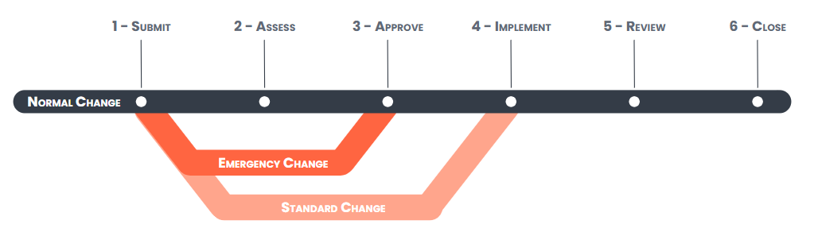

The diagram presents the standard lifecycle of a Normal Change, structured into six key stages:
- SUBMIT – The Change Request is formally created and submitted with all required information.
- ASSESS – The request is reviewed for impact, risk, dependencies, and feasibility.
- APPROVE – The change is evaluated and approved by the appropriate governance body
- IMPLEMENT– The change is deployed in the live environment according to the agreed plan.
- REVIEW – A Post-Implementation Review (PIR) is conducted, especially for major and emergency changes.
- CLOSE – The change is formally closed in the ITSM tool, with documentation and lessons learned captured if applicable.
The Emergency Change follows a fast-track process, bypassing the full assessment step due to its urgency. Approval is expedited, and a retrospective review is conducted afterward to eensure accountability.
The Standard Change being low-risk and predefined, it skips both assessment and approval stages. It follows a streamlined path directly from submission to implementation and closure.

Link with other ITSM processes
The Change Management process relies on structured interactions with several other practices to ensure effective control, risk mitigation, and alignment with business priorities.
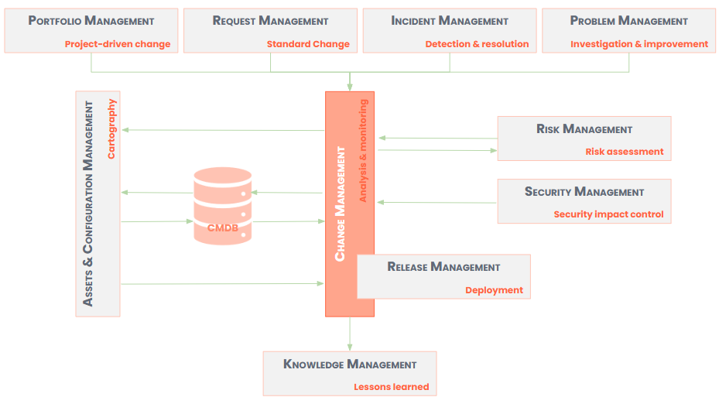

- Portfolio Management : Projects and programs often introduce changes to the IT environment. Portfolio Management is therefore a key input provider, triggering new change requests aligned with strategic initiatives.
- Request Management : Standard changes are often initiated through service requests. The two processes must be aligned to determine when a request qualifies as a change
- Incident Management : Change Management supports the resolution of incidents by enabling corrective actions. Conversely, poor change execution can lead to incidents. Close collaboration is essential for traceability and continuous improvement.
- Problem Management : Changes are often used to eliminate root causes identified through problem investigations. Problem Management also benefits from PIRs to improve diagnosis and prevention of future issues.
- Risk Management : Any significant change must undergo risk assessment. Risk Management provides insight into business impacts, regulatory constraints, and potential vulnerabilities.
- Security Management : Security teams assess and validate changes with potential impact on the organization's cybersecurity posture. Changes may also be initiated to remediate vulnerabilities or comply with security policies.
- Release Management : When a change is approved, it goes through the release management process to be implemented before returning to the change management process to analyze its proper implementation. Also, Release Management could ensure the coordinated deployment of one or more changes. Both processes must align on planning, rollback strategies, communication, and test validation.
- Knowledge Management : Post Implementation Reviews (PIRs) and feedback from change executions feed into the Knowledge Base. This contributes to process maturity and helps prevent recurring issues.
- Assets & Configuration Management : Every change must be reflected in the CMDB to ensure accurate tracking of configuration items and dependencies. In turn, CMDB data supports impact analysis and planning in Change Management.

Process Workflow

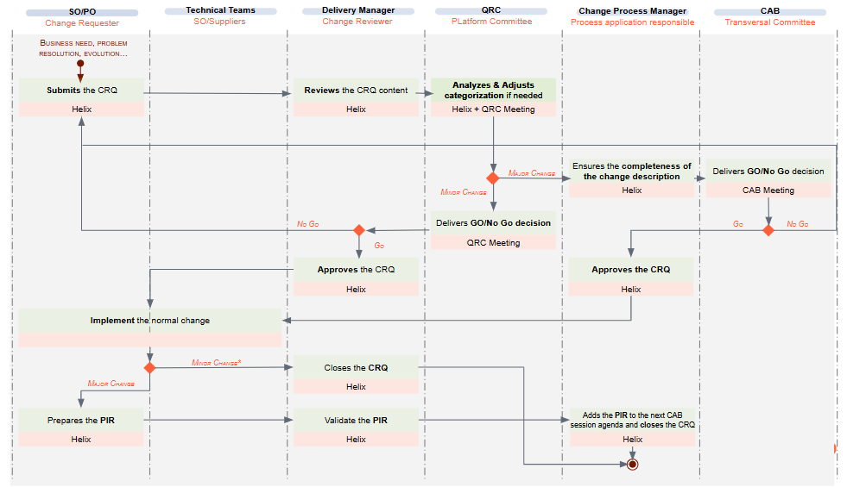
Detailed Normal Change Management workflow

*A PIR for minor change may be requested by the Delivery Manager or Change Process Manager
SUBMIT
- Submission of the Change - by Service Owner/Product Owner
The SO/PO submits a Normal Change Request in the ITSM tool.
As part of the submission, they must complete a structured impact assessment, including:
- Targeted environment (production / non-production)
- Criticality of the service affected
- Risk of business interruption or degradation
- Dependencies on other systems or teams
- Security or regulatory concerns
- Expected implementation window
- Need for stakeholder communication
Based on these inputs, the system performs an automatic categorization:
🟢 Minor Change
🟠 Major Change

ASSESS
- Categorization Review & Impact Reassessment - by Delivery Manager via QRC
The Delivery Manager reviews :
- Reviews the change request content
- May identify technical gaps, risk underestimation, or overlooked stakeholders
The QRC responsibilities include:
- Validating the declared impact
- Challenging or enriching the analysis (e.g. missed dependencies, overlooked stakeholders)
- Reclassifying the change (Minor ↔ Major), if necessary
- Logging any changes directly in the ITSM tool

APPROVE
- Review & Approval

a. Minor Change (QRC Level)
- Approved by the Delivery Manager
- Approval decision and implementation plan are recorded in the ITSM tool

b. Major Change (CAB Level)
- The change is escalated to the CAB, chaired by the Change Process Manager
- Prior to CAB, the Change Process Manager ensures that the impact assessment is complete
- CAB delivers a formal decision (Go / No-Go), recorded by the Change Process Manager in the tool

IMPLEMENT
- Implementation - by Technical Team & Service Owner/Product Owner
- The change is executed by the technical team according to the approved plan
- The SO/PO supports stakeholder communication only if previously declared during submission
- The implementation status, result, communication, and rollback are logged in the ITSM tool
- The CMDB is updated if impacted components are involved

REVIEW
- Post Implementation Review (Only for Major Changes)

a. For Major Changes – Mandatory PIR
- PIR includes:
  - Change objective vs outcome
  - Incident log (if any)
  - Deviations or complications
  - Lessons learned and recommendations
- Prepared by the SO/PO, validated by the Delivery Manager
- Added to the CAB agenda by the Change Process Manager
- Reviewed during CAB, and lessons are recorded in the Knowledge Base if relevant

b. For Minor Changes – No PIR by default
A PIR may be requested by the Delivery Manager or Change Process Manager only in case of:
- Incident
- Unexpected service degradation
- High stakeholder impact
🔔 The PIR has to be done maximum 48 hours after the change implementation

CLOSE
- Closure

a. For Minor Changes
- After successful implementation (and communication if applicable),
➤ the Delivery Manager closes the change in the ITSM tool

b. For Major Changes
- Once PIR is validated and reviewed,
➤ the Change Process Manager formally closes the change in the ITSM tool
- All traceability (PIR, CMDB, logs, KPIs) is complete at this point

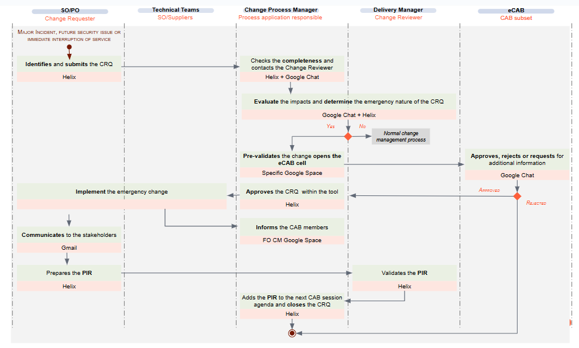
Detailed Emergency Change Management workflow

SUBMIT
- Identification & Submission - by Service Owner/Product Owner
- A SO/PO identifies an emergency change and submits an Emergency Change Request in the ITSM tool.
- The request must meet at least one of the following criteria:
- Response to a major incident
- Anticipation of a security issue
- Prevention of an immediate service interruption
⛔ Project deadlines or business pressure are not valid justifications.
- Pre-Validation - by Change Process Manager & Delivery Manager
- The Change Process Manager reviews the completeness and urgency
- The Delivery Manager assesses the technical and business impact
- Together, they confirm whether the change qualifies as Emergency
🛑 No escalation to eCAB without joint pre-validation.

APPROVE
- eCAB Discussion
- A focused eCAB discussion is held in a dedicated Google Space.
- Input and concerns are shared asynchronously
- Formal Approval in ITSM Tool - by Change Process Manager
- Following the eCAB discussion, the Change Process Manager records the official Go / No-Go decision in the ITSM tool.
- The request is approved, rejected, or requalified as Normal Change.

IMPLEMENT
- Immediate Implementation - by Technical Team
- The technical team implements the approved change without delay.
- All activities, timestamps, and outcomes are recorded in the ITSM tool.
- A rollback plan is applied if needed.
- Stakeholder Communication - by Service Owner/Product Owner & Technical Team
- Communicate to impacted business and IT stakeholders
- Share any service impacts or mitigations
- Ensure awareness during/after the change
- CAB Notification - by Change Process Manager
The Change Process Manager informs all CAB members via the “FO Change Management” Google Space that:
- An Emergency Change has been executed
- A PIR will be scheduled in the next CAB

REVIEW
- Post Implementation Review (PIR)

a. Preparation (by Service Owner/Product Owner)
- Completes the PIR document with summary, outcome vs. objective, deviations, lessons learned

b. Validation (by Delivery Manager)
- Reviews for clarity, completeness, relevance
- Approves or requests revision

c. Planning (by Change Process Manager)
- Adds the PIR to the CAB agenda
- Ensures prior sharing and coordination

d. Review (by CAB)
- Validates justification, execution, and impact
- Documents improvements and lessons in the Knowledge Base if applicable
🔔 The PIR has to be done maximum 48 hours after the change implementation

CLOSE
- Closure - by Change Process Manager
Once PIR is validated and all steps completed, the Change Process Manager:
- Closes the change in the ITSM tool
- Ensures the CMDB is updated if required
- Updates Emergency Change KPIs
- Flags any non-compliance for process improvement

Roles & responsibilities
The RACI matrices below define the roles and responsibilities of the key actors involved in the Normal and Emergency Change processes. It ensures clarity on who is Responsible, Accountable, Consulted, and Informed at each major step of the lifecycle, with strict adherence to the principle of single accountability per activity.

Normal Change Management process
 | Service Owner/Product Owner | Technical team | Delivery Manager | QRC | Change Process Manager | CAB
Submit | A,R |  | I
Assess | R | C | A(minor), R (major) | R | A (major)
Approve | C | I | A (minor) | R (minor) | A (major) | R (major)
Implement | A | R | I (minor) |  | I (major)
Review | R | C | R |  | A | I
Close | R (minor) |  | A (minor) |  | A,R (major)

Responsible (R), Accountable (A), Consulted (C), Informed (I)

Emergency Change Management process
 | Service Owner/Product Owner | Technical team | Delivery Manager | QRC | Change Process Manager
Submit | A,R |  | R | R
Approve | C | I | C | A | R
Implement | A | R | I | I
Review | R | C | R | A | I
Close |  |  |  | A,R

Responsible (R), Accountable (A), Consulted (C), Informed (I)

Metrics & KPIs
To effectively monitor the health and maturity of the Change Management process, the following KPIs are grouped into three categories:
- Efficiency & Performance – to measure operational workload and agility
- Quality & Reliability – to track risk, stability, and process control
- Continual Improvement – to ensure learning, follow-up, and stakeholder alignment
Each KPI includes a clear description and calculation method to support reporting and decision-making.

Efficiency & Performance KPIs
KPI | Description | Calculation mode
Total number of changes | Total number of changes processed (Emergency, Normal, Standard) over a period. | Count of all change records with status "Closed"
% of Emergency Changes | Proportion of Emergency Changes compared to the total volume of changes. | (Number of Emergency Changes / Total number of Changes) × 100

Quality & Reliability KPIs
KPI | Description | Calculation mode
Change success rate | % of changes implemented without incident, rollback, or unexpected impact.. | (Number of successful changes / Total number of implemented changes) × 100
% of changes rejected during the CAB | Proportion of Major Changes rejected or deferred by the CAB.. | (Number of changes rejected in CAB / Total number of changes presented to CAB) × 100
% of changes causing an incident | % of changes that led to the creation of an incident post-implementation. | (Number of changes linked to incidents / Total number of implemented changes) × 100
% of changes implemented on schedule | % of changes implemented within their initially approved implementation window. | (Number of changes implemented on planned date / Total number of implemented changes) × 100

Continual Improvement KPIs
KPI | Description | Calculation mode
PIR coverage rate on time | % of Major (or Emergency) Changes for which a Post Implementation Review was done. | (Number of changes with a completed PIR / Total number of Major and Emergency Changes) × 100
% of PIR recommendations implemented | % of improvement actions identified in PIRs that have been carried out. | (Number of PIR action items implemented / Total number of action items identified in PIRs) × 100
Stakeholder satisfaction rate | Satisfaction level of stakeholders involved in or impacted by the changes. | Average score from satisfaction surveys post-implementation

Governance
Change governance relies on two committee types: operational and continuous improvement. Each has a specific scope, rhythm, and ownership. The following tables outline their purpose, cadence, key participants, and designated animators to ensure clear accountability and structured decision-making.

Operational Committees
Committee | Objective | Frequence | Animator | Participants | Input (←) /Output (→)
Quality Review of Change (QRC) | Change quality review, impact analysis, approval of the minor changes and redirection of the major changes to the CAB | Up to the Platform  (usually weekly) | Delivery Manager | Service Owners/Product Owner, and necessary members | - Impact analysis  - Categorization and decision for minor change, change planning updated
Change Advisory Board (CAB) | Transversal evaluation, approval and prioritization of major changes | Weekly, on Thursday 5.15 pm CET | Change Process Manager | Delivery Managers of all the Platforms, Security representative, IT Global Support representative, and necessary temporary members | - PIR, Change presentation template  - Decision, change planning updated
emergency CAB (eCAB) | It is a subset of the CAB that makes decisions about the emergency changes | As needed | Change Process Manager | Service Owner/Product Owner, Delivery Manager, Security representative, Team lead, Global IT Support representative | - Emergency change request  - Decision, change planning updated

Continuous improvement Committees
Committee | Objective | Frequence | Animator | Participants | Input (←) /Output (→)
Review of the change management process | - Evaluate the overall performance of change management process  - Discuss KPIs and suggest improvements. | Quarterly | Change Process Manager | Delivery Managers, Delivery Lead | - Quarterly KPIs  - Action plan for improvement
Post Emergency Change Review  Could be merged with the major incident review | Review emergency changes after their implementation to extract lessons learned | After each emergency change | Change Process Manager or Problem manager (if merged) | Delivery Manager of the concerned domain, Service Owner/Product Owner, Technical teams, Problem manager | - Change record  - PIR, lessons learned, recommendations

Tools & Deliverables

Tools
To ensure consistency, traceability, and efficient collaboration, the Change Management process relies on two main tool ecosystems: the ITSM platform (BMC Helix) and the Google Workspace suite. Each tool plays a specific role, from request intake and implementation tracking to CAB governance, PIR management, and communication.
The table below outlines the tools and modules used, grouped by typology, along with their respective functions in the end-to-end process.
Typology | Tool/Module | Description of use in the process
ITSM Tool | BMC Helix – Change Module | Submission, categorization (Minor / Major / Emergency), validation, implementation tracking, PIR, and closure. The User Guide describes how to use the Module.
ITSM Tool | BMC Helix - CMDB | Identification of impacted CIs, support for impact analysis, and change traceability.
ITSM Tool | BMC Helix - Knowledge Module | Storage of lessons learned from PIRs for cross-domain reuse and continuous improvement.
Google Suite | Google Calendar | Scheduling CAB, QRC, and CSI committees
Google Suite | Gmail | Distribution of CAB/QRC meeting minutes
Google Suite | Google Space “FO Change Management" | Centralized space for communicating CAB agenda and Emergency Changes approved via eCAB to CAB members
Google Suite | Google Chat | Instant messaging channel discussions between eCAB members
Google Suite | Google Sheets / Slides | Preparation of CAB decks, KPI tracking

Deliverables
The Change Management process produces a set of structured deliverables at each stage of its lifecycle. These outputs ensure traceability, support decision-making, enable performance monitoring, and foster continuous improvement.
Each deliverable is aligned with a specific step of the process and contributes to strengthening operational control and governance.
Process step | Deliverable | Description
Submit | Request For Change (CRQ) | Form completed in BMC Helix at submission, including scope, impact, justification, affected CI, proposed schedule, and rollback plan.
Assess | Categorization Outcome | Normal Minor / Normal Major / Emergency classification based on auto-rules and/or QRC validation, stored in BMC Helix.
Approve | Change Planning | Planned implementation date, stored in BMC Helix
Approve | CAB Deck | Slide deck summarizing Major Changes for CAB review: objectives, impact, risks, plan.
Approve | CAB Meeting Minutes | Official recap (sent via Gmail) of CAB decisions
Implement | (No distinct deliverable) | Implementation is tracked in BMC Helix, along with execution logs and communication (if required)
Review | Post Implementation Review (PIR) | Structured review filled in BMC Helix for Major and Emergency Changes: outcomes, deviations, lessons learned.
Close | Change Record | Core object in BMC Helix capturing the full lifecycle of the change: from submission to closure, including all updates, comments, links to PIR and CMDB.
Close | Change KPIs Dashboard | Centralized dashboard reporting key performance and quality indicators of the change process.

Glossary
Term | Definition
BMC Helix | ITSM platform. Central system of record for the change process
Request For Change (CRQ) | Formal request to perform a change, submitted via the ITSM tool (BMC Helix).
Normal Change | Planned change evaluated before implementation; may be categorized as Minor or Major based on risk and impact.
Normal Minor Change | Normal change with limited impact: either in non-production or on non-critical services without business disruption.
Normal Major Change | Normal change in production that either affects a critical service or causes a business interruption. Requires CAB approval and PIR.
Emergency change | Change that must be implemented urgently, to respond to a major incident, to prevent an imminent service interruption or to anticipate or mitigate a security threat
QRC (Quality Review of Change) | Platform-level review instance for Minor Changes and categorization checks. Led by the Delivery Manager
CAB (Change Advisory Board) | Formal approval committee for Major Changes and PIR reviews. Chaired by the Change Process Manager.
eCAB (Emergency CAB) | Formal approval committee for Emergency Changes
PIR (Post Implementation Review) | Review conducted after a Major or Emergency Change to evaluate outcome, deviations, and lessons learned. Completed in BMC Helix.
CMDB (Configuration Management Database) | Database of CIs (Configuration Items) used to assess the impact and dependencies of a change.
Change Planning | Shared Calendar listing all upcoming changes, CAB dates, and blackout periods.

