Daily Process Chain Runtime
Contents
Daily Process Chain Runtime 1
Scope 1
Commitment to our users 1
Main Indicator: Process Chain Daily Runtime 1
Process Chains Included in the process 2
Rules of inclusion 2
Current list 2
List update process 2
KPI Communication 2
Process Chain Logs – The raw data 3
Process Chain Logs Explanations 3
How to collect the raw data 3

Scope
Currently this process is only covering the WBP BW Server (Rhodia legacy production).

Commitment to our users

The commitment we have with our users is that all daily data relevant to them must be correctly loaded and ready before 9 AM PARIS TIME.
This applies only for week days.
The objective of this process is therefore to calculate and publish an indicator that shows how often we finish before 9am as agreed.

Main Indicator: Process Chain Daily Runtime

The main indicator is the Daily Runtime.
For each week day, we calculate this daily runtime and then publish the percentage of days on which the daily runtime was less than 9 hours.
The daily runtime is defined as the time between 00h (Paris – Server time) and the end time of the last chain started that day.
For a given date D:
Daily Runtime D = MAX(End Date/Time) where Start Date = D
The %

Process Chains Included in the process

Rules of inclusion
All process chains should be included in the list but only some should be considered for the KPI/process. Those are shown by the “In Scope” flag. This flag is to be set only process chains which are:
- Daily Frequency with loading in weekdays.
- Main Chains - Chains which are scheduled directly (Not those scheduled via another chain).
- Used to load master data or transactional data (Not broadcasts, technical content, texts, hierarchies...>)
- Officially go live (Not chains in development/tests).

Current list
The list of kept up to date in a Gdrive spreadsheet :
https://docs.google.com/a/solvay.com/spreadsheets/d/1UrcvE_NcO8CSrqR01sjhtW5A_18O7bkZ1xfEa8pZkaw/edit#gid=1143911161
Definition of the fields:
- Chain : this is the technical name of the BW process chain
- In Scope: Yes/No Flag to include into the indicator.
- PCGoLiveDate: this is the date at which the process chain has to be included. This is used in order to not exclude development/tests periods on the chains (which do not affect users as the reporting is not yet published).
- Frequency: Frequency at which the process chain is scheduled to run as MAIN CHAIN. Used in the dashboard as an analysis dimension.
Important: If the process chain is not scheduled directly as a main chain but via another chain, then the frequency is “Ad-Hoc” (as it could be run as main via manually executing it)
- PC Description : English title of the process chain
- Type: Type of process chain. Used in the dashboard as an analysis dimension.

List update process
The list can be updated at any time by the monitoring team when they get notified about a new process chain to be added.
Otherwise a review meeting is set up every 3 months in order to check all the new process chains that were not included in the list.

KPI Communication

The KPI, as well as the explanations if needed, are published monthly, on the first week of the month, in the Reporting Group in Engage, by the monitoring team:
https://engage-solvay.jiveon.com/groups/the-reporting-group
The publication must contain:
- The % of successful days for the past 2 months
- The evolution graph showing the current month (if necessary a second graph, excluding special causes).
- An explanation of the bad numbers if any.

Process Chain Logs – The raw data

Process Chain Logs Explanations
These are the fields that are found in the raw data :
- Main : X or empty flag that shows if the process chain was run directly (=Main) or if it was launched by another process chain (=Subchain).
- Chain : Technical Name of the chain
- Log-ID : unique ID that identifies the log. There is one log for each chain execution.
- Subchains : number of subchains contained in the chain.
- Steps : number of steps in the chain (includes the subchains steps)
- Day : Week Day of the execution
- Date : Date of the start of execution
- Time : Time of the start of execution
- Runtime/Runtime[Sec] : time between the start and end of the process chain execution.
- End Date : date at which the process chain execution ended.
- End Time: time at which the process chain execution ended.
- Errors : number of errors in the process chain execution

How to collect the raw data
- Log into WBP
- Run Transaction ST13
- Select the “BW-TOOLS” toolname and execute :
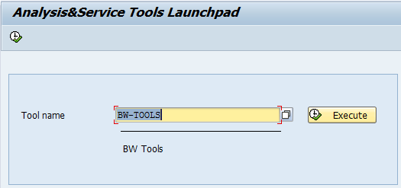
- Select the “Process Chain Analysis” and execute :
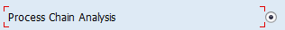
- Click on “Process Chains”

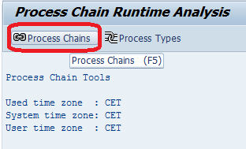
- In the “Start Date” and “End Date”, enter the interval you want to extract (keep the rest empty)
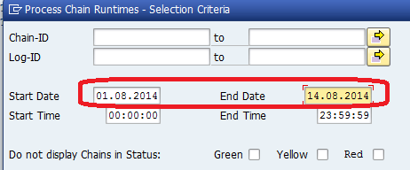
- Once on the result page, click on “Change Layout”.
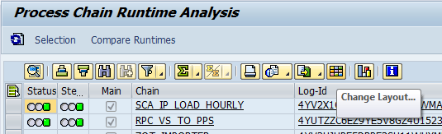
- By default the “Red Steps”, “Yel Steps”, “Errors” are not included in the layout. Add them :

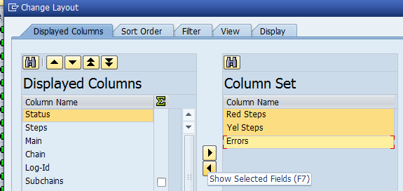
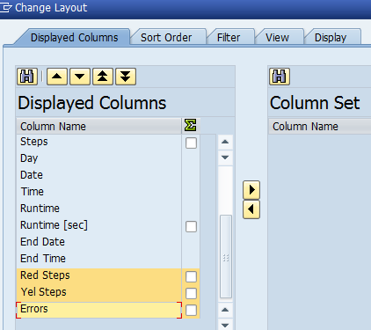
- Once Errors have been added, you need to export the data. Click on Export and “Local File” :
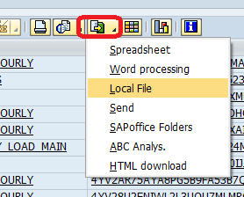
- Select “Spreadsheet”
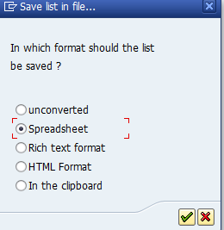
- Select a destination on your computer and click on “Generate” (or “Replace” if replacing a file)
