TC1: Create Amendment, supersede event will trigger (Automatically). Custom events will trigger and update Parent Agreement Previous Contract Value.
Note: This is a scripted field.
Parent Agreement Previous Contract value (Before custom task execution)
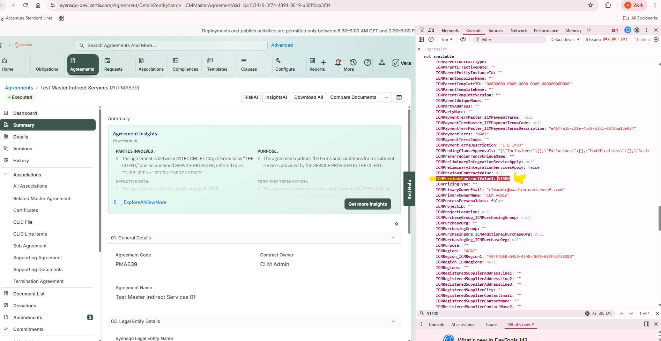

New Amendment Created -> Executed-> wait for supersede
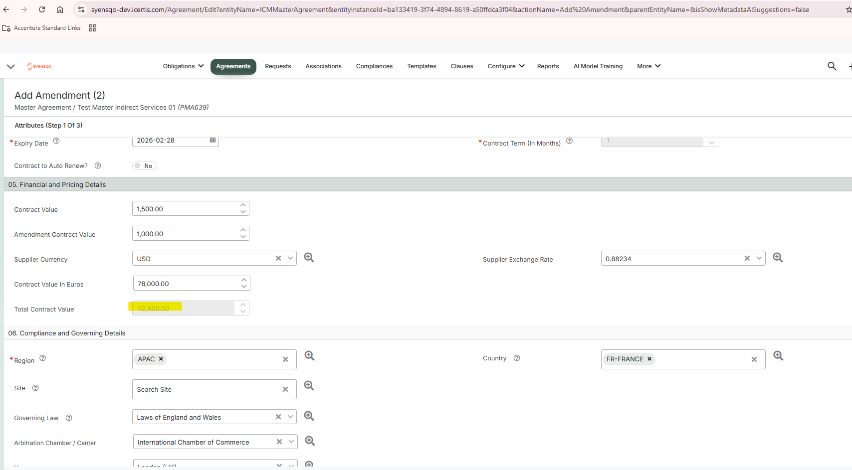
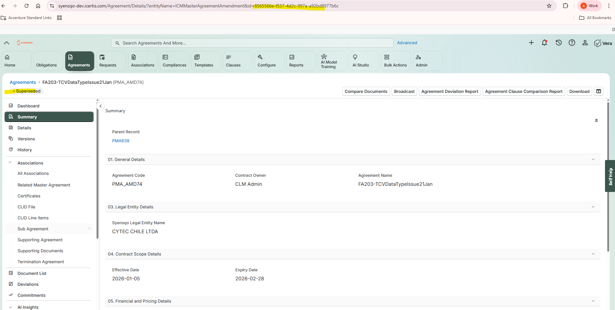

Parent Agreement Previous Contract value (After custom task execution)
