Automatic Check Job
-
Monitoring.

Versions.

Vers | Date | Title of Chapter | Section | Comments and Remarks | Who
1.0 | 28.04.2020 |  |  | Document creation | Francesco Bearzotti
1.1 | 27.01.2023 |  |  | Adapt document for Helix | Francesco Bearzotti

Table of contents.

Title Pages
1. Versions. 2
2. Table of contents. 3
3. Purpose. 4
4. Systems Impacted. 4
5. Follow this procedure. 4
5.1. Step 01 - Connect Mailbox. 4
5.2. Step 02 - Check jobs in error. 5
5.3. Step 03 - Execute Tr. SM37. 6
5.4. Step 04 - Determine report. 6
5.5. Step 05 - Execute Tr. SE38. 7
5.6. Step 06 - Determine Application. 8
5.7. Step 07 - Execute Tr. ZZS_JOBS_DOC . 9
5.8. Step 08 - Select entry. 10
5.9. Step 09 - Update entry. 11
5.10. Step 10 - Save entry. 11
5.11. Step 11 - Forward email. 12
5.12. Step 12 - Update label. 13
6. How to determine fields “Component” and “Owner E-mail” ? 14
7. How to determine the field “E-Mail Address” ?. 15
8. Contacts. 15

Purpose.
This document explains how to monitor the emails received in case of job error in the mailbox is-adagio-sap-operations-system-messages@solvay.com.
This type of email is generated by the report ZZS_JOBS_CANCELED_NOTIFICATION when a job is in error
(cfr document “Automatic_Check_Job.pdf”).
The goal is to update the tables with the information that will allow the process to send an email to the right address.

Systems Impacted.
The systems impacted by this process are :
- BP2, MPG, PF1, PF7, PI1, WP1, WPG.

Follow this procedure.

Step 01 - Connect Mailbox.
Connect the mailbox is-adagio-sap-operations-system-messages@solvay.com and check if there are emails with :
- Title : begin by “ Job - <sss>-<ccc> - “
where <sss> system and <ccc> client (for example : “Job - WP1-400 -” )
- From : is-adagio-sap-operations-system-messages@solvay.com
- To : is-adagio-sap-operations-system-messages@solvay.com

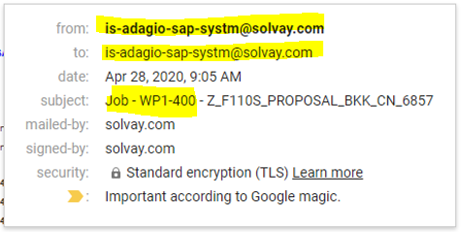

Step 02 - Check jobs in error.
Connect the system impacted by this job in error.
In this case, WP1-400 and the job in error is Z_F110S_PROPOSAL_BKK_CN_6857.

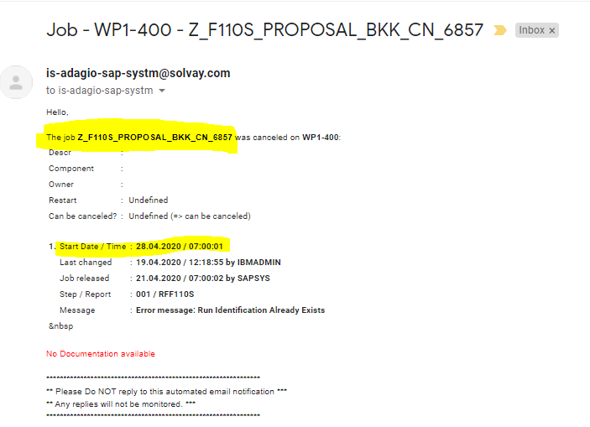

Step 03 - Execute Tr. SM37.
Execute the Tr. SM37 and select the job name in error during this period.
In this case Z_F110S_PROPOSAL_BKK_CN_6857 the 28/04/2020.

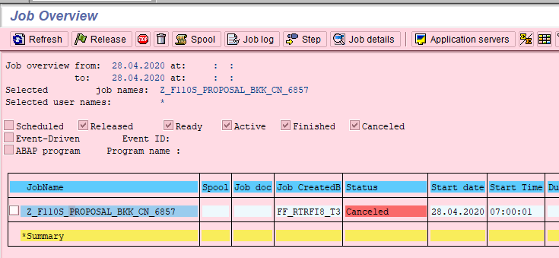

Step 04 - Determine report.
Determine the report in error via the log file.
In this case RFF110S.

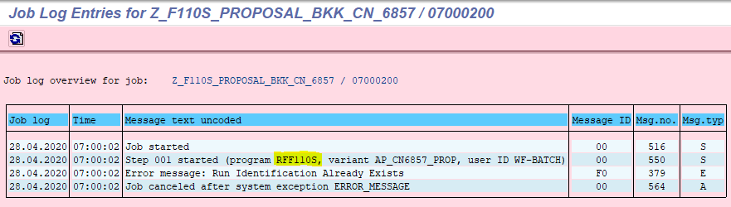

Step 05 - Execute Tr. SE38.
Execute the Tr. SE38 with the report name and subobjects “Attributes“.
In this case RFF110S.

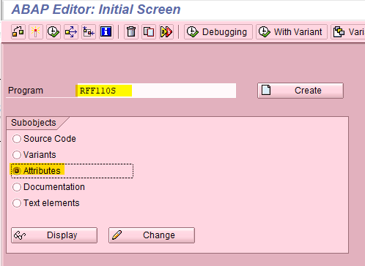

Step 06 - Determine Application.
Check for which SAP Application this report is defined.
In this case it is Financial Accounting.

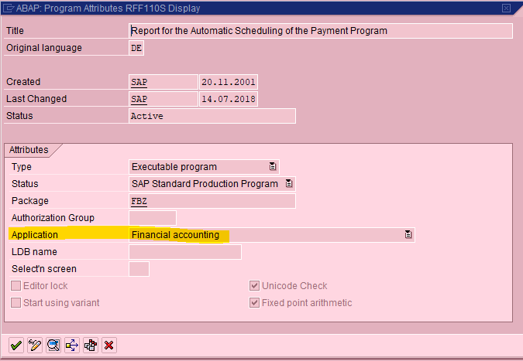

Step 07 - Execute Tr. ZZS_JOBS_DOC .
Execute the Tr. ZZS_JOBS_DOC and select the job Z_F110S_PROPOSAL_BKK_CN_6857.

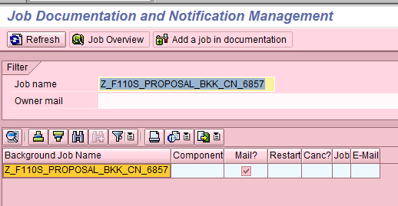

Step 08 - Select entry.
Double click on the entry and edit it.

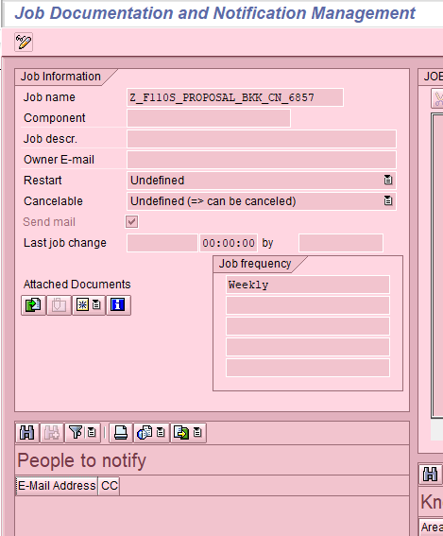

Step 09 - Update entry.
Like this job, runs the RFF110S report, and that this is a financial report.
This report therefore depends on the RTR team.
Update these fields with these information :
- Component = RTR
- Owner E-mail = IS-Appli-RTR-Operations@solvay.com
- E-Mail Address = incoming@solvay-mail.onbmc.com (=> Helix mailbox)

Step 10 - Save entry.
Save your modifications

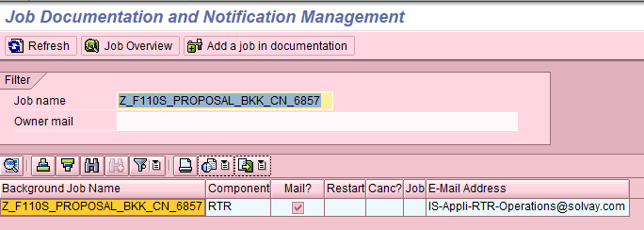

Step 11 - Forward email => DEACTIVATED.
Return back to the mailbox and forward the email to Helix
(incoming@solvay-mail.onbmc.com)

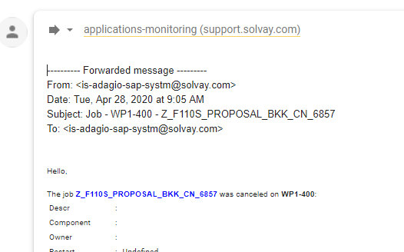

Step 12 - Update label.
Put the label “_Automatic Checks/_Job” and archive the email.
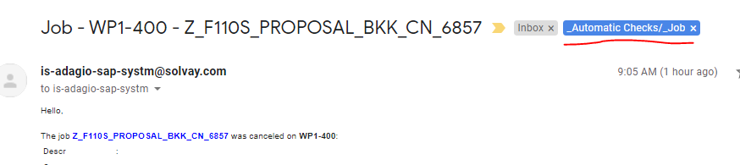

How to determine fields “Component” and “Owner E-mail” ?
This table is not exhaustive but can help you find the information to update the fields “Component” and “Owner E-mail”.
You can help yourself by checking if there is not a similar job, already encoded.
I propose that you execute the Tr. ZZS_JOBS_DOC before, and you analyse the situation of the previous job entries.

SAP Application | Component | Owner E-mail
BC | BC | is-adagio-sap-systm@solvay.com
BW | BW | IS-Appli-Reporting-Operations@solvay.com
EHS | EHS | IS-Appli-I-P-Operations@solvay.com
FI/CO | RTR | IS-Appli-RTR-Operations@solvay.com
GRC | GRC | IS-IAM-Background-Monitoring@solvay.com
HR | HTR | IS-Appli-HtR-Operations​@solvay.com
LO/OF/LE/SD/GTS | OTC | IS-Appli-OTC-Operations@solvay.com
MDG | MDG | mdg-support@solvay.com
MM/WM | PTP | IS-Appli-PTP-Operations@solvay.com
PP/PM/PS/QM/PR/WF | PP/PM/PS/QM/PR/WF | IS-Appli-I-P-Operations@solvay.com
SRM | SRM | applications-monitoring@support.solvay.com

How to determine the field “E-Mail Address” ?.
For the majority of the systems where this process is activated.
The emails are sent to Helix at address incoming@solvay-mail.onbmc.com.
But some of the functional teams decided to use a different receiving address than that of Freshdesk.
This table gives you for each system, the email address used in the “E-Mail Address” field.

System | E-Mail Address
BP2 | incoming@solvay-mail.onbmc.com
MPG | mdg-support@solvay.com
PF1 | incoming@solvay-mail.onbmc.com
PF7 | IS-Appli-I-P-Operations@solvay.com
PI1 | incoming@solvay-mail.onbmc.com
WP1 | incoming@solvay-mail.onbmc.com
WPG | IS-IAM-Background-Monitoring@solvay.com

Contacts.

Nom | Email
Adagio Team | is-adagio-sap-operations@solvay.com

